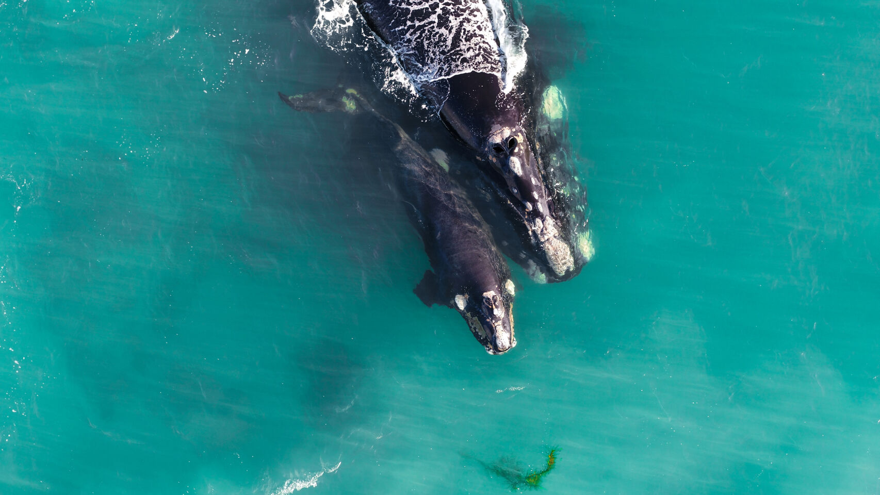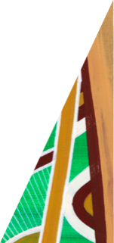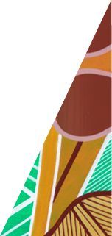

[deeca.vic.gov.au](https://delwpvicgovau.sharepoint.com/Users/fionadurante/Downloads/deeca.vic.gov.au)

# Southern Right Whale Monitoring Program Outcomes 2023

**.**

**Southern Right Whale Monitoring Program**

**What we were hoping to find out**

DEECA and the Arthur Rylah Institute have been working with the wider community to monitor the endangered Southern Right Whales along the Victorian coast during the breeding season. The community has been involved in assessing whale populations using our WhaleFace platform to assist with ongoing population modelling. The data collected will also contribute to national and global assessments of Southern Right Whale populations.

**What we did this year**

## WhaleFace Citizen Science Program

* 76 sightings (including associated photo ID data) collected from 29 contributors.
* We completed an upgrade of the online WhaleFace citizen platform to improve user experience.
* We delivered monthly Whale News newsletters (and email alerts) to subscribers.

In 2023 we:

* continued working with the community to deliver the **WhaleFace Citizen Science Program;** and
* conducted **aerial surveys** to monitor occupancy rates and residency patterns of whales.

## What we found

This year we had fewer than expected Southern Right Whales visit the Victorian coast.

There was **only one resident mother-calf pair for Victoria** (Portland area) however this pair were elusive and spent the majority of their time offshore (which is uncharacteristic). This pair had a relatively short residency period of approximately three weeks. As a result, drone surveys to obtain IDs and assess mother-calf health were not feasible.

There were no resident cow-calf pairs identified at the Logans Beach nursery ground. All up at least 5 calves were born in 2023 for the eastern population (i.e. including NSW and Tasmanian records).

Seventy-six whale sightings were received, including some single unacompanied adults and small groups of transiting adults. The number of individuals sighted is to be determined via photo-id anaylsis.

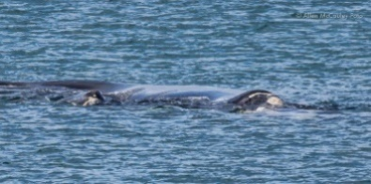

Figure 1 (right): Southern Right Whale, photo by Allen McCauley



## What does this mean?

Unfortunately, because the eastern population is so small, and females generally only breed every 3-4 years we do sometimes have years in Victoria where we see very few cow-calf pairs.

Given that low numbers were also seen in the western population in 2023, it is possible that food resources are having an impact on Southern Right Whale calving numbers and limiting the recovery of the eastern population.

## Recreational Boating Awareness Initiative

## Recreational Boaters Survey Results

As part of the 2023 program we surveyed the Victorian recreational boaters community.

We found **low awareness of the presence of Southern Right Whales** among this community.

* Only 32% of respondents knew that there are endangered Southern Right Whales breeding in Victoria; and
* only 23% of survey respondents knew when you are most likely to see the whales.

There was widespread (i.e. 80%) agreement amongst respondents that better awareness of whales and when they’re around would help boaters behave more responsibly during the whale season.

In 2023, we also launched the Recreational Boating Awareness initiative. This initiative was aimed at reducing the threat of vessel strike by encouraging responsible boating.

This initiative included:

* the promotion of three key actions for responsible boating around whales;
* the installation of seasonal corflute signs at 48 boat ramps across the Victorian coast; and
* 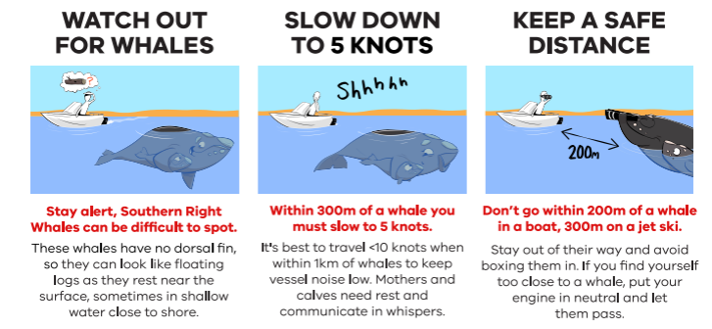the creation of stickers, posters, postcards, FAQs and social media content.

## Additional achievements

As well as the above initiatives, we were able to deliver the following projects in 2023:

* a report on supporting the recovery of Southern Right Whales in eastern Australia;
* a series of community talks to recreational fishing groups, traditional owners, DEECA staff and the general community;
* the creation of engagement packs on supporting Southern Right Whales which were then distributed to LGAs and other local land managers; and
* a survey of recreational boaters and their awareness of the whales and their seasonal habits.

.

We acknowledge Victorian Traditional Owners and their Elders past and present as the original custodians of Victoria’s  
 land and waters and commit to genuinely partnering with them and Victoria’s Aboriginal community to progress their aspirations.

© The State of Victoria Department of Energy, Environment and Climate Action March 2024.

## Filling gaps in our photo ID catalogue

The community helped us to track down images from the 1980s and 90s of Wilma (a well-known female) to fill in gaps in the photo-ID catalogue.

The search also uncovered images of other known females who we didn’t realise were breeding in the 1980s.

## Want to find out more?

Visit our information page at: [Southern Right Whales in Victoria (ari.vic.gov.au)](https://www.ari.vic.gov.au/research/threatened-plants-and-animals/southern-right-whlaes-in-victoria)

Or get in touch with Dr. Kasey Stamation Kasey.stamation@deeca.vic.gov.au

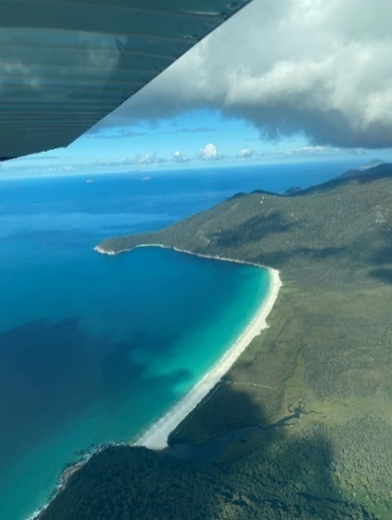



Figure 2 (left): View from plane near Wilsons Promontory while undertaking a whale survey.