# Victorian Semi-arid Woodlands

Broad vegetation condition change at monitoring sites



 



## Key Messages

* Findings from the Semi-arid Woodland Condition Monitoring Program show that in 2012, most woodland monitoring sites were in poor and fair condition, with only one site in good condition.
* Five to seven years later, condition remained unchanged at 83% of sites. Condition improved at 6% of sites (mostly Belah and Pine Woodlands) and declined at 11% of sites (mostly Buloke and Pine Woodlands).
* Most woodlands appear to be in a stable state or maintenance mode; however, some woodlands are still in decline and require enhanced management to maintain or improve in condition.

Monitoring program update January 2025

deeca.vic.gov.au

#### Semi-arid Woodlands

Semi-arid woodlands are characterised by one or more canopy species – Belah (*Casuarina pauper*), Buloke (*Allocasuarina luehmannii*), Slender Cypress Pine (*Callitris gracilis*), and Sugarwood (*Myoporum platycarpum) –* over a diverse ground layer of saltbushes, herbs, grasses and biological soil crust. They are slow-growing and reliant on high rainfall events to enhance regeneration success. Victorian woodlands are severely degraded due to historical land use, and recovery is slow and impeded by browsing. A long-term management (The Total Grazing Management Plan) and monitoring program (the Semi-arid Woodland Condition Monitoring Program) are being implemented to improve condition.

#### Vegetation condition change at 180 monitoring sites

This monitoring program update provides a quick snapshot of the observed changes in condition states (poor, fair and good) at 180 sites between 2012 (site establishment; M1) and the second monitoring period, approximately five to seven years later (M2). Site changes were assessed from two perspectives: the ecological management unit, and woodland type (plant community).

Findings – did site condition states change between monitoring?

When monitoring sites were established (2012) most were in poor to fair condition, with only one in good condition (Table 1). By the second monitoring period (M2) an additional three sites were classified as being in good condition; however, the number of poor condition sites increased.

Table 1. The number of Semi-arid Woodland monitoring sites in each condition state (poor, fair, good) across the two monitoring periods (M1 at site establishment and M2 at the second monitoring period ~5-7 years later).

|  |  |  |  |
| --- | --- | --- | --- |
| **Monitoring period** | **Condition State** | | |
| **Poor** | **Fair** | **Good** |
| M1 (establishment) | 91 | 88 | 1 |
| M2 (~5-7 years later) | 106 | 70 | 4 |

Vegetation condition remained stable at 150 (83%) of the 180 sites between the two monitoring periods (Figure 2, Table 2). Condition improved at 10 (6%) sites and declined at 20 (11%) sites.

A broad range of vegetation structural changes between monitoring periods were also observed. Such as a change from a grassy understorey in M1 (left) to shrubby in M2 (right) in the below image.

**M2**

Vegetation change (grassy to shrubby understorey) between monitoring periods (M1 and M2).

**Management unit differences**

Eastern Murray-Sunset, Hattah-Kulkyne and Wyperfeld National Parks had sites that both increased and decreased in condition. Most sites that declined in condition occurred in southern and north-west Murray-Sunset National Park (Figure 1a, Table 2).

**Woodland type differences**

Most woodland types with sites that improved in condition were Belah (13% of sites) and Pine Woodlands (7% of sites, Figure 1b, Table 2). Twenty percent of Buloke, 11% of Pine and 7% of Sugarwood Woodlands declined in condition.

**(a)**

**(b)**

**Figure 1.** The number of monitoring sites in poor, fair or good condition at site establishment (M1) and at the second monitoring period (M2 ~5-7 years later) in (a) the ecological management units of north-west, eastern and southern Murray-Sunset, Hattah-Kulkyne and Wyperfeld National Parks, and (b)Belah, Buloke, Pine and Sugarwood Woodlands.

**Table 2.** The number of sites that changed condition state between the two monitoring periods. Sites are classified according to the ecological management unit, and the woodland type.

|  |  |  |  |  |
| --- | --- | --- | --- | --- |
| **Scale** | **Change between condition states** | | | |
| **Declined** | **Improved** | **No change** | **Total** |
| **Total** | **20** | **10** | **150** | **180** |
| **Ecological management unit** |  |  |  |  |
| Murray-Sunset (north-west) | 5 | 1 | 54 | 60 |
| Murray-Sunset (eastern) | 1 | 2 | 24 | 27 |
| Murray-Sunset (southern) | 9 | 0 | 14 | 23 |
| Hattah-Kulkyne | 2 | 3 | 35 | 40 |
| Wyperfeld (central) | 3 | 4 | 23 | 30 |
| **Woodland type** |  |  |  |  |
| Belah | 2 | 4 | 30 | 36 |
| Buloke | 9 | 2 | 34 | 45 |
| Pine | 6 | 4 | 46 | 56 |
| Sugarwood | 3 | 0 | 40 | 43 |

## Management implications – What does this mean?

The slow-growing nature of these woodlands was highlighted by the fact that 83% of monitored sites showed no change in condition over a five-to-seven-year period. This is a positive outcome as it means that many sites did not decline in condition between monitoring periods. However, monitoring also shows that most sites are currently in poor (59%) or fair (39%) condition, while only four sites (2%) are in good condition. Although some sites improved in condition, this was limited to nine sites compared to twenty sites which declined in condition, particularly in Buloke woodlands.

*These slow-growing woodlands need assistance for long-term recovery.*

## Managing and monitoring long-term recovery

Victoria’s Semi-arid Woodlands are severely degraded due to historical land use (e.g. grazing, clearing). Woodland recovery is slow as regional productivity is low, and herbivore browsing (both feral and native) impedes recovery. The legacy of historical clearing and on-going ecological impacts (e.g. grazing, altered fire regimes) have long-lasting consequences for vegetation condition, including the loss of overstorey trees, degraded understorey and limited recruitment.

To improve woodland condition, a long-term restoration program (> 10 years) is underway. **The Total Grazing Management Plan** (Parks Victoria 2017) aims to achieve healthy Semi-arid Woodlands by undertaking management actions that reduce grazing impacts. A range of complementary restoration actions are also being employed (e.g. revegetation, weed control). **The Semi-arid Woodland Condition Monitoring Program** is being implemented across the Mallee National Parks to assist with measuring progress against the Total Grazing Management Plan goals and improve our knowledge of this plant community to enhance management effectiveness and recovery success.

Semi-arid Woodlands are slow-growing, thus vegetation change may occur over decades and successful regeneration is enhanced by several years of high rainfall. This slow growth rate means vegetation decline is also slow and may take many years before it is obvious. This is why annual monitoring is important as it highlights small shifts in indicators such as healthy mature trees, tree regeneration, weed cover and understorey plants. It is these small shifts that can eventually lead to a woodland declining or improving in condition. If small negative shifts (e.g. increased browsing on tree recruits) are recorded, then targeted management can be undertaken to reduce them (e.g. increased browser control), and annual monitoring can detect the success of these management actions (e.g. revegetation survival).

*This highlights the ongoing challenge for land managers as these woodlands need an ongoing long-term approach to recovery. Continued browser control and revegetation of woody plants in prioritised woodlands will enhance survival.*

**M2**

**M1**

Vegetation change (canopy health decline) between monitoring events (M1 and M2).

**M2**

**M1**

## Where to next?

* Continue monitoring to inform vegetation recovery.
* Ongoing implementation of browser control to reduce negative impacts on regenerating trees and shrubs.
* Determine priority Semi-arid Woodland sites for enhanced management to ensure that good quality examples remain in the landscape.
* Prioritise revegetation works at sites where the best return on investment can be confidently expected. For example, sites where planting of tube stock will result in increased large shrub species richness in the short-medium (3-5 years) term and increased healthy mature trees in the long-term (>10 years).

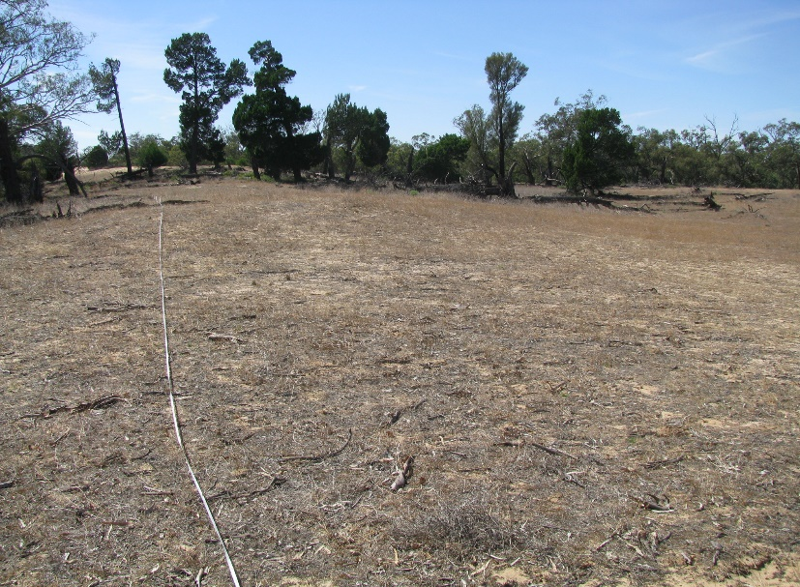

Vegetation decline (tree loss due to fire) between monitoring periods (M1 and M2).

**M1**

**M2**

#### Further Reading

Parks Victoria (2017) The total grazing management plan for the restoration of semi-arid woodland and floodplain vegetation communities in the north-western (Mallee) parks 2016-2010. Internal Parks Victoria report, Mildura, Victoria.

Moxham C., Kenny S. and Moloney P. (2024) Semi-arid Woodland Condition Monitoring Program: five-year evaluation: defining vegetation condition. Unpublished Report. Arthur Rylah Institute for Environmental Research, Department of Energy, Environment and Climate Action, Heidelberg, Victoria.

**For further information contact: Claire Moxham (**[**claire.moxham@deeca.vic.gov.au**](mailto:claire.moxham@deeca.vic.gov.au)**) or Sally Kenny (**[**sally.kenny@deeca.vic.gov.au**](mailto:sally.kenny@deeca.vic.gov.au)**)**

Appendix 1. The number of monitoring sites in each condition state (poor, fair, good), scale category (ecological management unit or woodland type) across the two monitoring periods.

|  |  |  |  |
| --- | --- | --- | --- |
| **Woodland type** | **Condition state** | | |
| **Poor** | **Fair** | **Good** |
| **Belah** |  |  |  |
| Survey 1 (establishment) | 9 | 26 | 1 |
| Survey 2 (~5-7 yrs later) | 10 | 24 | 2 |
| **Buloke** |  |  |  |
| Survey 1 (establishment) | 15 | 30 | 0 |
| Survey 2 (~5-7 yrs later) | 22 | 23 | 0 |
| **Pine** |  |  |  |
| Survey 1 (establishment) | 28 | 28 | 0 |
| Survey 2 (~5-7 yrs later) | 32 | 22 | 2 |
| **Sugarwood** |  |  |  |
| Survey 1 (establishment) | 39 | 4 | 0 |
| Survey 2 (~5 yrs later) | 42 | 1 | 0 |

#### 

|  |  |  |  |
| --- | --- | --- | --- |
| **Ecological management unit** | **Condition state** | | |
| **Poor** | **Fair** | **Good** |
| **Murray-Sunset (north-west)** |  |  |  |
| Survey 1 (establishment) | 52 | 8 | 0 |
| Survey 2 (~5 yrs later) | 56 | 4 | 0 |
| **Murray-Sunset (eastern)** |  |  |  |
| Survey 1 (establishment) | 3 | 23 | 1 |
| Survey 2 (~6 yrs later) | 4 | 22 | 1 |
| **Murray-Sunset (southern)** |  |  |  |
| Survey 1 (establishment) | 6 | 17 | 0 |
| Survey 2 (~7 yrs later) | 15 | 8 | 0 |
| **Hattah-Kulkyne** |  |  |  |
| Survey 1 (establishment) | 26 | 14 | 0 |
| Survey 2 (~6 yrs later) | 26 | 13 | 1 |
| **Wyperfeld (central)** |  |  |  |
| Survey 1 (establishment) | 4 | 26 | 0 |
| Survey 2 (~7 yrs later) | 5 | 23 | 2 |



© The State of Victoria Department of Energy, Environment and Climate Action January 2025.

Logo

**ISBN** 978-1-76176-080-8 **(pdf/online/MS word)**

Accessibility

If you would like to receive this publication in an alternative format, please telephone the DEECA Customer Service Centre on 136186, email [customer.service@delwp.vic.gov.au](mailto:customer.service@delwp.vic.gov.au), or via the National Relay Service on 133 677 [www.relayservice.com.au](http://www.relayservice.com.au).

This work is licensed under a Creative Commons Attribution 4.0 International

licence. To view a copy of this licence, visit

creative commons.org/licenses/by/4.0/