**Citizen Science:**

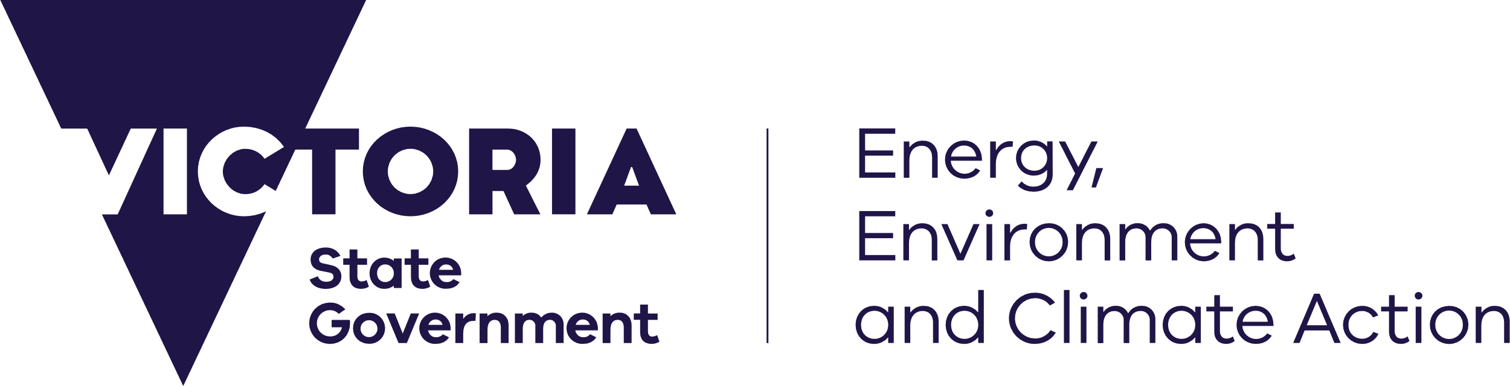

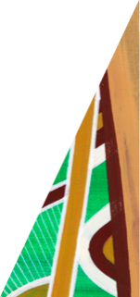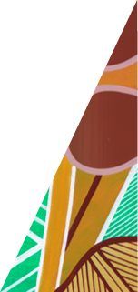

[deeca.vic.gov.au](https://delwpvicgovau.sharepoint.com/Users/fionadurante/Downloads/deeca.vic.gov.au)

## What is citizen science?

Citizen or people powered science is everyday people recording and sharing observations of the world around them. It provides essential information that contributes to our understanding of our environment and helps inform our decisions and actions to protect it.

***Citizen science involves public participation and collaboration in scientific research with the aim to increase scientific knowledge.***

**Australian Citizen Science Association**

## Who can get involved?

**Everyone!**

**No qualifications required**

Rapid advances in technology are making citizen science more accessible; see examples of programs on the following page.

## Citizen science in Victoria

Victoria has an established and growing citizen science sector which has been delivering essential data for biodiversity conservation for many years.

Citizen science plays a crucial role in **filling data gaps** on **private land** and providing **long term monitoring** of sites and species.

Citizen science observations contribute to important decisions about Victoria’s environment.

In 2023 our annual Volunteering Naturally snapshot showed there were over 213,500 volunteers in Victoria, including citizen scientists, contributing over 1.9 million hours of effort, an economic contribution of almost $85 million.

# Citizen Science:

# People Powered Science to Protect our Environment

## How can I contribute?

Check out the Australian Citizen Science Association’s Project Finder to see a list of a wide variety of citizen science programs underway in Victoria.

**What’s involved?**

Recording observations can be as simple as uploading photos of plants or animals you’ve seen via a smart phone app, right through to repeated field surveys with a community group. There are many ways to contribute.

## How is the data used?

Citizen science programs contribute valuable data to environmental monitoring and management projects across the state.

In some cases, this includes sharing data with the Victorian Biodiversity Atlas (VBA).

## Victorian Biodiversity Atlas

Data shared with the VBA is accessible via NatureKit and used in government modelling and decision making. This includes conservation assessments and emergency response operations. Not all citizen science programs currently contribute data to the VBA. However, this will change as data verification becomes easier.

**Every record counts!**

## Examples of Citizen Science programs:

Accessibility

If you would like to receive this publication in an alternative format, please telephone the DEECA Customer Service Centre on 136186, email [customer.service@delwp.vic.gov.au](mailto:customer.service@delwp.vic.gov.au), or via the National Relay Service on 133 677 [www.relayservice.com.au](http://www.relayservice.com.au).

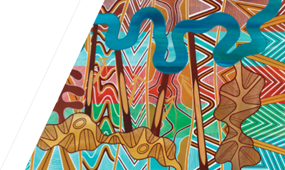

We acknowledge Victorian Traditional Owners and their Elders past and present as the original custodians of Victoria’s land and waters and commit to genuinely partnering with them and Victoria’s Aboriginal community to progress their aspirations.

|  |  |
| --- | --- |
| **Program** | **Record types** |
| **Birdata**  Birdlife Australia | Record bird observations. |
| **eBird**  Cornell Lab of Ornithology | Record and identify birds from photos and calls. |
| **Estuary Watch**  Vic Catchments | Record estuary health and conditions. |
| **Frog**  **Census**  Melbourne Water | Record and identify frogs from photos and calls. |
| **FrogID**  Australian Museum | Record and identify frogs from photos and calls. |
| **iNaturalist** | Record observations of plants, animals and fungi. |
| **The Great Biosecurity Quest**  Agriculture Victoria | Record sightings of pests plants and animals and plant diseases in Victoria. |
| **Water Watch Victoria**  Vic Catchments | Record water quality in rivers and streams across Australia. |
| **WhaleFace**  Arthur Rylah Institute (DEECA) | Record sightings and photos of whales along Victoria’s coastline. |

 © The State of Victoria Department of Energy, Environment and Climate Action. This work is licensed under a Creative Commons Attribution 4.0 International licence. To view a copy of this licence, visit <http://creativecommons.org/licenses/by/4.0/>

ISBN 978-1-76136-835-6 (pdf/online/MS word)