|  |
| --- |
| Riparian Intervention Monitoring Program  2021 update |
| Ongoing signs of improved riparian condition three years  following management intervention |

## Background

In Victoria, the Department of Environment, Land, Water and Planning (DELWP), catchment management authorities (CMAs) and Melbourne Water invest significant resources in riparian management interventions along waterways including stock-management fencing, revegetation and weed management. These interventions aim to improve vegetation condition, manage bank erosion, and contribute to long-term improvements in waterway condition. Further evidence, however, is needed to quantify the effectiveness of these management interventions, and the effect that variables such as initial site condition, type of management intervention and other landscape variables may have on management outcomes.

## What is RIMP?

The [Riparian Intervention Monitoring Program](https://www.ari.vic.gov.au/research/rivers-and-estuaries/riparian-intervention-monitoring-program) (RIMP) is a state-wide, long-term program developed by DELWP in 2014. The program works with CMAs and landholders to establish long-term monitoring sites (Figure 1) to assess the impact and effectiveness of riparian management.

Figure 1. Setting up a transect at a RIMP control site in the Corangamite CMA region.

RIMP contributes to demonstrating outcomes of the *Regional Riparian Action Plan* which delivers an accelerated riparian works program across regional Victoria as part of the Victorian Government’s Water Plan, *Water for Victoria,* to improve the health of waterways and catchments.

## Project objectives

The key objectives of the program are to:

* provide rigorous evidence of responses of riparian vegetation condition and bank stability to common management interventions (i.e. weed control, revegetation and livestock exclusion)
* understand how long it takes for condition attributes to change
* understand sources of variability in responses to management interventions
* improve conceptual models of expected outcomes of riparian management.

## Types of sites

Several approaches are being used to gather evidence of riparian responses to management:

* **Standard paired sites**: well matched intervention and control (unmanaged) site pairs that are monitored before and multiple times after intervention works are implemented.
* **Past intervention paired sites:** well matched past intervention and control (unmanaged) site pairs that are monitored multiple times after intervention works.
* **Before and after works**: these single sites are monitored before and after the intervention when a well-matched control (unmanaged) site is not available. They inform progress towards a target but are less robust in evaluating the effectiveness of interventions according to scientific principles.

The most rigorous is the standard paired sites which represent the core component of RIMP.

## What is being monitored?

Monitoring measures the following riparian attributes:

* exotic vegetation cover and stem density
* native vegetation cover and composition
* bare ground and litter cover
* vegetation structure
* recruitment of native trees and shrubs
* native vegetation extent and continuity
* bank stability

## Early responses to management

## Between 2014 and 2020, a total of 23 standard paired RIMP sites have been resurveyed three years following management. Management at intervention sites included at least one of three core management interventions (Livestock exclusion fencing, revegetation and weed management), but often included all three. These surveys form the basis for evaluating:

* the program’s ability to determine statistically significant changes in key indicators and
* the effectiveness of management intervention to improve riparian condition.

*Key indicator responses three years following management are (on average):*

* Bare ground decreased proportionally by ~41% at intervention sites but increased proportionally by ~61% at control sites.
* There was a greater proportional increase in organic litter at intervention sites (~78% increase) than control sites (~31% increase).
* There was a greater proportional increase in overall native vegetation cover (all strata combined) at intervention sites (~37% increase) than control sites (~14% increase).
* There was a small proportional decrease in all vegetation cover (native and exotic combined) at intervention sites (~6% decrease, likely due to removal of exotic woody weeds), while the cover at control sites remained constant.
* Density of native woody recruits (planted and natural recruits combined) increased proportionally by over 1600%, while at control sites they decreased proportionally by ~66% (Figure 2).
* The stem density of native tree or woody shrubs (irrespective of age class) increased proportionally at intervention sites by over 600%, while at control sites they decreased proportionally by ~42%.
* The number of native taxa increased proportionally by ~76% at intervention sites, while at control sites the number remained relatively unchanged.

*Results are based on data pooled across 23 resurveyed sites.

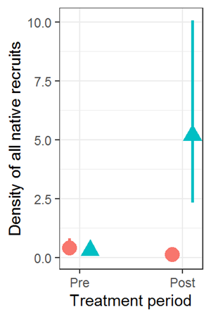

Figure 2. Stem density of native woody recruits across all 23 sites analysed. Estimates represent stems per 80 m-2 (transect length = 20 m). Intervention sites are represented in blue and control sites in red. The triangles and circles represent the mean and the lines represent the 95% credible interval.

## Conclusion

In just three years following management intervention, there is evidence of positive changes in a range of indicators associated with key management objectives. The positive results of the program to date provide confidence that interventions have been successful in achieving many of the management objectives of the program. The results also have significant implications in providing confidence to managers, funding bodies, and landholders that such interventions, if carried out well, provide a worthwhile return on investment. Before and after photos for well executed interventions across a range of CMA regions are shown in Figures 3-5.

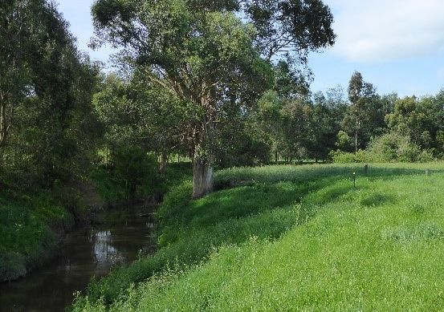

a

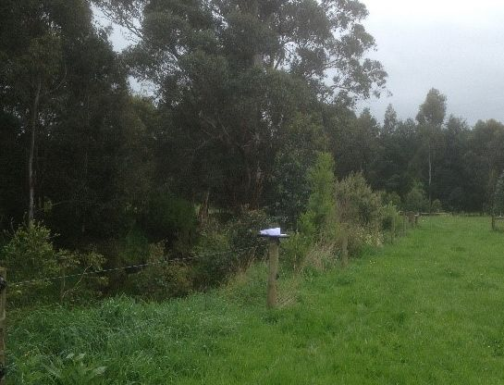

b

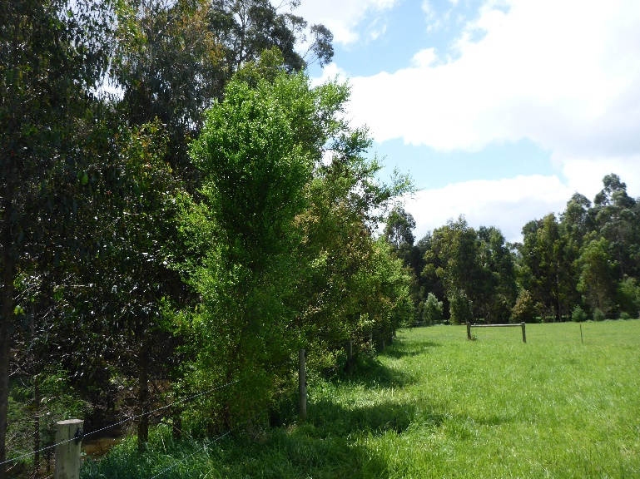

c

Figure 3. Well executed intervention on the Tarwin River, West Gippsland CMA. Before intervention (a), three years post intervention (b) and six years post intervention (c). Interventions at this site included fencing to exclude livestock and tubestock planting.

a

b

Figure 4. A well executed intervention site on the Koetong Creek in the Noth East CMA region showing pre-intervention condition (a) and natural recruitment of *Acacia dealbata,* Silver Wattle (at rear) and *Eucalyptus camaldulensis,* River Red Gum (foreground) three years after fencing to restrict livestock access (b).

a

b

Figure 5. Well executed intervention on Stoney Creek, Glenelg Hopkins CMA. Before intervention (a) and three years post intervention, including tubestock planting and fencing to exclude livestock (b).

## What’s next?

Ongoing monitoring is planned in the medium (6-10 years) and long term (20 years) to determine whether the early gains observed at intervention sites are maintained over time or are lost through emerging threats such as weed invasion.

Although the results clearly show that the management intervention improved vegetation condition, responses were variable among individual sites. For example, at a very small number of sites that included woody weed control, significant reinvasion or reshooting of exotic woody weeds had the potential to render the intervention unsuccessful if further intervention had not been undertaken. This highlights the importance of allocating adequate resources to allow post intervention monitoring and ongoing weed control.

As more sites are resurveyed, future analyses will examine potential causes for variability in restoration success such as the type of management intervention, initial site condition, or differences in site and landscape variables.

Field monitoring for sixth year assessments has recently commenced, although these data have not yet been analysed. Photo monitoring on the Tarwin River in the West Gippsland CMA region six years after intervention (Figure 3c) shows significant establishment and growth of planted tubestock.

**For more information:**

Contact: [bryan.mole@delwp.vic.gov.au](mailto:bryan.mole@delwp.vic.gov.au)

For more information visit the ARI website at: https://www.ari.vic.gov.au/research/rivers-and-estuaries/riparian-intervention-monitoring-program

|  |  |
| --- | --- |
| © The State of Victoria Department of Environment, Land, Water and Planning 2021  LogoThis work is licensed under a Creative Commons Attribution 4.0 International licence. You are free to re-use the work under that licence, on the condition that you credit the State of Victoria as author. The licence does not apply to any images, photographs or branding, including the Victorian Coat of Arms, the Victorian Government logo and the Department of Environment, Land, Water and Planning (DELWP) logo. To view a copy of this licence, visit http://creativecommons.org/licenses/by/4.0/  **ISBN** 978-1-76105-610-9 **(pdf/online/MS word)**  **ISBN** 978-1-76105-609-3 **(Print)**  Disclaimer  This publication may be of assistance to you but the State of Victoria and its employees do not guarantee that the publication is without flaw of any kind or is wholly appropriate for your particular purposes and therefore disclaims all liability for any error, loss or other consequence which may arise from you relying on any information in this publication. | Accessibility  If you would like to receive this publication in an alternative format, please telephone the DELWP Customer Service Centre on 136186, email [customer.service@delwp.vic.gov.au](mailto:customer.service@delwp.vic.gov.au) or via the National Relay Service on 133 677 [www.relayservice.com.au](http://www.relayservice.com.au). This document is also available on the internet at <https://www.ari.vic.gov.au/research/rivers-and-estuaries/riparian-intervention-monitoring-program> |