Native Fish Report Card 2024

**Yarra River**

**Port Phillip Region**



**This report card summarises the 2024 Native Fish Report Card (NFRC) survey in the Yarra River**

**Sites 11, Electrofishing**

**Fish found in Yarra River for NFRC**

**Target species**

Australian Grayling

Macquarie Perch#

Murray Cod#

**Non-target species recorded since 2017\***

**Large-bodied native species**

River Blackfish

Short-finned Eel

Tupong

Australian Bass#

Barramundi #

Golden Perch#

**Small-bodied native species**

Australian Smelt

Climbing Galaxias

Common Galaxias

Flatheaded Gudgeon

Ornate Galaxias

**Exotic species**

Brown Trout

Eastern Gambusia

Common Carp

Goldfish

Oriental Weatherloach

Roach

Redfin

* These non-target species were incidentally captured during NFRC surveys since 2017 but not measured as for target species. # Native species translocated outside of its natural range.

**Yarra River 2024**

**Fish Community**

**NFRC target species**

**The NFRC Program began in 2017 to monitor population dynamics of key iconic fish species that have high recreational and/or conservation values, in large rivers across Victoria. In the Yarra River, the target species are Australian Grayling, Macquarie Perch and Murray Cod. The equipment used and habitats surveyed target these species, which are measured to determine their population structures. Other fish species that are incidentally captured are counted, but not measured. Surveys occur in March/April each year, with 14 sites from upstream of Dights Falls to Yarra Glen fished in 2017-2021 and 11 sites fished from Heidelberg to Yarra Glen in 2022-2024. The Yarra River primarily uses boat electrofishing with bank-mounted electrofishing at two sites.**

**Summary of key health indicators for target species in 2024**

|  |  |  |  |
| --- | --- | --- | --- |
| **Species** | **Key Health Indicators** | | |
|  | Recent recruitment | Multiple size classes | Mature fish present |
| Australian Grayling* | - | - | - |
| Macquarie Perch | No | Yes | Yes |
| Murray Cod | Yes | Yes | Yes |

*Recent recruitment refers to young-of-year fish*

*\*- cannot be determined due to low abundances*

Australian Grayling were once widespread throughout coastal Victoria, including the Yarra River system. Changes to flow regimes and barriers negatively affect this species. The detection of Australian Grayling in six of the eight years is an encouraging sign that river conditions are enabling persistence of the species. Macquarie Perch have undergone a long-term decline in abundance with populations now fragmented and absent from much of its former range. Macquarie Perch were first translocated into the Yarra catchment in 1857 and the population is now considered important genetically. The population appears to be declining; however, we have detected an increase in adults post 2019 fishing regulation changes (when Macquarie Perch became a no-take species). Murray Cod were translocated into the Yarra River in 1857 and are now a popular recreational species. There appears to be a small self-sustaining population. The following pages have more detail about the population structures of each target species.

**Non-target species**

The non-target fish species that have been incidentally recorded in the Yarra River during NFRC surveys since 2017 are:

**Large-bodied native species**

Short-finned Eel and Golden Perch were recorded in the 2024 survey. Short-finned Eel is a diadromous species found throughout coastal Victoria and has been recorded in all eight NFRC surveys. Golden Perch has been recorded in six of the eight NFRC surveys and has been translocated into the Yarra River. Other large-bodied species previously recorded, although rarely, in NFRC surveys are Australian Bass, Barramundi, River Blackfish and Tupong. Australian Bass is found in eastern coastal Victoria and has been translocated to the Yarra River. While Barramundi has also been translocated to this river, it is a tropical species and thus conditions are not likely to be suitable for its survival. River Blackfish is a lowland species, generally found at altitudes below 200 m. This species has declined in distribution and abundance across the State. Tupong are a diadromous species found throughout coastal Victoria.

**Small-bodied native species**

Australian Smelt, Common Galaxias, Flatheaded Gudgeon and Ornate Galaxias were recorded in the 2024 survey. Australian Smelt and Flatheaded Gudgeon are common across Victoria with Australian Smelt recorded in all eight NFRC surveys and Flatheaded Gudgeon recorded six times. The Common Galaxias is a diadromous species found across coastal Victoria and has been collected in all eight NFRC surveys. The Ornate Galaxias is mainly confined to coastal Victoria between Wilsons Promontory and Cape Otway. In the Yarra River the Ornate Galaxias is widespread and patchy in the lower areas, but more common above 200 m altitude. It was collected in 2023 and 2024.

**Exotic fish species**

Common Carp, Eastern Gambusia, Goldfish, Oriental Weatherloach, Redfin and Roach were recorded in the 2024 survey. These species are generally widespread throughout the sampling reaches of the Yarra River. Common Carp, Redfin and Roach have been recorded in all eight NFRC surveys. Eastern Gambusia has been recorded in six of the eight surveys, while Goldfish and Oriental Weatherloach have been recorded seven times. Eastern Gambusia are often detected in slower flowing habitats. Brown Trout, recorded in three of the eight NFRC surveys, is present throughout the Yarra River. It is not a dominant species in the NFRC sampling area, being more abundant at higher altitudes.

**Other native fish species known from the Yarra River**

Some fish species known to occur in the Yarra River have never been recorded during NFRC surveys (e.g. Dwarf Galaxias, Spotted Galaxias, Pouched Lamprey, Short-headed Lamprey, Southern Pygmy Perch and Yarra Pygmy Perch). Spotted Galaxias, Pouched Lamprey and Shortheaded Lamprey are diadromous species in coastal Victoria. Spotted Galaxias has a patchy distribution and is hard to detect using NFRC sampling methods. Pouched and Short-headed Lamprey were considered widespread but in recent times adults are rarely seen and are usually active nocturnally. Dwarf Galaxias, Southern and Yarra Pygmy Perch are often found in offstream habitats (billabongs, wetlands and lagoons).

**Other notable species**

Surveys have also recorded Southern Victorian Spiny Crayfish.

**Yarra River 2024**

**Environmental and Management Context**

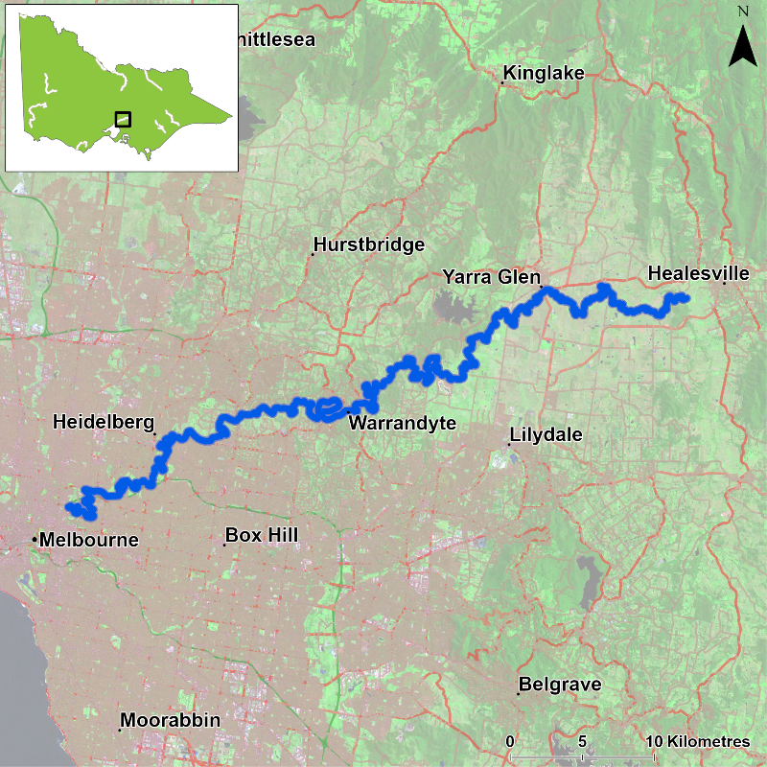

Figure 1. Map showing the section of Yarra River where NFRC sampling occurs

**Environment**

Low flow conditions were present in all eight sampling years, albeit slightly higher in 2018 and 2021 and slightly lower in 2022. The NFRC worked collaboratively with a Melbourne Water Macquarie Perch project with 14 sites fished from 2017-20. As the Melbourne Water Macquarie Perch project has finished, 11 sites were fished in 2022-2024.

**Waterway and fisheries management efforts in the Yarra River**

Many rehabilitation actions have occurred, and are underway, to improve the health of the Yarra River and its fish community. These are informed in particular by [Melbourne Water’s Healthy Waterways Strategy 2018-28](https://www.melbournewater.com.au/about/strategies-and-reports/healthy-waterways-strategy) and a Co-Designed Catchment Program for the Yarra Catchment. Efforts include revegetation, weed control and fencing of riparian areas, reintroduction of instream woody habitat, allocations of water for the environment (through seasonal watering planning),

removal of barriers to fish movement, pest control, management of water quality including stormwater, sewage and litter management.

Some monitoring of the fish community occurs in association with a variety of rehabilitation efforts. This includes monitoring fish responses to provision of water for the environment, the status of threatened species such as Macquarie Perch, fish monitoring in the upper Yarra, as well as eel and eDNA monitoring. [Melbourne Water](https://www.melbournewater.com.au/), DEECA and VFA support rehabilitation and management of the Yarra River and its fish community.

**Australian Grayling**

**Yarra River, Port Phillip region**

**Key Health Indicators**

Recent recruitment Cannot be determined

Multiple size classes Cannot be determined

Mature fish present Cannot be determined

**Monitoring Results**

Total number of fish caught 3

Fish per 1km of waterway 0.53

Largest fish by length (cm) 6.8

Largest fish by weight (kg) 0.05

% of the catch that is legal size NA

**Australian Grayling (*Prototroctes maraena*) is a diadromous species that has declined in distribution and abundance across its range. The species is listed as endangered in Victoria (*Flora and Fauna Guarantee Act* 1988) and nationally (*Environment Protection and Biodiversity Conservation Act* 1999). The NFRC does not expect to capture enough Australian Grayling to measure key health indicators. Rather, threatened species such as Australian Grayling are targeted for monitoring to gain a greater understanding of the current status of the populations which is essential information to inform the management of such species.**

**Small numbers of Australian Grayling were captured in 2024, similar to 2018-19 and 2021-23 (Figure 2). The highest capture rates occurred in 2022 and 2023 with five fish captured in each year. Adults have been detected in (2018, 2021 and 2023-2024) with highest abundances in 2023 (Figure 2; Figure 3). Juveniles and adults were collected in 2024, (Figure 2). Recruits have only been detected in 2022 and 2023. Juveniles have been detected the most consistently, detected in six of the eight years (2018-19 and 2021-24). The presence of recruits in 2022 and 2023 and juveniles in 2018-19 and 2021-24 (Figure 2; Figure 3) indicates stream conditions were suitable for recruits to be attracted into the system from coastal/marine waters and subsequent upstream dispersal.**

**Stocking**

No stocking has occurred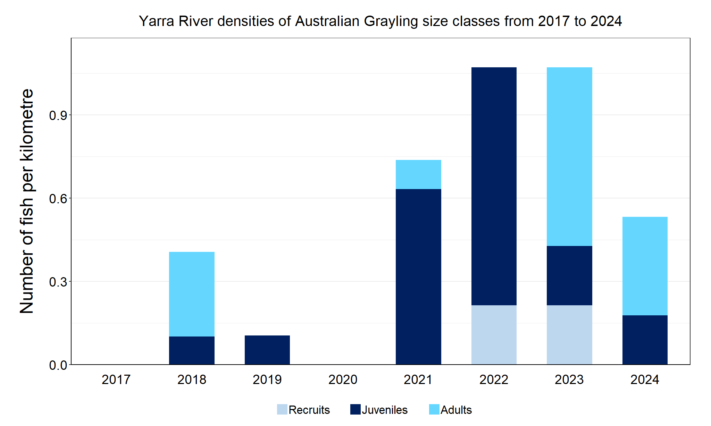

Figure 2. The densities of recruits, juveniles and adult Australian Grayling in the Yarra River from 2017 to 2024

Figure 3 The size range percentage of Australian Grayling in the Yarra River in 2024

**Macquarie Perch**

**Yarra River, Port Phillip region**

**Key Health Indicators**

Recent recruitment No

Multiple size classes Yes

Mature fish present Yes

**Monitoring Results**

Total number of fish caught 23

Fish per 1km of waterway 4.08

Largest fish by length (cm) 37.5

Largest fish by weight (kg) 0.80

% of the catch that is legal size NA

**Macquarie Perch (*Macquaria australasica*) has been translocated into this system, but the Yarra River population is considered an important population from a genetic perspective1. Macquarie Perch are listed as endangered in Victoria (*Flora and Fauna Guarantee Act* 1988) and nationally (*Environment Protection and Biodiversity Conservation Act* 1999). Adult and juvenile Macquarie Perch were recorded in 2024. In 2024, the presence of juveniles of 10-15 cm indicates low levels of recruitment have occurred in 2023 that were not detected during sampling (Figure 5). No recruits were detected in 2024 and have not been detected since 2018 (Figure 4). The Victorian fishing regulations changed Macquarie Perch to a no take species in 2019 to protect this important population. Low abundances of adults have been detected in all eight years of sampling, albeit higher in 2022 - 2024. The increase in adults recorded in 2022 - 2024 is an encouraging sign regarding the regulation changes. Future monitoring will see if the adult population continues to increase and leads to greater recruitment success.**

**Stocking**

No stocking has occurred.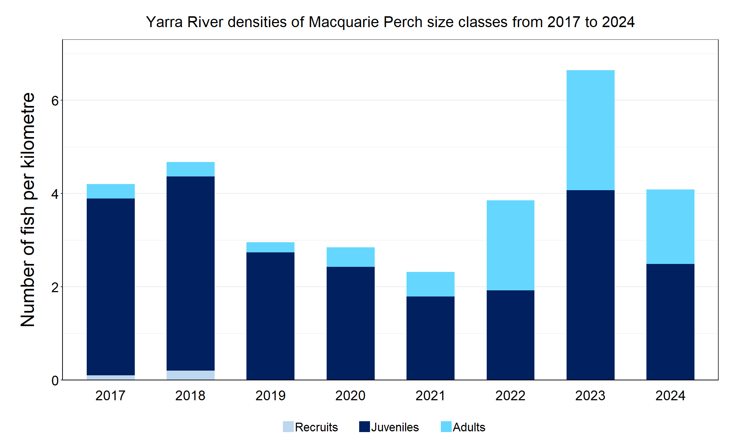

Figure 4. The densities of recruits, juveniles and adult Macquarie Perch in the Yarra River from 2017 to 2024

Figure 5. The size range percentage of Macquarie Perch in the Yarra River in 2024

1. Pavlova, A., Beheregaray, L.B., Coleman, R., Gilligan, D., Harrisson, K.A., Ingram, B.A., Kearns, J., Lamb, A.M., Lintermans, M., Lyon, J., Nguyen, T.T.T., Sasaki, M., Tonkin, Z., Yen, J.D.L., & Sunnucks, P. (2017) Severe consequences of habitat fragmentation on genetic diversity of an endangered Australian freshwater fish: a call for assisted gene flow. Evolutionary Applications 10, 531 – 550.

**Murray Cod**

**Yarra River, Port Phillip region**

**Key Health Indicators**

Recent recruitment Yes

Multiple size classes Yes

Mature fish present Yes

**Monitoring Results**

Total number of fish caught 12

Fish per 1km of waterway 2.13

Largest fish by length (cm) 65.2

Largest fish by weight (kg) 3.52

% of the catch that is legal size 8.3

**Murray Cod (*Maccullochella peelii)* is a translocated species in the Yarra River but is classed as a key recreational species in the Yarra system. Murray Cod is listed as endangered in Victoria (*Flora and Fauna Guarantee Act* 1988) and vulnerable nationally (*Environment Protection and Biodiversity Conservation Act* 1999). Adults, juveniles and recruits were recorded in 2024 (Figure 6, Figure 7). Recruits have been recorded in six of the eight years surveyed (2017-18, 2020 and 2022-24) with the highest number of recruits detected in 2022 (Figure 6). The number of recruits captured in 2024 was high compared to 2023 and constituted a third of the population (Figure 6). There was a broad size range of fish collected in 2024 (Figure 7), however only one was classified as an adult. Although in low abundances, adults have been detected in seven of the eight years surveyed (absent in 2021). The low abundances of adults may indicate a high angling pressure.**

**Stocking**

No stocking has occurred.

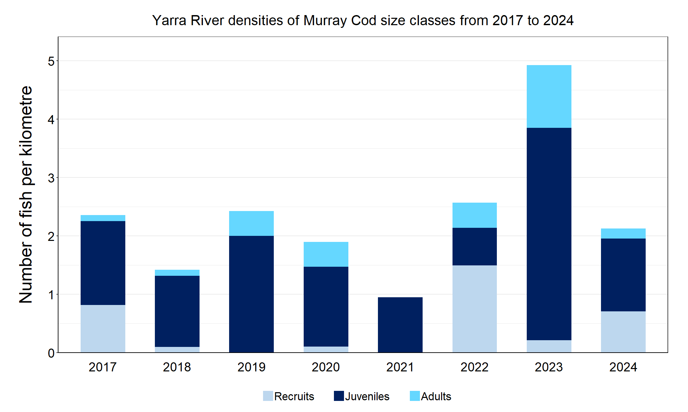

Figure 6. The densities of recruits, juveniles and adult Murray Cod in the Yarra River from 2017 to 2024

Figure 7. The size range percentage of Murray Cod in the Yarra River in 2024

We acknowledge and respect Victorian Traditional Owners as the original custodians of Victoria’s land and waters, their unique ability to care for Country and deep spiritual connection to it. We honour Elders past and present whose knowledge and wisdom has ensured the continuation of culture and traditional practices.

Logo*© The State of Victoria Department of Energy, Environment and Climate Action 2024. This work is licensed under a Creative Commons Attribution 4.0 International licence. To view a copy of this licence, visit creativecommons.org/licenses/by/4.0/ ISSN 2981-9105 Online (pdf/word)*