# Victorian Semi-arid Woodlands

Defining vegetation condition

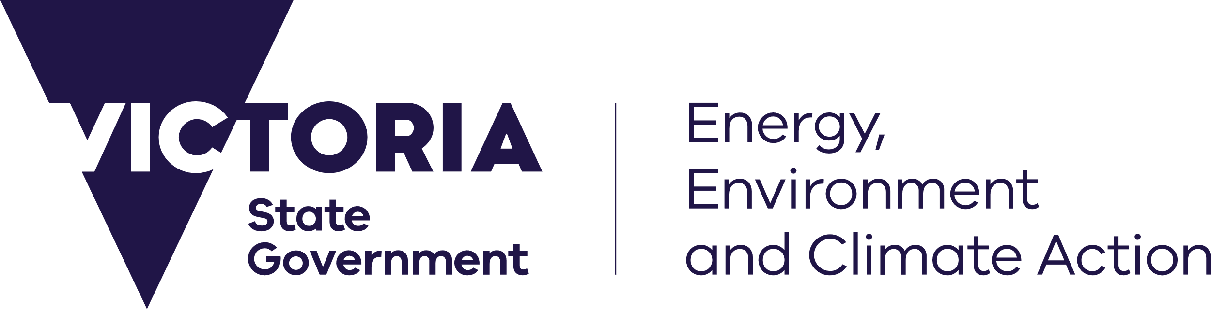

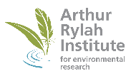 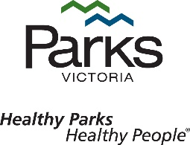

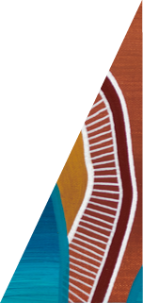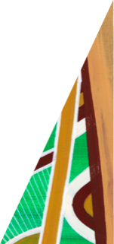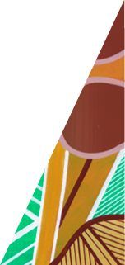

## Key Messages

* For interventions to be effective, managers need to know what good condition looks like, and what they are managing for. Establishment of these benchmarks enables managers to identify what actions are needed and where, and to set targets and measure outcomes.
* In this project, Semi-arid Woodlands were classified into three vegetation condition states: poor, fair and good.
* Most woodlands were in ‘poor’ or ‘fair’ condition, with only 3% classified as being in ‘good’ condition.
* Good condition woodlands can act as a reference on which to base future management.
* There are a range of fair-condition woodlands that, with targeted management, may improve in condition in time.

Monitoring program update January 2025

deeca.vic.gov.au

## Semi-arid Woodlands

Semi-arid woodlands are characterised by one or more canopy species – Belah (*Casuarina pauper*), Buloke (*Allocasuarina luehmannii*), Slender Cypress Pine (*Callitris gracilis*), and Sugarwood (*Myoporum platycarpum) –* over a diverse ground layer of saltbushes, herbs, grasses and biological soil crust.

#### Management and monitoring long-term recovery

Victoria’s Semi-arid Woodlands are severely degraded due to historical land use. They are slow-growing and reliant on high rainfall events to enhance regeneration success. Woodland recovery is slow and impeded by browsing. Thus, historical and current ecological impacts (e.g. grazing, altered fire regimes) have long-lasting impacts on condition. To improve woodland condition, a long-term restoration program (The Total Grazing Management Plan) has been running for over 10 years. In addition to this, the Semi-arid Woodland Condition Monitoring Program is being implemented to enhance management effectiveness, measure recovery success and improve our knowledge of these woodlands.

**Defining Semi-arid Woodland vegetation condition**

To accurately evaluate the effectiveness of management actions, managers need to know what sustainable or good condition Semi-arid Woodlands look like, and what they are managing for. Establishment of these benchmarks enables managers to identify what actions are needed and where, and to set targets and measure outcomes of the Total Grazing Management Plan.

This monitoring program update provides a quick snapshot of findings that uses on-ground data to help define, and in turn assess, Semi-arid Woodland vegetation condition. This will enable improved management and conservation of this long-lived plant community.

## Findings

**Defining vegetation condition**

Semi-arid Woodlands were classified into three broad vegetation condition states: poor, fair and good (Figures 1 & 2).

**Good condition** woodlands represent those that are the most sustainable in the long-term and provide a reference state for management. Good condition woodlands have the most viable tree populations with, on average (in a hectare), a high number of recruits (> 20) and healthy mature adults (> 50), and few unhealthy or dead trees. These sites have low weed cover (< 10%) and high native species richness (> 10 species). All life forms are present, with a good diversity of small to medium shrubs, large shrubs and small trees. Good condition sites are also characterised by high cover of biological soil crust, litter, large shrubs and, small and large trees. These sites have a low cover of native graminoids. Good condition woodlands only require management to maintain condition.

**Fair condition** woodlands are represented by tree populations that, on average (in a hectare), have few recruits (either seedlings or juveniles, but usually have at least one individual), and at least 19 healthy mature trees, with few unhealthy and dead trees (1-5 individuals). The understorey is variable and has a wide range of secondary states which range from relatively good-quality understorey with moderate native plant diversity and low weed cover, to medium weed cover and low native plant diversity. On average most native life forms are represented, but many are in low abundance. Fair condition woodlands require targeted, often strategic management actions to support their improvement.

**Poor condition** woodlands are characterised by there being no or few trees in any life stage present. These sites have the highest weed cover (> 25%, particularly exotic herbs), low litter and tree cover, and native species richness (< 10 species). Poor-condition woodlands often require intensive investment in a variety of management actions to improve their condition.

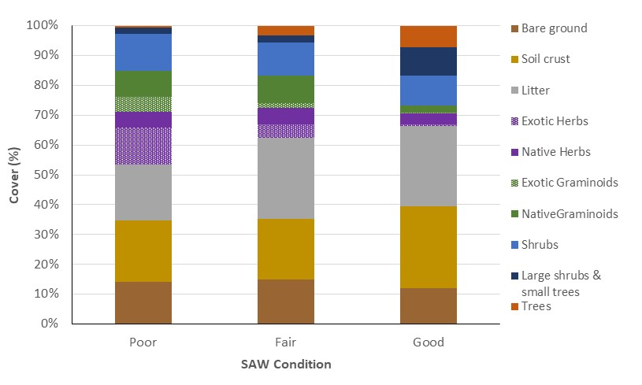

**Figure 1.** Average percent cover of native life forms (herbs, graminoids, shrubs, large shrubs/small trees, trees), exotic life forms (herbs, graminoids) and substrate (bare ground, litter, biological soil crust) within poor-, fair- and good-condition Semi-arid Woodlands. The only exotic species recorded were herbs and graminoids.

**Current condition of Semi-arid Woodlands**

* Most Semi-arid Woodlands are in poor condition (60%), with few sites assessed as being in good condition (3%), and a further 37% in fair condition.
* Good condition woodlands can be found in eastern Murray-Sunset, central Wyperfeld and across a range of smaller reserves (e.g. Wemen, Dunstans, Yarrara). Most of these woodlands are dominated by Belah, with only three sites each dominated by Pine and Buloke, and none dominated by Sugarwood.
* Woodlands in fair condition could be improved with targeted management, such as the interplanting of large shrubs and trees, thus improving the long-term viability of these woodlands.
* Most poor condition sites were in north-west Murray-Sunset (Sugarwood woodlands), Hattah-Kulkyne and Pine Plains in Wyperfeld (particularly Pine woodlands).

**Poor Fair Good**

**Belah**

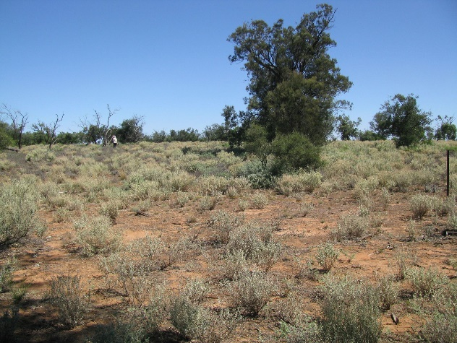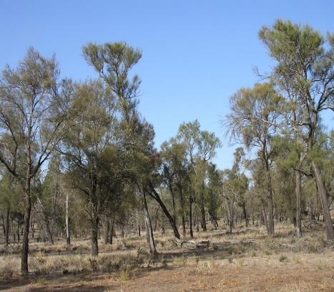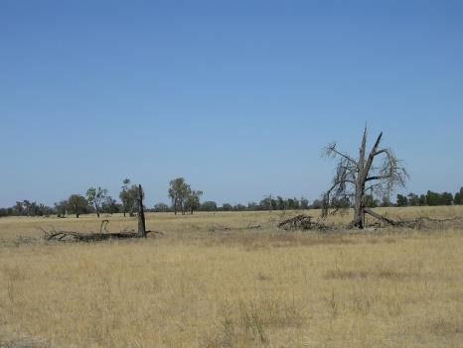**Buloke**

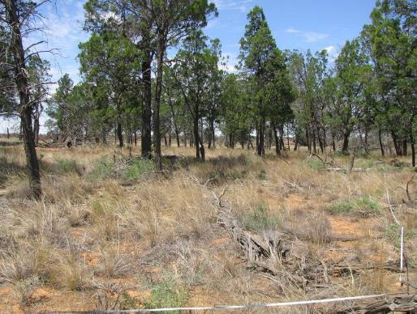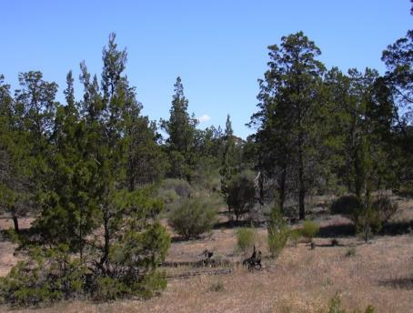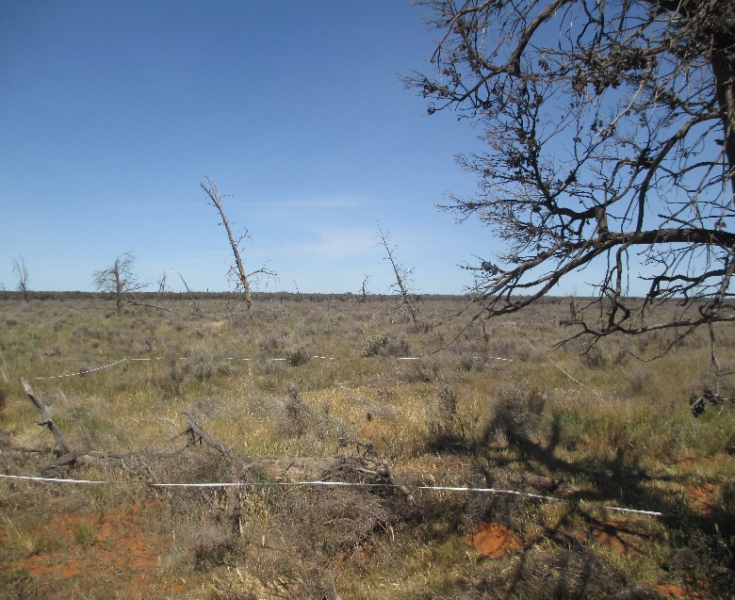**Slender Cypress Pine**

**Sugarwood**

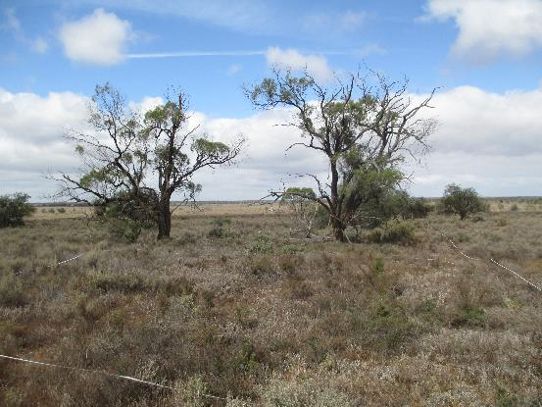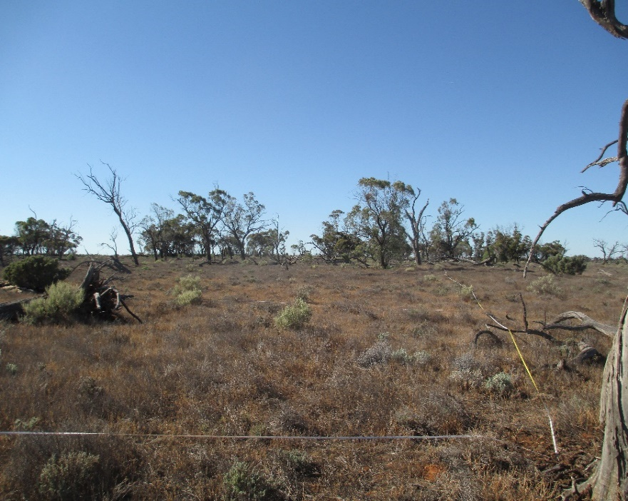

**Figure 2.** Examples of the Semi-arid Woodland condition states (left to right: poor, fair and good) for the four woodland types (top to bottom: Belah, Buloke, Slender Cypress Pine, and Sugarwood).

## Where to next?

Semi-arid Woodlands occur across a large area of north-west Victoria and are slow-growing, thus improvements or declines in condition are usually not immediately obvious and may take decades to become apparent. Although we have detected some improvements in condition, such as evidence of natural regeneration, most woodlands remain in poor to fair condition with very little change appearing to occur. To further complicate matters, these woodlands are now experiencing negative climate change impacts (e.g. increased storm damage, drought, lightning strikes and fire), particularly on tree populations, and to a lesser extent changing understorey composition from shrubby to grassy.

*Woodlands are in poor or fair condition & enhanced management is required for long-term viability.*

## Management implications

The Semi-arid Woodland condition states act as a basis to inform a more targeted management approach, with actions that are more effective and cost-efficient, enhancing woodland condition and long-term viability:

* Good condition woodlands act as reference sites on which to base management targets (i.e. what should the woodland look like and where do we need to target works?)
* A selection of fair condition woodlands offer the highest restoration potential, with the most cost-effective management outcomes. Fair condition woodlands contain a range of secondary condition states. In some states the vegetation is approaching ‘good condition’ thus targeted management, such as inter-planting of large shrubs and trees, would increase diversity, structural complexity, and plant recruitment, shifting the state from fair to good.
* The condition project report (Moxham *et al.* 2024) outlines targeted and effective restoration actions to ensure representative examples of Semi-arid Woodland tree populations remaining in the landscape. Sites, species and the number of individuals to be interplanted are provided to enhance tree population recruitment, condition and viability.
* Spatial condition mapping could be undertaken to form the basis for management (i.e. what actions should be implemented and where), and could involve a combination of remote sensing, modelling, existing data and ground truthing, using the condition state definitions we have developed here. The current project defines condition and allocates it at the site scale, but does not provide a landscape-scale spatial representation of condition.
* To ensure that representative examples of good condition Semi-arid Woodlands remain in the landscape, a range of focal woodlands could be prioritised for ongoing protection and management. Focal woodlands would act as reference sites for enhanced management, allowing for a more targeted cost-effective approach to management.

#### Further Reading

Moxham C., Kenny S. and Moloney P. (2024) Semi-arid Woodland Condition Monitoring Program: five-year evaluation: defining vegetation condition. Unpublished Report. Arthur Rylah Institute for Environmental Research, Department of Energy, Environment, and Climate Action, Heidelberg, Victoria.

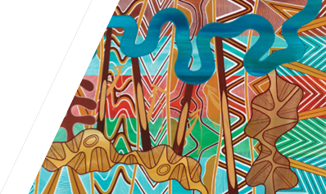

We acknowledge Victorian Traditional Owners and their Elders past and present as the original custodians of Victoria’s land and waters and commit to genuinely partnering with them and Victoria’s Aboriginal community to progress their aspirations.

**For further information contact: Claire Moxham (**[**claire.moxham@deeca.vic.gov.au**](mailto:claire.moxham@deeca.vic.gov.au)**) or Sally Kenny (**[**sally.kenny@deeca.vic.gov.au**](mailto:sally.kenny@deeca.vic.gov.au)**)**

© The State of Victoria Department of Energy, Environment and Climate Action January 2025.

Logo

**ISBN** 978-1-76176-081-5 **(pdf/online/MS word)**

Accessibility

If you would like to receive this publication in an alternative format, please telephone the DEECA Customer Service Centre on 136186, email [customer.service@delwp.vic.gov.au](mailto:customer.service@delwp.vic.gov.au), or via the National Relay Service on 133 677 [www.relayservice.com.au](http://www.relayservice.com.au).

This work is licensed under a Creative Commons Attribution 4.0 International

licence. To view a copy of this licence, visit

creative commons.org/licenses/by/4.0/