Native Fish Report Card 2024

**Glenelg River**

**Glenelg Hopkins Region**



**This report card summarises the 2024 Native Fish Report Card (NFRC) survey in the Glenelg River**

**Sites 10, GHCMA, Electrofishing**

**Fish found in Glenelg River for NFRC**

**Target species**

Estuary Perch

**Non-target species captured since 2017\***

**Large-bodied native species**

Australian Bass#

Australian Grayling

Black Bream

Freshwater Catfish#

Golden Perch#

Mulloway

River Blackfish

Short-finned Eel

Tupong

Yellow-eye Mullet

**Small-bodied native species**

Australian Smelt

Bridled Goby

Carp Gudgeon

Common Galaxias

Flatheaded Gudgeon

Southern Pygmy Perch

Tamar River Goby

Variegated Pygmy Perch

**Exotic species**

Common Carp

Eastern Gambusia

Goldfish

Rainbow Trout

Redfin

Tench

* These non-target species were incidentally captured during NFRC surveys since 2017 but not measured as for target species. # Native species translocated outside of its natural range.

**Glenelg River 2024**

**Fish Community**

**NFRC target species**

**The NFRC Program began in 2017 to monitor population dynamics of key iconic fish species that have high recreational and/or conservation values, in large rivers across Victoria. In the Glenelg River, the target species is Estuary Perch. Surveys occur in February/March each year, at 10 sites from Dartmoor to Yat Nat (between Balmoral and Rocklands Reservoir). In 2022, 2023 and 2024, two sites could not be fished due to access logistics. Two new sites were added into the estuary between Sapling Creek Boat ramp and Dartmoor in 2023 and were also fished in 2024. The equipment used and habitats surveyed target Estuary Perch, which are measured to determine their population structures. Other fish species that are incidentally captured are counted, but not measured.**

**Summary of key health indicators for target species in 2024**

|  |  |  |  |
| --- | --- | --- | --- |
| **Species** | **Key Health Indicators** | | |
|  | Recent recruitment | Multiple size classes | Mature fish present |
| Estuary Perch | No | Yes | Yes |

*Recent recruitment means young-of-year fish*

Estuary Perch is considered an estuarine species, which often moves into lower freshwater reaches of rivers, particularly rivers with elevated baseline salinity levels.

**Non-target species**

The non-target fish species that have been incidentally recorded in the Glenelg River during NFRC surveys since 2017 are:

**Large-bodied native species**

Freshwater Catfish, River Blackfish, Short-finned Eel and Tupong were recorded in the 2024 survey. Freshwater Catfish is a northern Victorian species, translocated into the Glenelg system. River Blackfish is a lowland species, generally found at altitudes below 200m. It has declined in distribution and abundance across the State1,2, however, numerous fish have been detected in the Glenelg River (ARI unpublished data). Short-finned Eel and Tupong are diadromous (migratory between salt water and fresh water) species found throughout coastal Victoria. Three estuarine species were recorded in 2024 (Black Bream, Mulloway and Yellow-eye Mullet). These estuarine species are only expected to be recorded from Dartmoor and into the estuary. Black Bream have been recorded in all eight NFRC surveys, while Mulloway have only been recorded in 2023 and 2024 (from the two new estuarine sites included in 2023). Other species recorded in previous NFRC surveys are Australian Bass, Australian Grayling and Golden Perch. One Australian Grayling was collected in 2019 and another in 2021. These are only the second and third records of this species in the Glenelg River system; the other confirmed record was 124 years ago. This species is listed as endangered in Victoria (*Flora and Fauna Guarantee Act 1988*) and nationally (*Environmental Protection and Biodiversity Conservation* Act 1999). Australian Bass is native to coastal systems in eastern Victoria and has been translocated into the Glenelg system. Golden Perch is also a translocated species, endemic to the Murray-Darling Basin.

**Small-bodied native species**

Australian Smelt, Carp Gudgeon, Common Galaxias, Flatheaded Gudgeon and Southern Pygmy Perch were recorded in the 2024 survey. Australian Smelt, Flatheaded Gudgeon and Common Galaxias have been recorded in all eight NFRC surveys. Australian Smelt and Flatheaded Gudgeon are common across the state. The Common Galaxias is a diadromous species common across coastal Victoria. Carp Gudgeon, recorded in four of the NFRC surveys, is a lowland species and is hard to detect via boat electrofishing. Southern Pygmy Perch, a species translocated into the Glenelg system, has been recorded in four of the NFRC surveys. Variegated Pygmy Perch has also been recorded in previous NFRC surveys, except for 2024; this species is listed as endangered in Victoria (*Flora and Fauna Guarantee Act* 1988). Two small-bodied estuarine species Bridled Goby and Tamar River Goby were also recorded in 2024, both with restricted distributions (to the two estuarine sites downstream of Dartmoor).

**Exotic fish species**

Common Carp, Eastern Gambusia, Goldfish, Redfin and Tench were detected in 2024 (and in all eight NFRC surveys). Common Carp, Eastern Gambusia, Goldfish and Redfin are widely distributed across survey sites but are more likely detected and more abundant as you progress further upstream. Tench has only been detected in low abundances. Small Carp (young-of-year) were detected at most sites in 2019. In all other NFRC surveys, the presence of small Carp has been restricted at the upper sites indicating they are spawning in these areas consistently. Rainbow Trout have been recorded in five NFRC surveys and are restricted in distribution to the Warrock area.

**Other native species known from the Glenelg River**

Some fish species known to occur in the Glenelg River have never been recorded in NFRC surveys (e.g. Climbing Galaxias, Obscure Galaxias, Spotted Galaxias, Little Galaxias, Pouched Lamprey and Short-headed Lamprey). Both Climbing Galaxias and Spotted Galaxias historically had patchy distributions within the Glenelg River system and are hard to detect using the NFRC sampling methods. Both lamprey species also had patchy distributions historically. Obscure Galaxias are hard to detect using the NFRC sampling methods. Little Galaxias are normally found in lower altitude areas but are found in the Glenelg River upstream of Rocklands Reservoir.

**Other notable species**

Surveys have also recorded Eastern Long-necked Turtles, Glenelg Spiny Crayfish, Platypus and Yabbies.

1.Khan et al. (2004). Habitat use and movement of river blackfish (*Gadopsis marmoratus* R.) in a highly modified Victorian stream, Australia. *Ecology of Freshwater Fish,* 13: 285–293.

2. Hammer et al. (2014) A multi-gene molecular assessment of cryptic biodiversity in the iconic freshwater blackfishes (Teleosti: Perchichthyidae: Gadopsis) of south-eastern Australia. Biological journal of the Linnean Society.

**Glenelg River 2024**

**Environmental and Management Context**

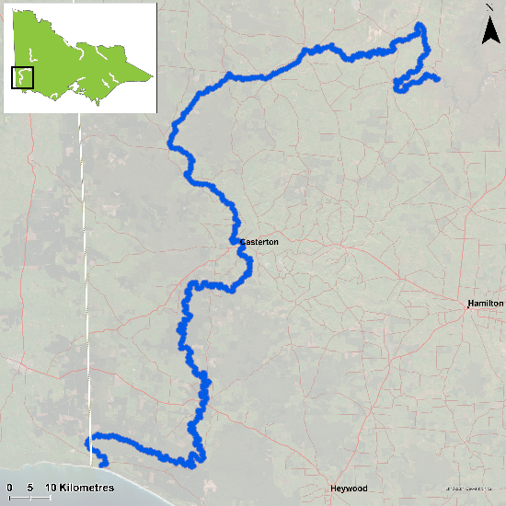

Figure 1. Map showing the section of Glenelg River where NFRC sampling occurs

**Environment**

Low flow conditions were present in all eight sampling seasons. Two sites were not fished in 2022-2024 due to limitations in access and have been replaced with two new estuarine sites in 2023. It is expected the addition of the two new estuarine sites will increase the abundance of Estuary Perch detected during sampling.

**Waterway and fisheries management efforts in the Glenelg River**

Many rehabilitation actions have occurred, and are underway, to improve the health of the Glenelg River. These are informed by the Glenelg Hopkins Waterway Strategy 2014-2022 and the Glenelg River Restoration Program. Actions include revegetation, weed control and fencing of riparian areas, reintroduction of instream woody habitat, allocations of water for the environment, removal of migration barriers and pest control. There are a range of fish monitoring efforts related to these management efforts. These include the Victorian Environmental Flow Monitoring and Assessment Program ([VEFMAP](https://www.ari.vic.gov.au/research/rivers-and-estuaries/assessing-benefits-of-water-for-the-environment)). The [Glenelg Hopkins Catchment Management Authority](https://www.ghcma.vic.gov.au/), DEECA and the Victorian Fisheries Authority support rehabilitation and management of the Glenelg River and its fish community.

**Estuary Perch**

**Glenelg River, Glenelg Hopkins region**

**Key Health Indicators**

Recent recruitment No

Multiple size classes Yes

Mature fish present Yes

**Monitoring Results**

Total number of fish caught 209

Fish per 1km of waterway 25.8

Largest fish by length (cm) 44.3

Largest fish by weight (kg) 1.6

% of the catch that is legal size 39.23

Estuary Perch (*Percalates colonorum* - formerly *Macquaria colonorum*) is an estuarine species that can inhabit the lower freshwater reaches of streams. Within the Glenelg River, the species moves further inland than other rivers in Victoria. No Estuary Perch have been detected as far upstream as Balmoral, but sites have been included this far upstream to monitor the potential for further expansion in range, as the species seems to be slowly moving further upstream (based on previous surveys). The abundance of Estuary Perch was much higher in 2024 than the previous seven years (Figure 2a); even without the two new estuarine sites, a substantial increase was observed (Figure 2b). This increase in abundance in 2024 is due to a rise in the number of juvenile fish captured with 70% being juveniles, despite a wide range of sizes collected (Figure 3). The increase in numbers coinciding with the addition of two new estuarine sites is not unexpected, as Estuary Perch are largely an estuarine species. These new sites are expected to continue to be surveyed into the future. Multiple size classes, including mature and juvenile fish, were captured in all eight years, with young-of-year fish also detected in 2018. This is an indication that conditions in the Glenelg River are supporting spawning, recruitment, and survival of this species throughout its lifecycle and providing good, ongoing angling opportunities.

**Stocking**

No stocking has occurred.

a)

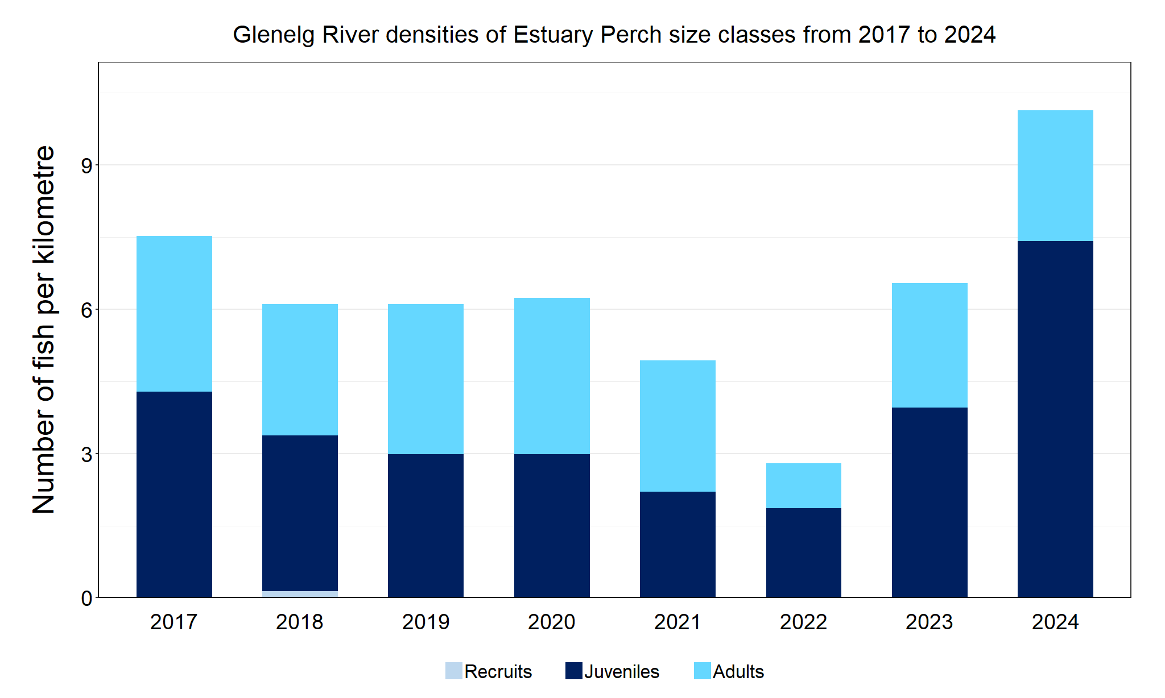

b)

Figure 2. The densities of recruits, juveniles and adult Estuary Perch in the Glenelg River from 2017 to 2024 . a) without the two new estuarine sites; b) with the two new estuarine sites.

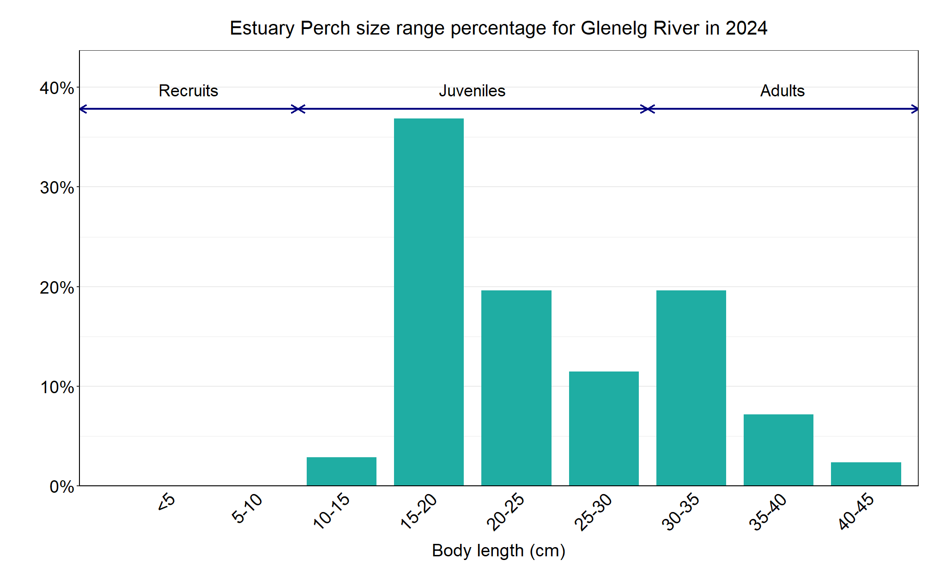

Figure 3. The size range percentage of Estuary Perch in the Glenelg River in 2024

We acknowledge and respect Victorian Traditional Owners as the original custodians of Victoria’s land and waters, their unique ability to care for Country and deep spiritual connection to it. We honour Elders past and present whose knowledge and wisdom has ensured the continuation of culture and traditional practices.

Logo© The State of Victoria Department of Energy, Environment and Climate Action 2024. This work is licensed under a Creative Commons Attribution 4.0 International licence. To view a copy of this licence, visit creativecommons.org/licenses/by/4.0/

ISSN 2981-9008 Online (pdf/word)