Native Fish Report Card 2024

**Gunbower Creek**

**North Central Region**



**This report card summarises the 2024 Native Fish Report Card (NFRC) survey in the Gunbower Creek**

**Sites 11, Electrofishing**

**Fish found in Gunbower Creek for NFRC**

**Target species**

Golden Perch

Murray Cod

Silver Perch

Trout Cod

**Non-target species captured since 2017\***

**Large-bodied native species**

Bony Bream

**Small-bodied native species**

Australian Smelt

Carp Gudgeon

Flatheaded Gudgeon

Murray-Darling Rainbowfish

Unspecked Hardyhead

**Exotic species**

Common Carp

Eastern Gambusia

Goldfish

Redfin

* These non-target species were incidentally captured during NFRC surveys since 2017 but not measured as for target species

**Gunbower Creek 2024**

**Fish Community**

**NFRC target species**

**The NFRC Program began in 2017 to monitor population dynamics of key iconic fish species that have high recreational and/or conservation values, in large rivers across Victoria.**

**In the Gunbower Creek, the target species are Golden Perch, Murray Cod, Silver Perch and Trout Cod. Surveys occur in April/May each year, at 11 sites from the offtake with the Murray River upstream of Torrumbarry to the junction of the Murray River at Koondrook. The equipment used and habitats surveyed target these species, which are measured to determine their population structures. Other fish species that are incidentally captured are counted, but not measured.**

**Summary of key health indicators for target species in 2024**

|  |  |  |  |
| --- | --- | --- | --- |
| **Species** | **Key Health Indicators** | | |
|  | Recent recruitment | Multiple size classes | Mature fish present |
| Golden Perch | No | Yes | Yes |
| Murray Cod | No | Yes | Yes |
| Silver Perch | - | - | - |
| Trout Cod | - | - | - |

*Recent recruitment means young-of-year fish*

*\*- cannot be determined due to low abundances*

Silver Perch were historically abundant throughout Gunbower Creek, while Trout Cod were rare downstream of Torrumbarry on the Murray River system. Both of these species have experienced dramatic declines across their range. The Yarrawonga population of Trout Cod was shown to have extended downstream from Barmah to Gunbower Island in 20121. Trout Cod were then captured in 2014, with NFRC sampling detecting this species in six of the eight sampling years from 2017, although in low densities. Silver Perch are also present in low densities. Overall, the Gunbower Creek appears to be maintaining healthy populations of Golden Perch and Murray Cod.

**Non-target species**

The non-target fish species that have been incidentally recorded in the Goulburn River during NFRC surveys since 2017 are:

**Large-bodied native species**

Bony Bream was the only other large-bodied species recorded in the 2024 survey. It has been recorded in five of the eight years of NFRC surveys. Bony Bream is a lowland species across the Murray-Darling Basin, is intolerant of cold water and, within Gunbower Creek, is likely to be restricted to the lower portion (i.e., downstream of Koondrook). It is unlikely this species would be detected upstream of the barrier at Koondrook, although a new fishway installed in 2021 may assist fish passage to areas upstream of Koondrook. In 2024, Bony Bream was recorded downstream of Koondrook Weir, but also downstream of the Headworks (top of National Chennel/Gunbower Creek), likely migrating over the weir from the Murray River.

**Small-bodied native species**

Australian Smelt, Flatheaded Gudgeon, Murray-Darling Rainbowfish and Unspecked Hardyhead were recorded in 2024. With the exception of Murray-Darling Rainbowfish, all these species are common and expected to be widespread throughout the Gunbower Creek. Australian Smelt and Unspecked Hardyhead have been recorded in all eight NFRC surveys. Flatheaded Gudgeon has been recorded in six of the eight years of surveys. Murray-Darling Rainbowfish was recorded in six of the eight NFRC surveys. Once widespread in the Murray-Darling Basin, this species now has a patchy distribution and a restricted range and is listed under the *Flora and Fauna Guarantee Act* 1988 in Victoria. Carp Gudgeon has been recorded in seven NFRC surveys. Carp Gudgeon are common and are expected to be widespread throughout the Gunbower Creek.

**Exotic fish species**

Common Carp, Eastern Gambusia and Goldfish were recorded in 2024. Common Carp and Goldfish have been recorded in all eight NFRC surveys and are widely distributed across sampling sites. Eastern Gambusia has been recorded in five of the eight NFRC surveys and is more common in the slower flowing waters. Redfin has been previously recorded twice in NFRC surveys and is also distributed throughout, but in lower abundances.

**Other native species known from Gunbower Creek**

Some fish species known to occur in the Gunbower Creek system have never been recorded during NFRC surveys (e.g. Flatheaded Galaxias, Freshwater Catfish). These species are more common in offstream habitats (such as billabongs, lagoons and wetlands), with Freshwater Catfish detected in permanent offstream habitats. No Obscure Galaxias has been recorded during the surveys. No Southern Pygmy Perch has been recorded during the NFRC surveys and this species has been absent from the Gunbower Creek system for over 30 years. The species outlined above are hard to detect using the NFRC sampling methods.

**Other notable species**

Surveys have also recorded Rakali, Yabbies and Turtle species.

1. Douglas, J, Hunt, T and Trueman, W. (2012). Confirmed records of the endangered Trout Cod *Maccullochella macquariensis* from the Murray River at Gunbower Island, Victoria. [Victorian Naturalist](https://www.researchgate.net/journal/Victorian-Naturalist-0042-5184) 129(4):152-155.

**Gunbower Creek 2024**

**Environmental and Management Context**

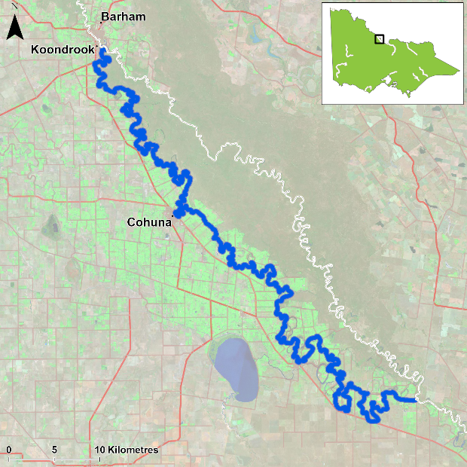

Figure 1. Map showing the section of Gunbower Creek where NFRC sampling occurs

**Environment**

Stream flow was consistent for the majority of Gunbower Creek from 2017 to 2024. However, at the time of sampling, the two sites downstream of Koondrook had fluctuating heights which were often very low. These sites were often fished later in autumn or early winter, when water levels had increased. Periods of low dissolved oxygen are frequently experienced in Gunbower Creek in the summer months of each year.

**Waterway and fisheries management efforts in the Gunbower Creek**

Many rehabilitation actions have occurred, and are underway, to improve the health of the Gunbower Creek and its fish community. These are informed by the North Central Regional Catchment Strategy 2021-2027 and in particular by the Native Fish Recovery Plan – Gunbower and lower Loddon. Actions include allocations of water for the environment, increasing connectivity by establishing fishways at Koondrook and Cohuna to improve fish passage, fish screens to prevent loss of fish to irrigation channels and pumps at Cohuna, protection and revegetation of riparian areas, management actions to control Carp, and reintroduction of threatened species including Southern Pygmy Perch into two wetlands (Black Charlie and Reedy lagoons) and River Blackfish into flowing water habitats.

There are a range of fish monitoring efforts related to the rehabilitation efforts above. These include the Victorian Environmental Flow Monitoring and Assessment Program ([VEFMAP](https://www.ari.vic.gov.au/research/rivers-and-estuaries/assessing-benefits-of-water-for-the-environment)) and The Living Murray program. The [North Central Catchment Management Authority](http://www.nccma.vic.gov.au/), DEECA and VFA support rehabilitation and management of the Gunbower Creek and its fish community.

**Golden Perch**

**Gunbower Creek, North Central Region**

**Key Health Indicators**

Recent recruitment No

Multiple size classes Yes

Mature fish present Yes

**Monitoring Results**

Total number of fish caught 15

Fish per 1km of waterway 0.99

Largest fish by length (cm) 52.1

Largest fish by weight (kg) 2.98

% of the catch that is legal size 93.3

**The abundance of Golden Perch (*Macquaria ambigua*) was lower in 2024 compared to the previous three years and is more consistent with abundances found in 2018 to 2020. The majority of Golden Perch recorded were found at the Headworks Road and Three Corner Hole sites. These sites are close to the inflow and outflow of water from the Murray River respectively, indicating very few Golden Perch are present through the middle reaches of Gunbower Creek. Higher abundances recorded in 2017 and 2021-23 are often associated with higher flow rates passing downstream of Koondrook Weir.**

**A large proportion (94%) of Golden Perch collected in 2024 were adults (Figure 3). Juveniles have been present in all years, with recruits only detected in 2019 (Figure 2). It is unlikely that these are natural recruits, as the creek has many barriers which would limit spawning opportunities and egg/larval survival. The presence of adults and juveniles in all eight NFRC surveys indicates conditions in the system are suitable for recruit and juvenile survival and for maintaining adult Golden Perch populations. The population has likely been maintained by stockings. The construction of the Koondrook fishway in 2021 should allow Golden Perch to access areas further upstream in the Gunbower Creek system.**

**Stocking**

Golden Perch were stocked into Gunbower Creek for the first time in 2016. Twenty thousand Golden Perch were stocked in 2016; 40,500 in 2017; 200,000 in 2018; 70,000 in 2019; 70,000 in 2020; 70,000 in 2021; 65,000 in 2022; and 70,000 in 2024. No Golden Perch were stocked in 2023.

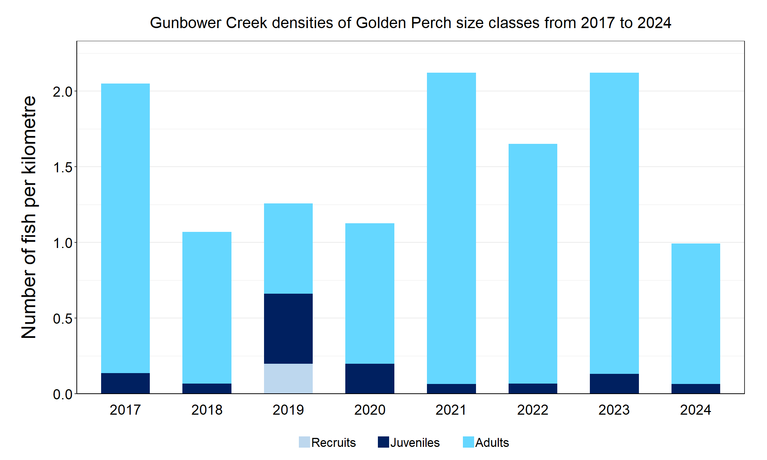

Figure 2. The densities of recruits, juveniles and adult Golden Perch in Gunbower Creek from 2017 to 2024

Figure 3. The size range percentage of Golden Perch in Gunbower Creek in 2024

**Murray Cod**

**Gunbower Creek, North Central region**

**Key Health Indicators**

Recent recruitment No

Multiple size classes Yes

Mature fish present Yes

**Monitoring Results**

Total number of fish caught 18

Fish per 1km of waterway 1.19

Largest fish by length (cm) 100.5

Largest fish by weight (kg) 16.0

% of the catch that is legal size 33.3

**The Murray Cod (*Maccullochella peelii*) population in 2024 was the lowest since NFRC surveys commenced and has been reducing in size since 2019 (Figure 4). Multiple size classes (adults and juveniles) have been recorded in all eight years. Recruitment was not detected in 2023 and 2024. Most fish caught in 2024 represent smaller one- to two-year-old fish and are likely the result of stocking. Other size classes are largely absent with a small number of legal-size Murray Cod and one large fish making up the remainder of the catch. The decrease in Murray Cod populations in 2023 and 2024 may have been influenced by the blackwater event of 2022/2023 where there were reported fish deaths as well as translocations out of the system. This may have reduced the adult population, limiting natural recruitment. Five fish recorded that were less than 12cm in length may be recruits that have grown rapidly to this size. It is unclear if these fish are a result of stocking or natural recruitment.**

**Stocking**

Twenty thousand Murray Cod were stocked in 2016; 55,000 in 2017; 150,000 in 2018; 115,690 in 2020; 60,000 in 2022; and 60,000 in 2023. Murray Cod stocking started in 2001, with 20,000 stocked in most years until 2016. The exceptions to this are: 120,000 in 2012 and 80,000 in 2014. No Murray Cod were stocked in 2019 or early 2024.

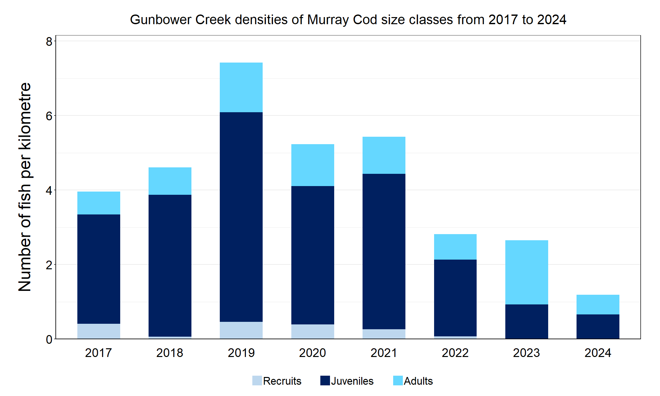

Figure 4. The densities of recruits, juveniles and adult Murray Cod in Gunbower Creek from 2017 to 2024

Figure 5. The size range percentage of Murray Cod in Gunbower Creek in 2024

2. Stuart et al. (2019). From an irrigation system to an ecological asset: adding environmental flows establishes recovery of a threatened fish species. *Marine and Freshwater Research*: **70 (9)**, 1295-1306.

**Silver Perch**

**Gunbower Creek, North Central region**

**Key Health Indicators**

Recent recruitment Cannot be determined

Multiple size classes Cannot be determined

Mature fish present Cannot be determined

**Monitoring Results**

Total number of fish caught 2

Fish per 1km of waterway 0.13

Largest fish by length (cm) 38.2

Largest fish by weight (kg) 0.8

% of the catch that is legal size NA#

# This species is a Protected Freshwater Species and taking or possessing is prohibited (Victorian Recreational Fishing Guide 2023-24).

**The natural range of Silver Perch (*Bidyanus bidyanus*) includes most of the Murray-Darling Basin, excluding the cool, higher altitude upper reaches of streams. River regulation and barriers have all negatively affected Silver Perch populations, with these prevalent in Gunbower Creek. The NFRC does not expect to capture enough Silver Perch to measure key health indicators. However, by collecting data for non-recreational species including threatened species such as Silver Perch, it will allow a greater understanding of the current status of the populations providing essential information to the management of these species. Silver Perch is listed as endangered in Victoria (*Flora and Fauna Guarantee Act* 1988) and nationally (*Environment Protection and Biodiversity Conservation Act* 1999).**

**Low abundances of adult Silver Perch were detected in 2024. Low abundances of Silver Perch have been recorded in all eight NFRC surveys, with the highest abundance detected in 2023 (Figure 6). Due to the low abundances of Silver Perch collected during NFRC, the key health indicators cannot be measured. The Silver Perch detected were predominantly adults (Figure 6; Figure 7). Juveniles were only detected in 2017, 2022 and 2023. Recruits of this species are difficult to catch using this sampling methodology and none have been detected in all eight years of sampling. Silver Perch are unlikely to successfully spawn in Gunbower Creek due to the many barriers to fish movement.**

**Stocking**

No stocking has occurred.

Figure 6. The densities of recruits, juveniles and adult Silver Perch in Gunbower Creek from 2017 to 2024

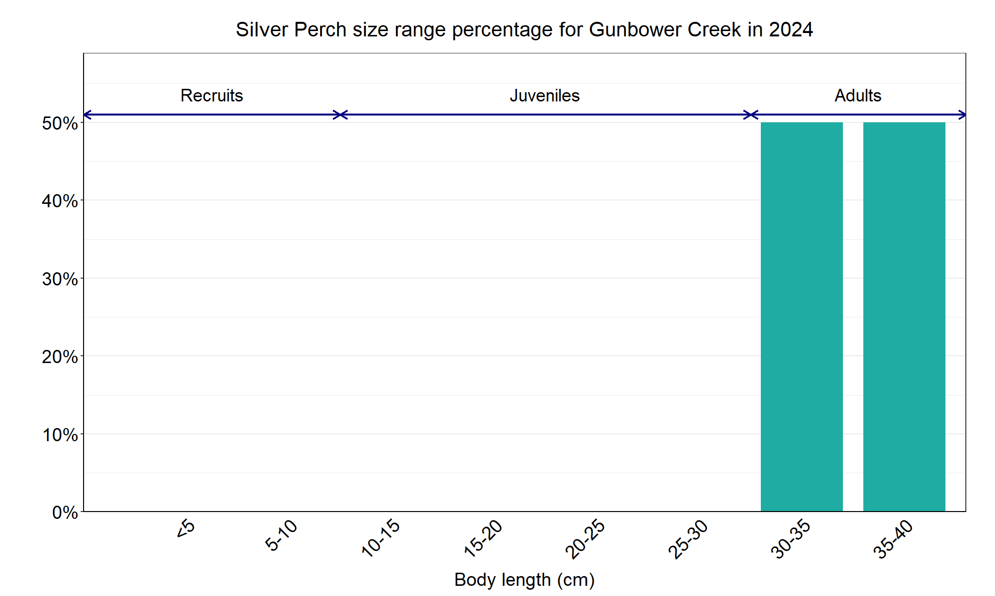

Figure 7. The size range percentage of Golden Perch in Gunbower Creek in 2024

**Trout Cod**

**Gunbower Creek, North Central region**

**Key Health Indicators**

Recent recruitment Cannot be determined

Multiple size classes Cannot be determined

Mature fish present Cannot be determined

**Monitoring Results**

Total number of fish caught 0

Fish per 1km of waterway 0

Largest fish by length (cm) NA

Largest fish by weight (kg) NA

% of the catch that is legal size NA#

**# This species is a Protected Freshwater Species and taking or possessing is prohibited (Victorian Recreational Fishing Guide 2023-24).**

**The natural range of Trout Cod included Gunbower Creek, but the species was absent in this area from the 1980s until 2012. The NFRC does not expect to capture enough Trout Cod to measure key health indicators. However, collecting data for non-recreational species including threatened species such as Trout Cod, allows a greater understanding of the current status of the populations providing essential information to the management on these species. Due to the low abundances of Trout Cod collected during NFRC the key health indicators cannot be measured. Trout Cod was first detected again in Gunbower Creek**3 **in 2012 and have regularly been recorded since then, albeit in low abundances.**

**No Trout Cod were recorded in 2024, however, Trout Cod have been recorded in six of the eight years of NFRC sampling (Figure 8). No recruits have been detected in NFRC sampling, and juveniles have only been detected in 2017 and 2021. This indicates that Trout Cod are persisting in Gunbower Creek, but it is uncertain if they are breeding. It is possible that larvae or recruits enter the system via the national channel inlet upstream of Torrumbarry Weir. Monitoring during Koondrook and Cohuna fishway installations in 2021 captured juvenile Trout Cod (in higher abundances than NFRC sampling) immediately downstream of the weirs - potentially accumulating, which indicates a barrier to fish passage. The construction of the Koondrook fishway in 2021 should allow Trout Cod to access areas further upstream in the Gunbower Creek system.**

**Stocking**

No stocking has occurred.

Figure 8. The densities of recruits, juveniles and adult Trout Cod in Gunbower Creek from 2017 to 2024

3 River Murray Channel Monitoring Plan. The Department of Agriculture, the Environment and Water, through its Commonwealth Environmental Water Office (CEWO), on behalf of River Murray jurisdictions (via the Southern Connected Basin Environment Watering Committee), has agreed to engage a consortium team, led by CSIRO, to implement the River Murray Channel Monitoring Plan

We acknowledge and respect Victorian Traditional Owners as the original custodians of Victoria’s land and waters, their unique ability to care for Country and deep spiritual connection to it. We honour Elders past and present whose knowledge and wisdom has ensured the continuation of culture and traditional practices.

Logo*© The State of Victoria Department of Energy, Environment and Climate Action 2024. This work is licensed under a Creative Commons Attribution 4.0 International licence. To view a copy of this licence, visit creativecommons.org/licenses/by/4.0/*

*ISSN 2981-9032 Online (pdf/word)*