Yarra River 2022
Port Phillip region

This report card summarises the 2022 Native Fish Report Card (NFRC) survey in the Yarra River
Sites 11, Electrofishing

Fish found in Yarra River for NFRC
Target species
Australian Grayling
Macquarie Perch#
Murray Cod#

Non-target species recorded since 2017*
Large-bodied native species
Australian Bass
Golden Perch
River Blackfish
Short-finned Eel
Tupong
Barramundi (translocated outside of its natural range)

Small-bodied native species
Australian Smelt
Common Galaxias
Flatheaded Gudgeon

Exotic species
Brown Trout
Eastern Gambusia
Common Carp
Goldfish
Oriental Weatherloach
Roach
Redfin

* These non-target species were incidentally captured during NFRC surveys since 2017 but not measured as for target species

# Native species translocated outside of its natural range

LOGOS – ARI, DELWP
Yarra River 2022
Fish Community

NFRC target species
The NFRC Program began in 2017, with a focus on targeting the monitoring of population dynamics of key iconic fish species that have high recreational and/or conservation values, in large rivers across Victoria. In the Yarra River, the target species are Australian Grayling, Macquarie Perch and Murray Cod. Surveys occur in March/April each year, at 14 sites from upstream of Dights Falls to Yarra Glen. The Yarra River primarily uses boat electrofishing^{X} with bank-mounted electrofishing at two sites. The equipment and habitats surveyed are focused on these species, which are measured to determine population structures. Other fish species that are incidentally captured are recorded, but not measured to determine their population structures.
Summary of key health indicators for target species in 2022
Species | Key Health Indicators
 | Recent recruitment | Multiple size classes | Mature fish present
Australian Grayling | - | - | -
Macquarie Perch | No | Yes | Yes
Murray Cod | Yes | Yes | Yes

Recent recruitment refers to young-of-year fish
*- cannot be determined due to low abundances

Australian Grayling were once widespread throughout coastal Victoria, including the Yarra river system. Changes to flow regimes and barriers impact this species. The detection of Australian Grayling in three years of five is an encouraging sign that river conditions are enabling persistence of the species. Macquarie Perch have undergone a long-term decline in abundance with populations now fragmented and absent from much of its former range. Macquarie Perch were first translocated into the Yarra catchment in 1857 and the population is now considered important genetically. The population appears to be declining, with very few adults detected in surveys. Murray Cod were translocated into Yarra River in 1857 and are now a popular recreational species. There appears to be a small self-sustaining population, albeit with low abundances of adult fish. The following pages have more detail about the population structures of each target species.

Non-target species
The non-target fish species that have been incidentally recorded in the Yarra River during NFRC surveys since 2017 are:

Large-bodied native species
As well as the target species, other recorded large bodied species are Australian Bass, Golden Perch, River Blackfish, Short-finned Eel and Tupong. Australian Bass and Golden Perch are native species which have been translocated to the Yarra River. While Barramundi has also been translocated to this river, it is a tropical species and thus conditions are not likely to be suitable for its survival. River Blackfish are a lowland species, generally found at altitudes below 200 metres. This species has suffered a decline in distribution and abundance across the State. Short-finned Eel and Tupong are diadromous species found throughout coastal Victoria.

Small-bodied native species
Australian Smelt and Flatheaded Gudgeon are common across all of Victoria. The Common Galaxias is a diadromous species found across coastal Victoria.

Exotic fish species
Brown Trout are present throughout the Yarra River, but are not a dominant species in the NFRC sampling area and are more abundant at higher altitudes. Common Carp, Goldfish, Oriental Weatherloach, Roach and Redfin have been detected in all sampling years and are widespread throughout the Yarra River. Eastern Gambusia have been detected in four of the five sampling years and are often detected in slower flowing habitats.

Some fish species known to occur in the Yarra River have never been recorded during NFRC surveys. For example, no Climbing Galaxias, Dwarf Galaxias, Flatheaded Galaxias or Spotted Galaxias, Pouched Lamprey or Shortheaded Lamprey or Southern Pygmy Perch or Yarra Pygmy Perch have been detected in the surveys. The Climbing Galaxias, Spotted Galaxias, Pouched Lamprey and Shortheaded Lamprey are diadromous species in coastal Victoria. The Climbing Galaxias and Spotted Galaxias have patchy distributions and are hard to detect using NFRC sampling methodology. The Pouched Lamprey and Shorthead Lamprey were considered widespread but in recent times adults are rarely seen. Both lamprey species are usually active nocturnally. The Flatheaded Galaxias is a species found both sides of the divide from Melbourne eastwards in Victoria. In the Yarra River they were widespread and patchy in the lower areas, but more common above 200 metres altitude and are hard to detect using the NFRC sampling methodology. The Dwarf Galaxias, Southern Pygmy Perch and Yarra Pygmy Perch are often found in offstream habitats such as billabongs, wetlands and lagoons.

Other notable species
Surveys have also recorded Southern Victorian Spiny Crayfish.

^{x} Electrofishing is a common fish survey method that employs a direct electric current to water to attract and temporarily immobilize fish for easy capture and recording.

LOGOS – ARI, DELWP, NFRC

Yarra River 2022
Environmental and Management Context

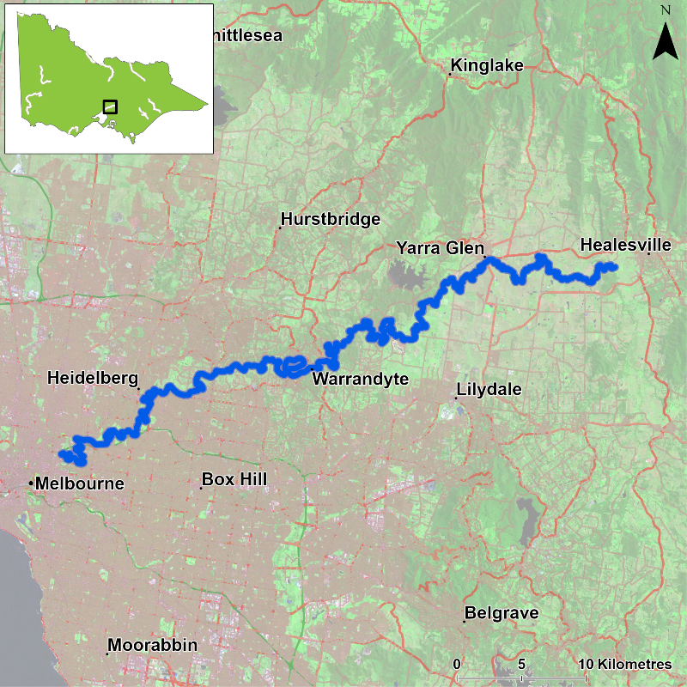
Figure 1. Map showing the section of Yarra River where NFRC sampling occurs

Environment
Low flow conditions were present in all six sampling seasons, albeit slightly higher in 2018 and, 2021 and slightly lower in 2022. The NFRC worked collaboratively with a Melbourne Water Macquarie Perch project with 14 sites fished from 2017-20. As the Melbourne Water Macquarie Perch project has finished, 11 sites were fished in 2022.

River rehabilitation efforts in the Yarra River
Many rehabilitation actions have occurred, and are underway, to improve the health of the Yarra River and its fish community. These are informed in particular by Melbourne Water’s Healthy Waterways Strategy 2018-28 and a Co-Designed Catchment Program for the Yarra Catchment. Efforts include revegetation, weed control and fencing of riparian areas, reintroduction of instream woody habitat, allocations of water for the environment, removal of barriers to fish movement, pest control, management of water quality including stormwater, sewage and litter management.

Some monitoring of the fish community occurs in association with a variety of rehabilitation efforts. This includes monitoring the effectiveness of the new fish passage facilities at Dights Falls, fish responses to provision of water for the environment, and the status of threatened species such as Macquarie Perch. Melbourne Water, DELWP and VFA support rehabilitation and management of the Yarra River and its fish community.

PHOTOS
LOGOS – ARI, DELWP, NFRC

Australian Grayling

Yarra River, Port Phillip region

Key Health Indicators
Recent recruitment Cannot be determined
Multiple size classes Cannot be determined
Mature fish present Cannot be determined

Monitoring Results
Total number of fish caught 5
Fish per 1km of waterway 0.84
Largest fish by length (cm) 12.7
Largest fish by weight (kg) 0.02
% of the catch that is legal size NA

Australian Grayling (Prototroctes maraena) is a diadromous species that has declined in distribution and abundance across its range. Australian Grayling are listed as endangered in Victoria (FFG Act 1988) and nationally (EPBC Act 1992). The NFRC does not expect to capture enough Australian Grayling to measure key health indicators. Rather, threatened species such as Australian Grayling are targeted for monitoring to gain a greater understanding of the current status of the populations which is essential information to inform the management of such species.
Low abundances have been captured in 2018, 2019, 2021 and 2022 (Figure 4). Recruits were detected for the first time in 2022, while juveniles (2018, 2019, 2021 and 2022) and adults (2018 and 2021) have been recorded in low abundances (Figures 4 and 5). The presence of recruits in 2022 and juveniles in 2018-19 and 2021-22 (Figures 4 and 5) indicates stream conditions were suitable for recruits to be attracted into the system.

Stocking
No stocking has occurred.
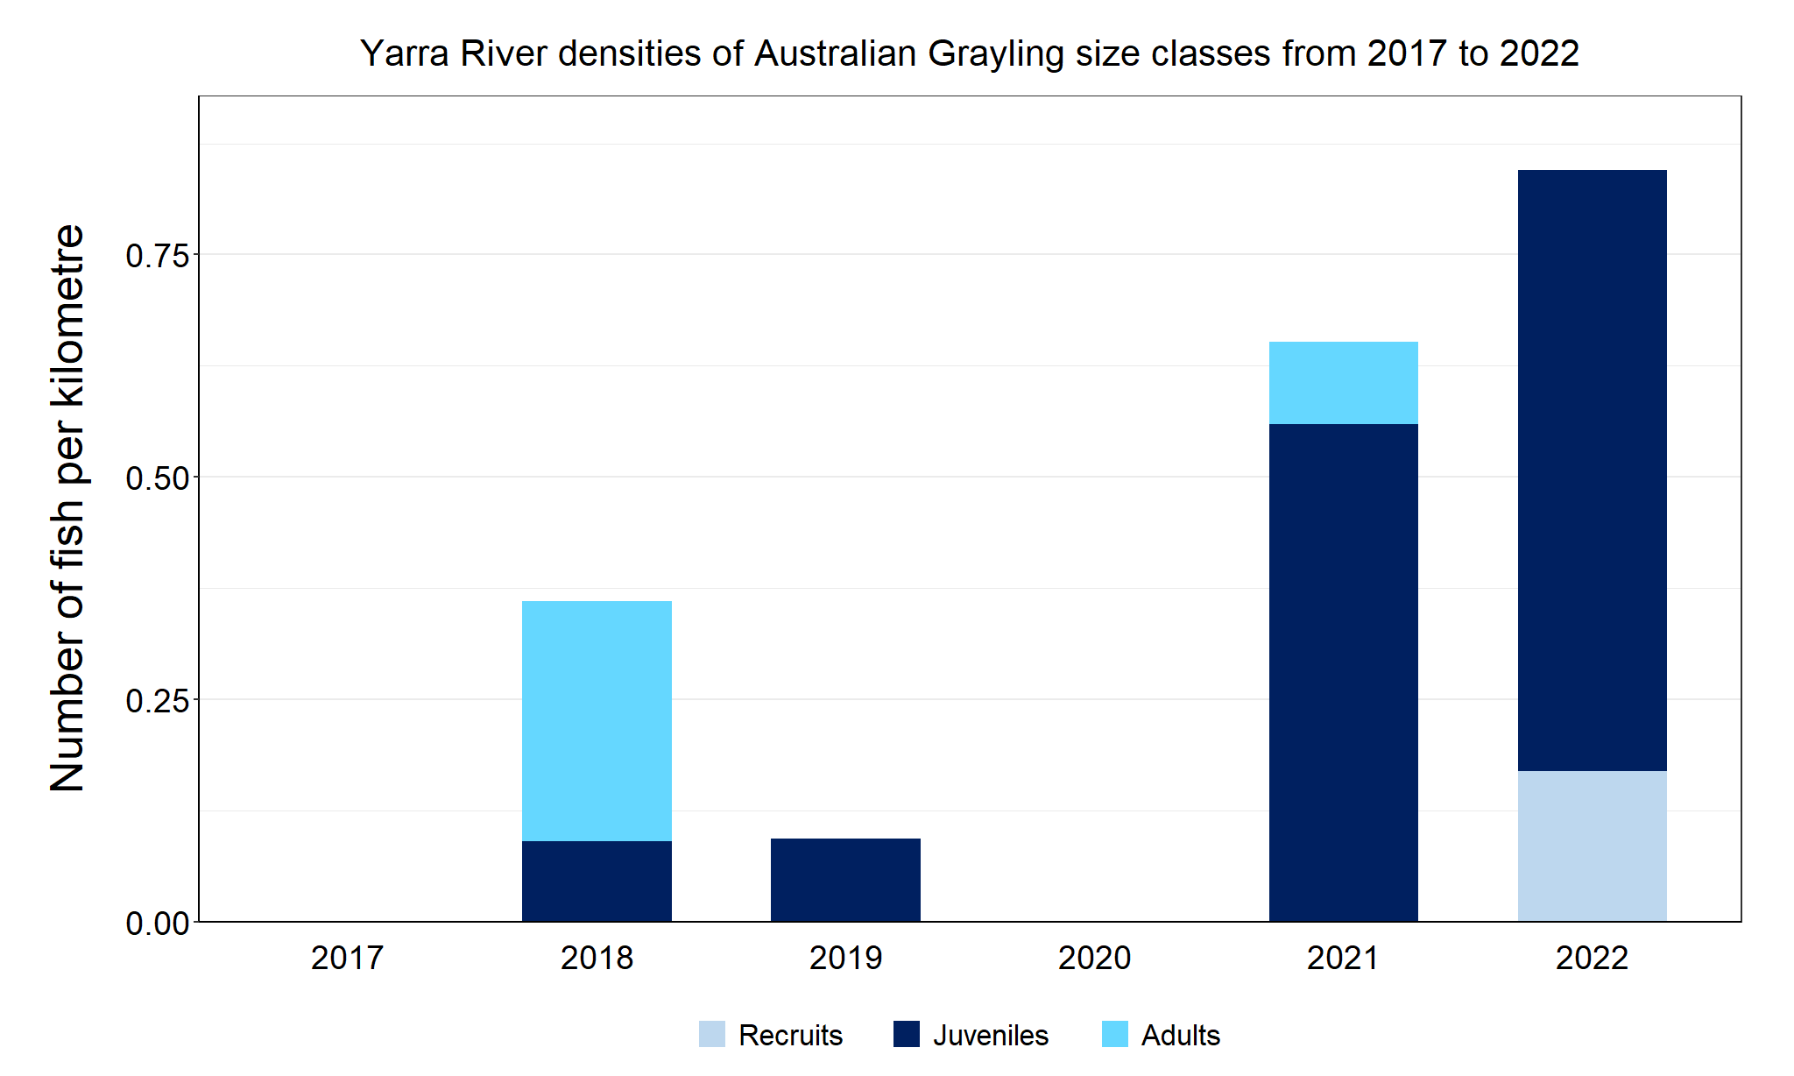
Figure 4. The densities of recruits, juveniles and adult Australian Grayling in the Yarra River from 2017 to 2022

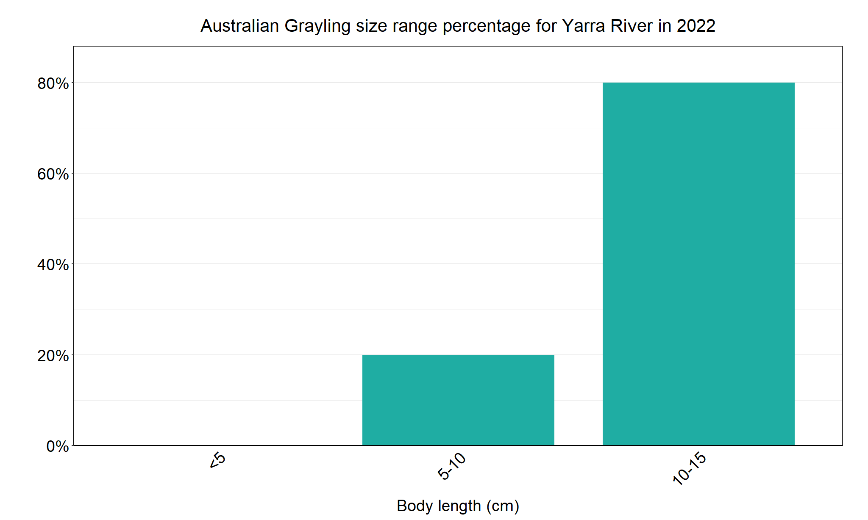
Figure 5 The size range percentage of Australian Grayling in the Yarra River in 2022

Macquarie Perch

Yarra River, Port Phillip region

Key Health Indicators
Recent recruitment No
Multiple size classes Yes
Mature fish present Yes

Monitoring Results
Total number of fish caught 19
Fish per 1km of waterway 3.21
Largest fish by length (cm) 37.5
Largest fish by weight (kg) 0.73
% of the catch that is legal size NA

Macquarie Perch (Macquaria australasica) have been translocated, but the Yarra River population is considered an important population¹. Macquarie Perch are listed as endangered in Victoria (FFG Act 1988) and nationally (EPBC Act 1992). Abundances of Macquarie Perch appear to have declined since 2018 (Figure 6). No recruits have been detected since 2018, but the presence of juveniles of 10-15 centimetres in 2021 (Figure 7) indicates low levels of recruitment occurred in 2019 that were not detected during sampling. Low abundances of adults have been detected in all six years of sampling, albeit higher in 2022. The Victorian fishing regulations changed to a no take species in 2019 to protect this important population. Future monitoring will see if the adult population continues to increase.

Stocking
No stocking has occurred.
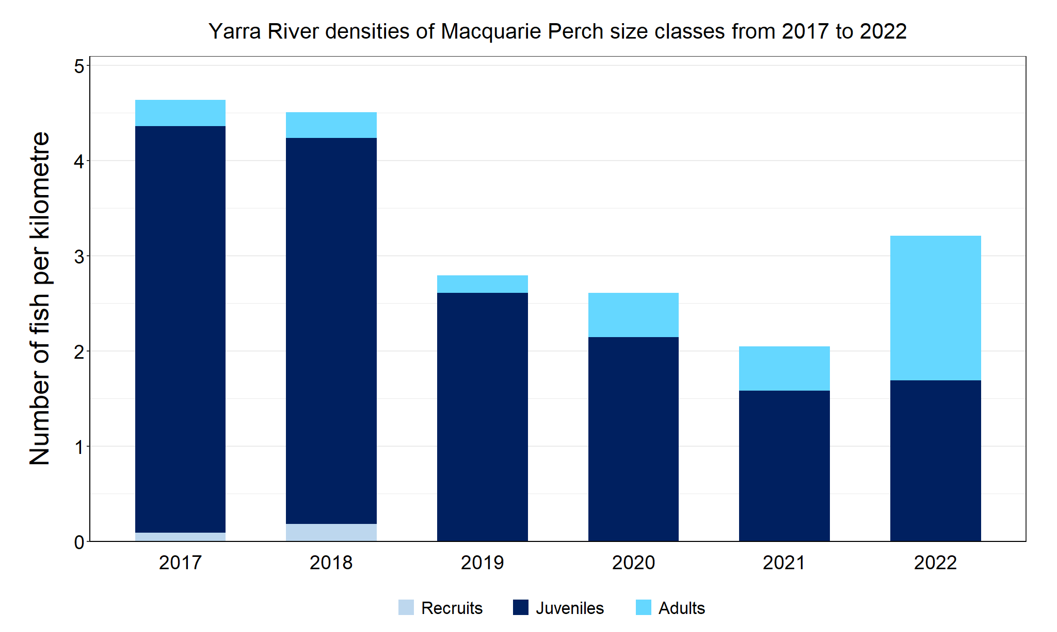
Figure 6. The densities of recruits, juveniles and adult Macquarie Perch in the Yarra River from 2017 to 2022

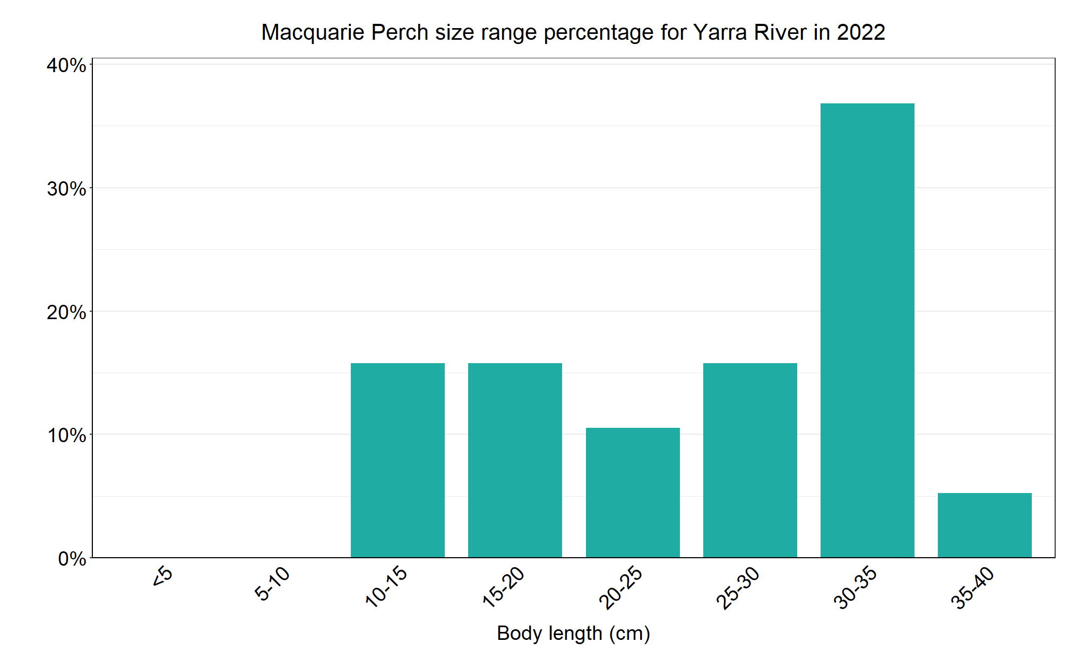
Figure 7. The size range percentage of Macquarie Perch in the Yarra River in 2022

1. Pavlova, A., Beheregaray, L.B., Coleman, R., Gilligan, D., Harrisson, K.A., Ingram, B.A., Kearns, J., Lamb, A.M., Lintermans, M., Lyon, J., Nguyen, T.T.T., Sasaki, M., Tonkin, Z., Yen, J.D.L., & Sunnucks, P. (2017) Severe consequences of habitat fragmentation on genetic diversity of an endangered Australian freshwater fish: a call for assisted gene flow. Evolutionary Applications 10, 531 – 550.

Murray Cod

Yarra River, Port Phillip region

Key Health Indicators
Recent recruitment Yes
Multiple size classes Yes
Mature fish present Yes

Monitoring Results
Total number of fish caught 13
Fish per 1km of waterway 2.2
Largest fish by length (cm) 69.6
Largest fish by weight (kg) 4.8
% of the catch that is legal size 15.4

Murray Cod (Maccullochella peelii) are a translocated species in the Yarra River but are classed as a key recreational species in the Yarra system. Murray Cod are listed as endangered in Victoria (FFG Act 1988) and vulnerable nationally (EPBC Act 1992). Recruits were recorded in four of the six years surveyed (2017, 2018, 2020 and 2022) with the highest number of recruits detected in 2022 (Figure 8). Over 50% of Murray Cod in 2022 were recruits (Figure 9). There was also a large gap with no Murray Cod detected in the 30-60 cm size range in 2022 (Figure 9). Juvenile Murray Cod have been detected every year and were the only size class detected in 2021, which also correlated with the lowest abundances of Murray Cod (Figure 8). Although in low abundances, adults have been detected in five of the six years surveyed (absent in 2021). The low abundances of adults may indicate a high angling pressure.

Stocking
No stocking has occurred.
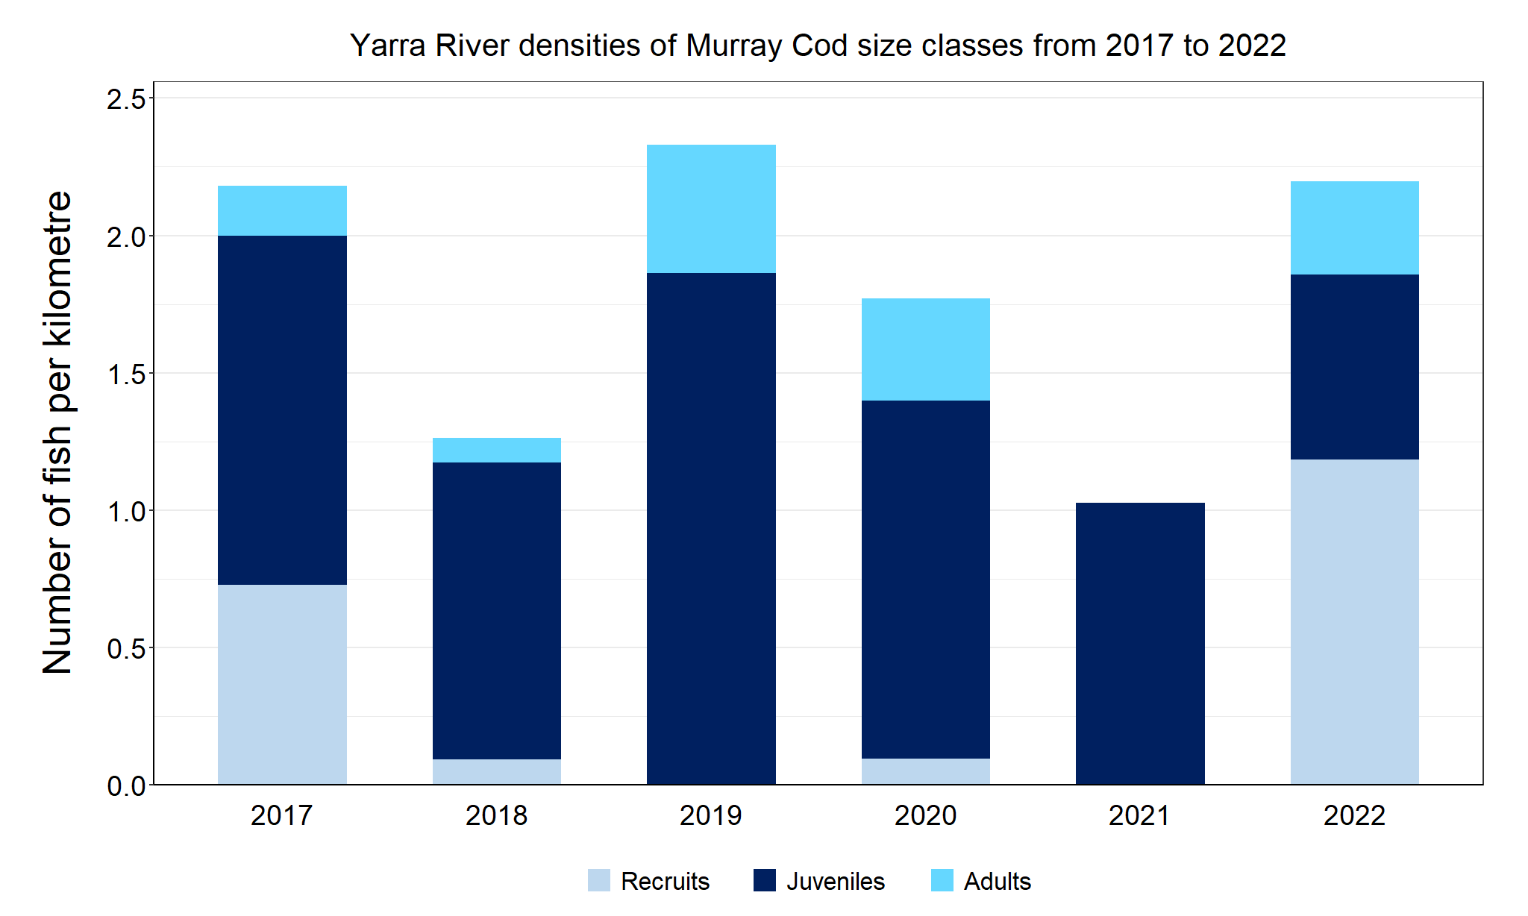
Figure 8. The densities of recruits, juveniles and adult Murray Cod in the Yarra River from 2017 to 2022

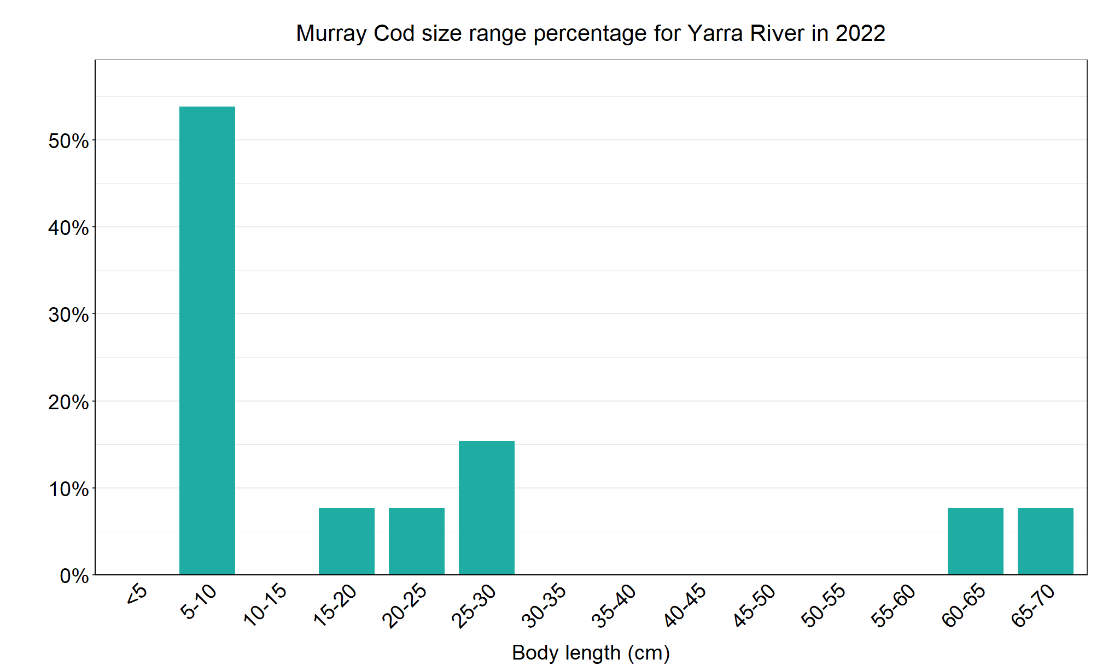
Figure 9. The size range percentage of Murray Cod in the Yarra River in 2022

We acknowledge and respect Victorian Traditional Owners as the original custodians of Victoria’s land and waters, their unique ability to care for Country and deep spiritual connection to it. We honour Elders past and present whose knowledge and wisdom has ensured the continuation of culture and traditional practices.

