Native Fish Report Card 2024

**Gellibrand River**

**Corangamite Region**



**This report card summarises the 2024 Native Fish Report Card (NFRC) survey in the Gellibrand River**

**Sites 9, CCMA, Electrofishing, Fyke Netting**

**Fish found in Gellibrand River for NFRC**

**Target species**

River Blackfish

**Non-target species captured since 2017\***

**Large-bodied native species**

Australian Grayling

Pouched Lamprey

Short-finned Eel

Short-headed Lamprey

Tupong

**Small-bodied native species**

Australian Smelt

Climbing Galaxias

Common Galaxias

Ornate Galaxias

Southern Pygmy Perch

Spotted Galaxias

**Exotic species**

Brown Trout

* These non-target species were incidentally captured during NFRC surveys since 2017 but not measured as for target species

**Gellibrand River 2024**

**Fish Community**

**NFRC target species**

**The NFRC Program began in 2017 to monitor population dynamics of key iconic fish species that have high recreational and/or conservation values, in large rivers across Victoria. In the Gellibrand River, the target species is River Blackfish. Surveys occur in March/April each year, at seven sites from upstream of Chapple Vale to Dandos Campground on the Gellibrand River and two sites on tributaries. In 2022, one site was not fished due to access difficulties. Backpack electrofishing is undertaken in the tributaries, whilst backpack electrofishing and fyke netting is undertaken in the Gellibrand River. The equipment used and habitats surveyed target River Blackfish, which are measured to determine their population structures. Other fish species that are incidentally captured are counted, but not measured.**

**Summary of key health indicators for target species in 2024**

|  |  |  |  |
| --- | --- | --- | --- |
| **Species** | **Key Health Indicators** | | |
|  | Recent recruitment | Multiple size classes | Mature fish present |
| River Blackfish | Yes | Yes | Yes |

*Recent recruitment means young-of-year fish*

River Blackfish are a lowland species, generally found at altitudes below 200m. This species has suffered a decline in distribution and abundance across Victoria1,2. The Gellibrand River was previously known as having a well-established River Blackfish population with large adults present3.

**Non-target species**

The non-target fish species that have been incidentally recorded in the Gellibrand River during NFRC surveys since 2017 are:

**Large-bodied native species**

Australian Grayling, Pouched Lamprey, Short-finned Eel, Short-headed Lamprey and Tupong were recorded in NFRC 2024 surveys. Of these five species, Short-finned Eel is the only species recorded in all eight NFRC surveys. The remaining four species have been recorded in least four years. Australian Grayling is listed as endangered in Victoria (*Flora and Fauna Guarantee Act 1988*) and nationally (*Environmental Protection and Biodiversity Conservation Act* 1999). Numbers of Australian Grayling are low in the Gellibrand River catchment and the species is rarely found. Two fish were captured in 2024; the first records of this species in the Gellibrand River catchment during NFRC since 2019. The fish were captured at Clancys, the furthest upstream this species has been detected in the surveys. Previous captures in the catchment during the NFRC surveys (2017-19) were predominantly from the most downstream site with only one recruit captured further upstream in 2017 (at the third most downstream site). The Pouched Lamprey, Short-finned Eel, Short-headed Lamprey and Tupong are diadromous (migratory between salt water and fresh water) species found throughout coastal Victoria.

**Small-bodied native species**

Australian Smelt, Common Galaxias and Ornate Galaxias were recorded in 2024 and have been detected in all eight NFRC surveys. Australian Smelt is a common species distributed across all of Victoria. The Common Galaxias is a diadromous species found across coastal Victoria. The Ornate Galaxias is known from West Gippsland across to the Gellibrand area. In previous NFRC surveys the Climbing Galaxias, Southern Pygmy Perch and Spotted Galaxias have been recorded, although rarely. The Climbing Galaxias and Spotted Galaxias are diadromous species found across coastal Victoria. Southern Pygmy Perch is more common in offstream habitats such as wetlands, billabongs and lagoons.

**Exotic fish species**

Brown Trout was the only exotic species recorded in 2024 and has been detected in all eight NFRC surveys. The species is present throughout the Gellibrand River, occurring in low to moderate abundances. Brown Trout is however not a dominant species downstream of Gellibrand but increases in abundances higher in the catchment.

**Other native fish species known from the Gellibrand River**

Some fish species known to occur in the Gellibrand River have never been recorded during NFRC surveys. This includes the Flatheaded Gudgeon which is a common species across Victoria.

**Other notable species**

Surveys have also recorded Burrowing Crayfish (not identified to species), Southern Victorian Spiny Crayfish and Platypus.

1. Hammer et al. (2014) A multi-gene molecular assessment of cryptic biodiversity in the iconic freshwater blackfishes (Teleosti: Perchichthyidae: Gadopsis) of south-eastern Australia. Biological journal of the Linnean Society.

2. Khan et al. (2004). Habitat use and movement of river blackfish (*Gadopsis marmoratus* R.) in a highly modified Victorian stream, Australia. *Ecology of Freshwater Fish,* 13: 285–293.

3. Koehn, J. 1984. Survey of angling and recreational use of the Gellibrand River, south-western Victoria. Arthur Rylah Institute for Environmental Research Technical Report Series No. 10. Department of Conservation, Forests and Lands. Fisheries and Wildlife Service Victoria.

**Gellibrand River 2024**

**Environmental and Management Context**

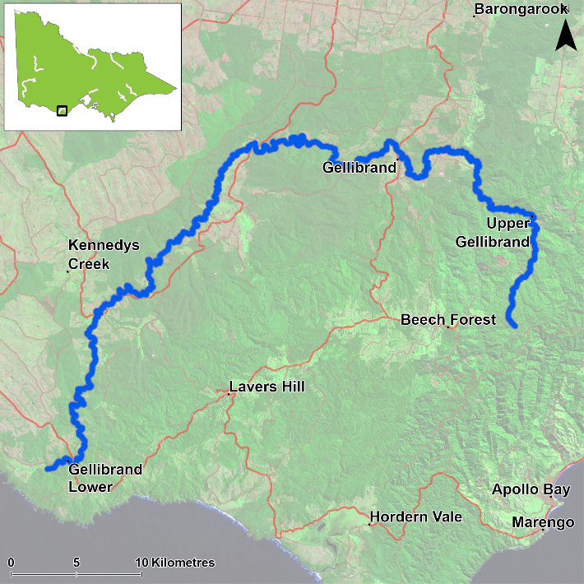

Figure 1. Map showing the section of Gellibrand River where NFRC sampling occurs

**Environment**

Low flow conditions were present in all eight sampling years. Since 2022 the pH in Boggy Creek has been extremely low in each of the sampling seasons, however fish have been detected from this site. The upper sites on the Gellibrand River main stem have been experiencing increased levels of sand deposition during NFRC surveys. One site on the Gellibrand River was not fished in 2022 due to access difficulties.

**Waterway and fisheries management efforts in the Gellibrand River**

Many rehabilitation actions have occurred, and are underway, to improve the health of the Gellibrand River. These are informed by the [Corangamite Waterway Strategy 2014-2022](https://issuu.com/gsdm/docs/waterway_strategy_2014-22) as well as the Gellibrand River Estuary Management Plan. Actions include revegetation, weed control including large scale removal of willows, fencing of riparian areas, bank stabilisation, reintroduction of instream woody habitat, removal of migration barriers and pest control. Some fish monitoring has occurred, including related to rehabilitation efforts. The [Corangamite Catchment Management Authority](https://ccma.vic.gov.au/), DEECA and VFA support rehabilitation and management of the Gellibrand River and its fish community.

**River Blackfish**

**Gellibrand River, Corangamite region**

**Key Health Indicators**

Recent recruitment Yes

Multiple size classes Yes

Mature fish present Yes

**Monitoring Results**

Total number of fish caught 30

Fish per 1km of waterway 15.92

Largest fish by length (cm) 54.5

Largest fish by weight (kg) 1.48

% of the catch that is legal size 50

**Recruits, juveniles and adult River Blackfish (*Gadopsis marmoratus*) were recorded in 2024 and have been recorded in seven of the eight years surveyed (Figure 2). No recruits were recorded in 2023 and only two recruits were detected in 2024 (Figure 2; Figure 3). Sixty percent of the River Blackfish were recorded from the two tributary sites (Boggy Creek and Loves Creek) in 2024, with all the recruits and four of the five juveniles from Boggy Creek. Most recruitment occurs in the tributaries, with only one recruit (in 2022) and three juveniles (two in 2023 and one in 2024) detected at main stem sites of the Gellibrand River during this project. Only low abundances of River Blackfish were detected in the mainstem (5-18 fish each year), despite seven of the nine sites being on the mainstem. This highlights the potential importance of tributary habitats for recruitment to the population in the Gellibrand River catchment. It is unknown why abundances were lower in 2023.**

**Stocking**

No stocking has occurred.

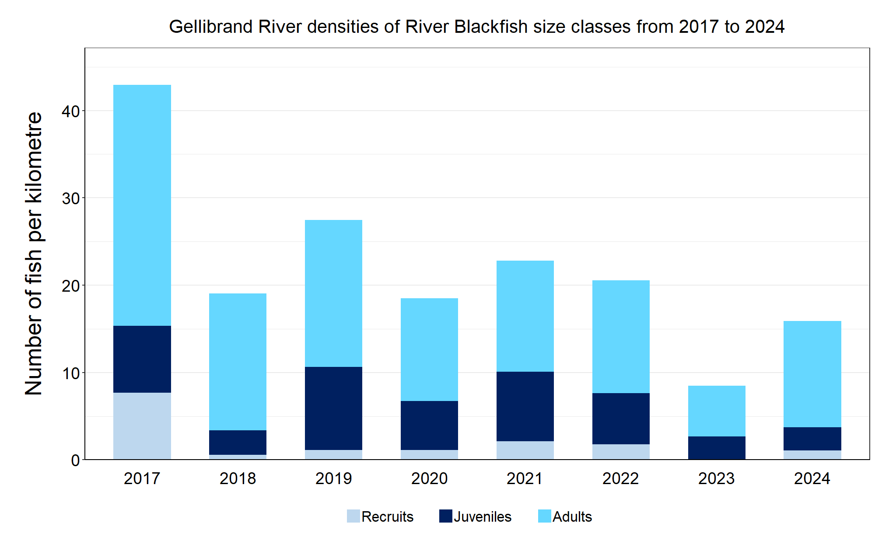Figure 2. The densities of recruits, juveniles and adult River Blackfish in the Gellibrand River from 2017 to 2024

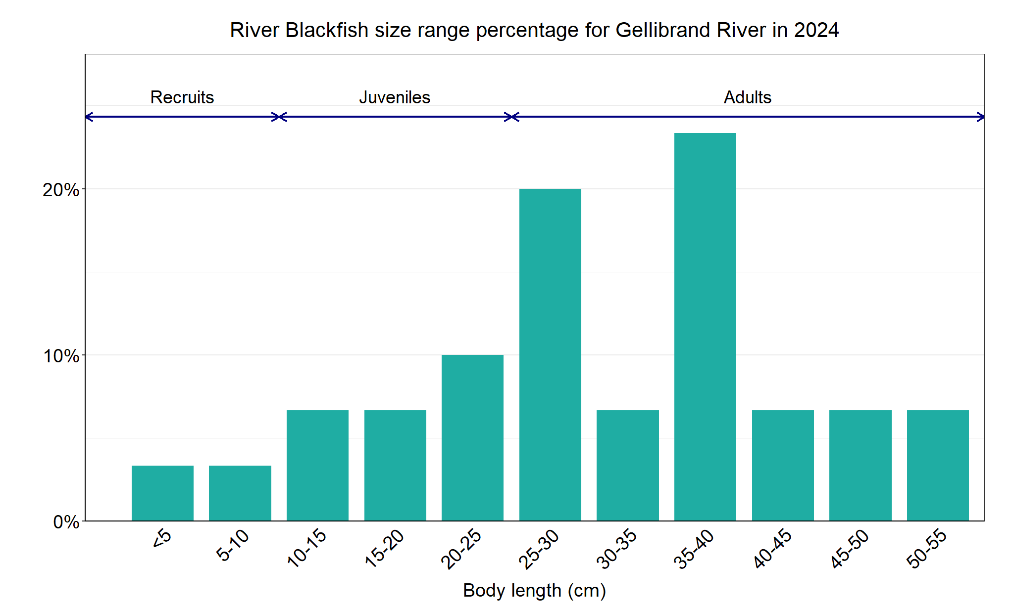Figure 3. The size range percentage of river Blackfish in the Gellibrand River in 2024

We acknowledge and respect Victorian Traditional Owners as the original custodians of Victoria’s land and waters, their unique ability to care for Country and deep spiritual connection to it. We honour Elders past and present whose knowledge and wisdom has ensured the continuation of culture and traditional practices.

Logo*© The State of Victoria Department of Energy, Environment and Climate Action 2023. This work is licensed under a Creative Commons Attribution 4.0 International licence. To view a copy of this licence, visit creativecommons.org/licenses/by/4.0/*

*ISSN 2981-8990 - Online (pdf/word)*