|  |
| --- |
| Victorian Environmental Flows Monitoring and Assessment Program (VEFMAP) Stage 6 |
| Project Update – 2017  Fish Study – Northern Victorian Rivers |

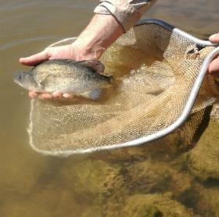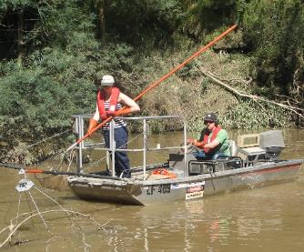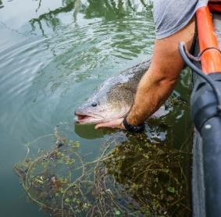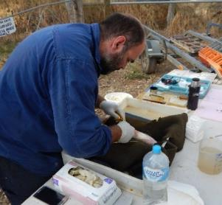

## Background

The Victorian Environmental Flows Monitoring and Assessment Program (VEFMAP) was established by the Victorian Government in 2005 to monitor and assess ecosystem responses to environmental watering in priority rivers across Victoria. The program’s results help inform decisions for environmental watering by Victoria’s Catchment Management Authorities (CMAs), Melbourne Water and the Victorian Environmental Water Holder (VEWH). Over the past 12 years, the information collected through VEFMAP has provided valuable data and informed significant changes to the program. VEFMAP is now in its sixth stage of delivery and includes a strong focus on “intervention” or “flow event” type questions, for vegetation and fish.

## Fish Monitoring – Northern Victorian Rivers

The core objective for fish monitoring in VEFMAP Stage 6 is to examine the importance of environmental flows in promoting population growth and the rehabilitation of native fish populations via dispersal, colonisation, recruitment and survival.

There are two key evaluation questions for fish in northern Victorian rivers, which were developed in collaboration with CMAs. (Note: KEQs 1 and 2 relate to southern Victorian rivers.)

KEQ 3 Do environmental flows support immigration of native fish into, and dispersal throughout, northern Victorian rivers?

KEQ 4: Does environmental flow management used for native large-bodied species enhance: (i) survival (ii) abundance and (iii) distribution?

## 2016/17 Survey Sites and Timing

In 2016/17 surveys were undertaken to investigate KEQ 3 and 4 processes at the following sites:

* ***Immigration*** – Murray River (Torrumbarry Weir fishway), Campaspe and Goulburn rivers (Dec 2016-Feb 2017).
* ***Dispersal*** – Loddon River catchment; fishway trapping (The Chute, Kerang Weir, Box Creek fishlock) (Mar-April 2017)
* ***Population demography*** – Broken, Campaspe, Goulburn and lower Loddon rivers (including Little Murray River and Pyramid Creek) (Mar-May 2017).

## Methods

Different survey methods were used for each component of the study.

***Immigration***

* *Acoustic telemetry* – fish were tagged in Dec 2016 and Feb 2017 at the Torrumbarry Weir fishway. Eighteen acoustic listening stations were deployed in the Murray River (Torrumbarry Weir to Yarrawonga Weir), and single listening stations were deployed in the Campaspe, Goulburn and Edwards rivers. A PIT (Passive Integrated Transponder) tag reader on Broken Creek, about 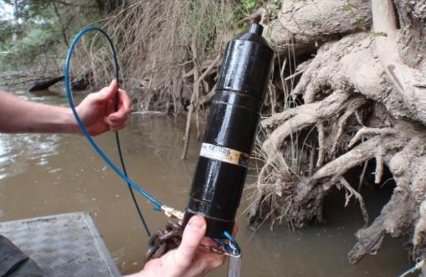0.5 km upstream of the junction with the Murray River, also provided data.

***Dispersal***

* *Fishway trapping ­*- undertaken for 24 hr x 4 replicates/week at three sites (Mar-April 2017): The Chute fishway on the Loddon River near Appin South, Kerang Weir fishway on the Loddon River near Kerang, Box Creek fishlock on Pyramid Creek at Kow Swamp. Fish >200 mm were PIT tagged.
* *Acoustic telemetry –* boat electrofishing was undertaken in the lower Loddon River and Pyramid Creek and 34 Golden Perch *Macquaria ambigua* were captured, acoustically tagged and released.Twelve acoustic listening stations were deployed In the Loddon River, Pyramid Creek and Washpen Creek (Jan-March 2017).
* *Electrofishing* – boat electrofishing was undertaken at three sites: immediately downstream of Kerang Weir fishway, immediately downstream of Box Creek fishway, and about 10 km downstream of Box Creek fishway. Each site was surveyed three times (Mar-April 2017) - twice before the environmental water delivery and once during.

***Population demographics***

* *Electrofishing* – boat electrofishing was undertaken at 15 sites in the Broken River, 20 sites in the Campaspe River, 16 sites in the Goulburn River, five sites in the Little Murray River, nine sites in the Loddon River, and six sites in Pyramid Creek.

All fish were identified to species, counted, weighed and measured. Fish >250mm TL were externally tagged with a T-bar or Dart tag. Samples of Golden Perch, Silver Perch *Bidyanus bidyanus* and Murray Cod *Maccullochella peelii* were also collected for aging to contribute to the generation of system specific growth models.

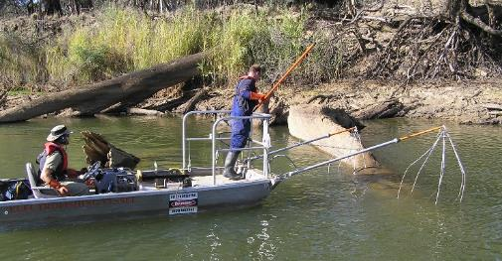**Figure 1 – Boat electrofishing is one of the survey techniques used in VEFMAP.**

**Figure 2 – Setting up an acoustic listening station.**

## Results

***Hydrology and environmental flow delivery***

Environmental water was delivered to the Murray, Goulburn and Campaspe rivers in late summer/autumn as within-channel pulses (‘freshes’; i.e. small flow events that exceed the baseflow and last for up to several weeks). Environmental water was delivered to the downstream end of the Loddon River in April 2017. There were also two natural rainfall events which resulted in elevated flows in the lower Loddon River in late April and mid May.

***Immigration***

A total of 41 sub-adult Silver Perch and 23 Golden Perch were captured at Torrumbarry Weir fishway and tagged with acoustic transmitters. Thirty-nine of the sub-adult Silver Perch were detected by the listening stations, generally undertaking rapid upstream movements in the Murray River from late Feb-early March, typically over distances of 50-150 km, coinciding with the elevated discharge associated with the Murray River environmental watering event. Twenty-two of the Golden Perch were detected by the listening stations.

Silver Perch exhibited long-distance upstream migrations in the Murray River and movement into tributary streams, in association with elevated river flows. Approximately half of the tagged fish moved from the Murray River into tributaries, coinciding with the environmental flows in the tributary rivers. About 70% of these fish remained in a tributary, and some fish then returned to the Murray River, usually as flows in the tributary receded.

Golden Perch exhibited a diversity of movements that included local, long-distance and mainstem-tributary components. Elevated river flows promoted movement.

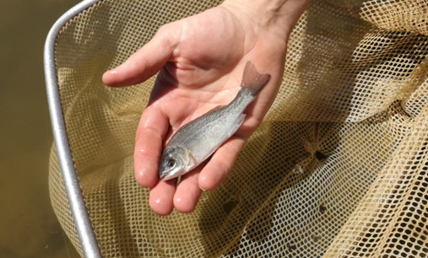**Figure 3 – A tagged juvenile Silver Perch being released in the Murray River.**

***Dispersal***

A total of 12 fish species (seven native, five exotic) were captured during fishway sampling. Four native fish species were collected prior to environmental watering, and seven during the release. With the exception of Bony Bream *Nematalosa erebi*, the Catch Per Unit Effort (CPUE) of native fish recorded in fishway trapping (and electrofishing) increased substantially during the flow release at The Chute fishway and the Kerang Weir. Issues associated with the Box Creek fishway operation during the surveys prevented an assessment of the environmental flow delivery. Nevertheless, these results indicate a positive response to delivery of environmental water in autumn 2017.

Of the 34 Golden Perch that were acoustically tagged, 22 were recorded. A number of movements appeared to be related to an increase in discharge in Pyramid Creek at the beginning of the environmental flow in early April. Two fish tagged downstream of Kerang Weir moved substantial distances upstream, moving through the fishway during peak discharge of the environmental flow release.

***Population demography***

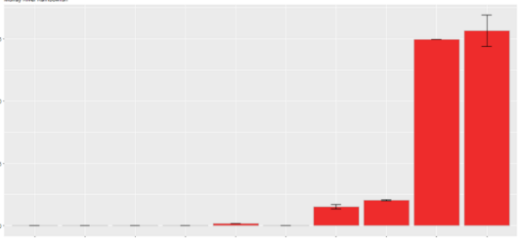

CPUE

0 5 10 15

*Broken River* – A total of 526 fish were recorded (eight native and four exotic species), with Murray Cod, Carp and Murray River Rainbowfish *Melanotaenia fluviatilis* the most abundant. Temporal trends in CPUE for Murray Cod and Golden Perch showed a decrease from 2008-2011, followed by an increase to the highest recorded levels in the system in 2016 and 2017. Murray River Rainbowfish showed a similar pattern, although their numbers peaked in 2015.

*Campaspe River* – A total of 4745 fish were recorded (nine native and six exotic species) with Murray River Rainbowfish, Carp *Cyprinus carpio*, Australian Smelt *Retropinna semoni* and Gambusia *Gambusia holbrooki* the most abundant. A total of 25 Murray Cod and 48 Golden Perch were collected, with size structure differing between reaches. Twelve juvenile Silver Perch were recorded, and Murray River Rainbowfish occurred at all sites. There has been an increasing trend in CPUE of Murray Cod, Golden Perch and Murray River Rainbowfish (Figure 4) in reaches 3 and 4. Silver Perch were detected for the first time in Reach 3 since the inception of the program in 2007.

*Goulburn River* – A total of 2974 fish were recorded (10 native and four exotic species) with Australian Smelt, Carp and Murray River Rainbowfish the most abundant. Trends in CPUE in Reach 4 for Golden Perch, Murray Cod, Murray River Rainbowfish and Silver Perch declined from 2008-2011, and then increased until 2017. A similar trend was detected in Reach 5 for Murray Cod, Golden Perch and Murray River Rainbowfish. CPUE for Trout Cod and Silver Perch was low throughout the study period, although Silver Perch CPUE increased significantly in 2017.

*Loddon system* – A total of 6273 fish were recorded (eight native and four exotic species) with Australian Smelt, Bony Bream and Carp the most abundant. Murray River Rainbowfish were captured in all sites except Pyramid Creek. Temporal trends in CPUE showed a decline in Golden Perch in Reach 4 from 2008-2016, followed by an increase for Golden Perch and Murray River Rainbowfish in 2017.

Temporal patterns in fish population demography show encouraging patterns in recruitment, survival and distribution specific to species, reaches and systems. At a broad level, this data shows a general increase in abundance and distribution for most priority species since 2012. While this pattern likely represents recovery from the Millennium drought, it highlights that flow conditions since this time, which include environmental water, have potentially facilitated this recovery. Results for Silver Perch and Murray River Rainbowfish in the Campaspe River highlight the importance of connectivity in facilitating movement of fish between river reaches.

**Figure 4 - Annual trends in catch per unit effort (CPUE; Mean number of fish per 1000 EF seconds-1 ± SE) for Murray River Rainbowfish recorded from electrofishing surveys in Reach 3 of the Campaspe River from 2007 - 2017. Note: sampling was not undertaken in 2013.**

## Highlights

The 2016/17 approach, which combined both flow-event based intervention monitoring and condition monitoring, has provided a robust link between trends in population processes and population demography. This has been underpinned by an up-to-date conceptual understanding of flow links for Murray-Darling Basin fish species. This first year of VEFMAP Stage 6 identified:

* A strong link between coordinated environmental flow delivery in tributaries and immigration of Silver Perch.
* Encouraging results linking increased within-system dispersal of small and large-bodied native species to environmental flow pulses delivered in the Loddon system.
* A general increase in abundance and distribution for many priority species including Silver Perch, Murray River Rainbowfish, Murray Cod and Golden Perch across the waterways since 2012.

There has been strong collaboration between program managers, CMAs and other key stakeholders. Regular and active communication has been integral to the effective delivery of the program and communication of outcomes.

## What’s next?

During a recent revision of the program by the Independent Review Panel, the methods have been approved for continued use, with minor refinements.

## Further details

See DELWP (2017) VEFMAP Stage 6: Monitoring fish response to environmental flow delivery in northern Victorian rivers, 2016/17. A client report to Water and Catchments, the Department of Environment, Land, Water and Planning.

## Acknowledgements

Goulburn River sites were surveyed as part of the Long- term Intervention Monitoring Program (Commonwealth Environmental Water Office) and Native Fish Report Card monitoring program (DELWP/Victorian Fishery Authority).

**Contacts:**

Zeb.Tonkin@delwp.vic.gov.au (fish program leader and population demographics)

Matthew.Jones@delwp.vic.gov.au (Dispersal)

Wayne.Koster@delwp.vic.gov.au (Immigration)

Justin.O’Connor@delwp.vic.gov.au (Dispersal)

|  |  |
| --- | --- |
| © The State of Victoria Department of Environment, Land, Water and Planning 2017  LogoThis work is licensed under a Creative Commons Attribution 4.0 International licence. You are free to re-use the work under that licence, on the condition that you credit the State of Victoria as author. The licence does not apply to any images, photographs or branding, including the Victorian Coat of Arms, the Victorian Government logo and the Department of Environment, Land, Water and Planning (DELWP) logo. To view a copy of this licence, visit http://creativecommons.org/licenses/by/4.0/  ISBN 978-1-76047-797-4 (print), 978-1-76047-798-1 (pdf/online)  Disclaimer  This publication may be of assistance to you but the State of Victoria and its employees do not guarantee that the publication is without flaw of any kind or is wholly appropriate for your particular purposes and therefore disclaims all liability for any error, loss or other consequence which may arise from you relying on any information in this publication. | Accessibility  If you would like to receive this publication in an alternative format, please telephone the DELWP Customer Service Centre on 136186, email [customer.service@delwp.vic.gov.au](mailto:customer.service@delwp.vic.gov.au), or via the National Relay Service on 133 677 [www.relayservice.com.au](http://www.relayservice.com.au). This document is also available on the internet at [www.delwp.vic.gov.au](http://www.delwp.vic.gov.au). |

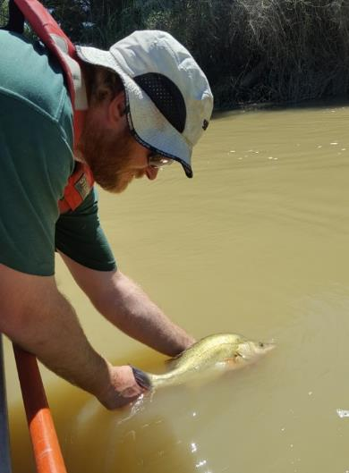

**Figure 5 -** **Release of an acoustically tagged Golden Perch into Pyramid Creek.**