Native Fish Report Card 2024

**Mitchell River**

**East Gippsland Region**



**This report card summarises the 2024 Native Fish Report Card (NFRC) survey in the Mitchell River**

**Sites 10, EGCMA, Electrofishing**

**Fish found in Mitchell River for NFRC**

**Target species**

Australian Bass

Australian Grayling

**Non-target species captured since 2017\***

**Large-bodied native species**

Cox’s Gudgeon

Long-finned Eel

Pouched Lamprey

Short-finned Eel

Short-headed Lamprey

Striped Gudgeon

Tupong

A further 10 species which are estuarine (see next page)

**Small-bodied native species**

Australian Anchovy

Australian Smelt

Common Galaxias

Dwarf Flatheaded Gudgeon

Flatheaded Gudgeon

Flinder’s Pygmy Perch

Port Jackson Glassfish

Tamar River Goby

**Exotic species**

Common Carp

Goldfish

* These non-target species were incidentally captured during NFRC surveys since 2017 but not measured as for target species.

**Mitchell River 2024**

**Fish Community**

**NFRC target species**

**The NFRC Program began in 2017 to monitor population dynamics of key iconic fish species that have high recreational and/or conservation values, in large rivers across Victoria.**

**In the Mitchell River, the target species are Australian Bass and Australian Grayling. The equipment used and habitats surveyed target these species, which are measured to determine their population structures. Other fish species that are incidentally captured are counted, but not measured. Surveys occur in February each year, at 11 sites from** **Bairnsdale to Kingswell Bridge. One site on the upper Mitchell was unable to be fished in 2022 and 2024 due to higher flows restricting access. Surveys on the Mitchell River use Smith-Root boat electrofishing at most sites, with elevated salinities at the two bottom sites requiring Grassl boat electrofishing1.**

**Summary of key health indicators for target species in 2024**

|  |  |  |  |
| --- | --- | --- | --- |
| **Species** | **Key Health Indicators** | | |
|  | Recent recruitment | Multiple size classes | Mature fish present |
| Australian Bass | Yes | Yes | Yes |
| Australian Grayling | - | - | - |

*Recent recruitment means young-of-year fish*

*\*- cannot be determined due to low abundances*

Australian Bass are close to the edge of their natural range in the Mitchell River system. Historically they occurred no further west than Wilsons Promontory. Australian Bass are an important recreational species in the Mitchell River with the population aided by stockings. Australian Grayling was once widespread throughout coastal Victoria, including the Mitchell River system. Changes to flow regimes and addition of barriers have negatively affected this species. The detection of Australian Grayling in seven of the eight years indicates that conditions are favourable for the survival of the population.

**Non-target species**

The non-target fish species that have been incidentally recorded in the Mitchell River during NFRC surveys since 2017 are:

**Large-bodied native species**

Cox’s Gudgeon, Long-finned Eel, Pouched Lamprey, Short-finned Eel, Short-headed Lamprey and Tupong were recorded in 2024. The Striped Gudgeon has also been recorded in previous NFRC surveys. Four large-bodied estuarine species (Black Bream, Estuary Perch, River Garfish and Sea Mullet) were also recorded in 2024. Other large-bodied estuarine species previously recorded in surveys are Eastern Australian Salmon, Flat-tail Mullet, Luderick, Sand Mullet, Tailor and Yellow-eye Mullet. All ten estuarine species are restricted to the lowest Mitchell River site (Bairnsdale) and Clifton Creek. Long-finned and Short-finned Eel, Pouched and Short-headed Lamprey and Tupong are diadromous species found throughout coastal Victoria. Cox’s and Striped Gudgeon are only found in coastal areas of eastern Victoria. Cox’s Gudgeon is listed as endangered under the *Flora and Fauna Guarantee Act* 1988 in Victoria. It was recorded in 2019 (the first record in the Mitchell catchment since 1982), 2021, 2022 and 2024.

**Small-bodied native species**

Tamar River Goby, an estuarine species, was recorded in 2024 for the first time during NFRC surveys. Australian Smelt, Common Galaxias and Flatheaded Gudgeon were recorded in 2024, with Australian Smelt and Common Galaxias recorded in all eight NFRC surveys and Flatheaded Gudgeon in seven. Australian Smelt and Flatheaded Gudgeon are common species distributed across all of Victoria. The Common Galaxias is a diadromous species found in coastal Victoria. Other species recorded in previous NFRC surveys are Dwarf Flatheaded Gudgeon and Flinder’s Pygmy Perch (listed as vulnerable in Victoria under the *Flora and Fauna Guarantee Act* 1988) which have a more restricted distribution and are rarer. Two small-bodied estuarine species have also been recorded in previous NFRC surveys; Australian Anchovy and Port Jackson Glassfish which are only expected to be detected at the lowest Mitchell River site (Bairnsdale) and Clifton Creek.

**Exotic fish species**

Common Carp is the only exotic species detected in 2024 and has been detected in all eight NFRC surveys. It is widespread throughout the Mitchell River, with juveniles detected as far upstream as Kingswell Bridge in 2020 and 2023. Goldfish has been recorded in previous surveys. It prefers slower flowing waters and was detected at Bairnsdale, the lowest site on the Mitchell River mainstem.

**Other native species known from the Mitchell River**

Some fish species known to occur in the Mitchell River have never been recorded during NFRC surveys (e.g. Climbing Galaxias, Dwarf Galaxias, Mountain Galaxias, Spotted Galaxias, River Blackfish). The Climbing and Spotted Galaxias are diadromous species occurring in coastal Victoria. They have patchy distributions, in lowland areas, but are hard to detect using NFRC sampling methods. The Mountain Galaxias occurs on both sides of the Great Dividing Range from Melbourne eastwards in Victoria. In the Mitchell River it is widespread and patchy in the lower areas, but more common in higher altitudes and is hard to detect using the NFRC sampling methods. The Dwarf Galaxias (listed as vulnerable nationally under the *Environmental Protection and Biodiversity Conservation Act* 1992) is often found in offstream habitats. River Blackfish is a lowland species, generally found at altitudes below 200 m. This species has declined in distribution and abundance across Victoria. It was historically considered to be widespread, but with a patchy distribution in the Mitchell River basin2.

**Other notable species**

Surveys have also recorded Platypus.

1. Lieschke, Jason A., Dean, Jan, C and Pickworth, Andrew 2019. Extending the Effectiveness of Electrofishing to Estuarine Habitats: Laboratory and Field Assessments. *Transactions of the American Fisheries Society*, 148:584–591.

2. Lieschke, J.A., Dodd, L., Stoessel, D., Raadik, T.A., Steelcable A., Kitchingman, A. and Ramsey, D. (2013). The status of fish populations in Victorian rivers 2004–2011 – Part A. Arthur Rylah Institute for Environmental Research Technical Report Series No. 246. Department of Environment and Primary Industries, Heidelberg, Victoria.

**Mitchell River 2024**

**Environmental and Management Context**

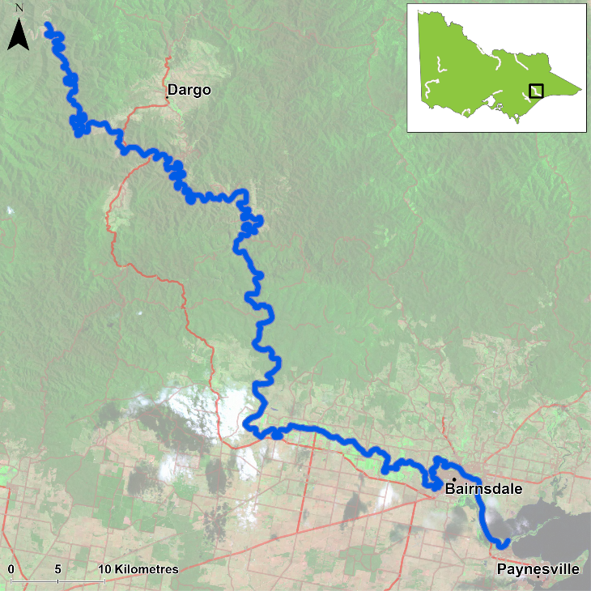

Figure 1. Map showing the section of Mitchell River where NFRC sampling occurs

**Environment**

Summer base flows were recorded in 2017-20 and 2023, with slightly higher flows in 2021 and above summer base flows in 2022 and 2024. During 2020 and 2021 turbidity was elevated at sites due to increased sediment loads following the 2019/2020 fires. The elevated turbidity decreased electrofishing efficiency in those two years. Higher flows restricted access to one site, therefore only 10 sites were fished in 2022 and 2024.

**Waterway and fisheries management efforts in the Mitchell River**

Many rehabilitation actions have occurred, and are underway, to improve the health of the Mitchell River. These are informed in particular by the [East Gippsland Waterway Strategy 2014-2022](https://egcma.com.au/wp-content/uploads/2019/06/East_Gippsland_Waterway_Strategy-Final.pdf).

The [East Gippsland Catchment Management Authority](https://egcma.com.au/) continues to work closely with landholders, partner agencies and Traditional Owners to improve the health of the Mitchell River. This year the focus has been on controlling weeds, particularly willows, along waterways in the catchment. This work is of particular importance following bushfires. Other works in the Mitchell River have included planting native plants, constructing stock exclusion fencing along rivers, stabilising the banks and creating more habitat for fish by reintroducing large woody habitat.

Some monitoring of the fish community has occurred including in relation to associated rehabilitation efforts. In the upper Mitchell River catchment well above the NFRC area, there have been surveys of a suite of threatened galaxiid species as well as Forest Protection Survey Program (FPSP) surveys of fish and crayfish. The EGCMA, DEECA and VFA support rehabilitation and management of the Mitchell River and its fish community.

**Australian Bass**

**Mitchell River, East Gippsland region**

**Key Health Indicators**

Recent recruitment Yes

Multiple size classes Yes

Mature fish present Yes

**Monitoring Results**

Total number of fish caught 124

Fish per 1km of waterway 20.8

Largest fish by length (cm) 42.8

Largest fish by weight (kg) 1.26

% of the catch that is legal size 23.4

**Australian Bass (*Percalates novemaculeata*) - formerly *Macquaria novemaculeata* – have been collected in all eight NFRC surveys. Abundance of Australian Bass in 2024 was lower than the peak found in 2023, which is attributed to a reduction in the number of juveniles present without a corresponding rise in the number of adults (Figure 2). Recruits, juveniles and adults have been collected in all eight years of surveys. The population in 2024 was dominated by recruits (which are likely from stockings), but the spread of fish sizes detected (Figure 3) indicates that stocked fish are surviving and reaching maturity.**

**Stocking**

Ten thousand Australian Bass were stocked in 2016; 150,000 in 2017; 30,000 in 2018; 44,000 in 2019; 66,000 in 2020; 100,000 in 2021; 67,000 in 2022 and 101,000 in 2023.

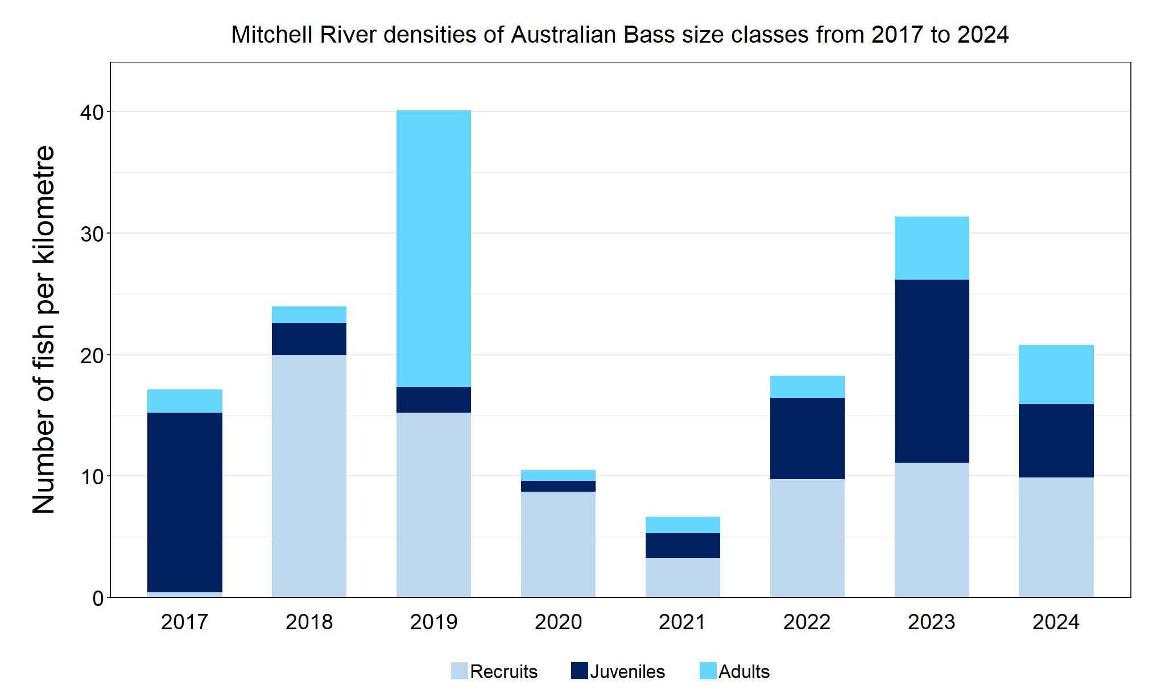

Figure 2. The densities of recruits, juveniles and adult Australian Bass in the Mitchell River from 2017 to 2024

Figure 3. The size range percentage of Australian Bass in the Mitchell River in 2024

**Australian Grayling**

**Mitchell River, East Gippsland region**

**Key Health Indicators**

Recent recruitment Cannot be determined

Multiple size classes Cannot be determined

Mature fish present Cannot be determined

**Monitoring Results**

Total number of fish caught 8

Fish per 1km of waterway 1.34

Largest fish by length (cm) 23.8

Largest fish by weight (kg) 0.12

% of the catch that is legal size NA#

# This species is a Protected Freshwater Species and taking or possessing is prohibited (Victorian Recreational Fishing Guide 2023-24).

**Australian Grayling (*Prototroctes maraena*) is a diadromous species which has undergone declines in distribution and abundance across its range. The species is listed as endangered in Victoria (*Flora and Fauna Guarantee Act 1988*) and nationally (*Environmental Protection and Biodiversity* Act 1999). While NFRC expects to only capture low numbers of this species, the monitoring can provide a greater understanding of the current status of the populations which is essential to inform management of these species. Due to the low abundances of Australian Grayling collected during NFRC, the key health indicators cannot be determined.**

**Adults have been captured in six of the eight years of NFRC surveys (2017, 2019–21 and 2023-24) (Figure 4). The continued presence of adult Australian Grayling indicates conditions continue to be favourable for the survival of this species in the Mitchell River.**

**Only adults and juveniles were detected in 2024 (Figure 4; Figure 5), however, all the fish classified as juveniles were at the bottom range (100-105mm) of the metric used to classify juveniles (100-150mm). This would suggest stream conditions were suitable for recruits to be attracted into the system in spring 2023 and is the first time in several years (since the springs of 2019 and 2020) that recruits have been detected in the Mitchell River.**

**Stocking**

No stocking has occurred.

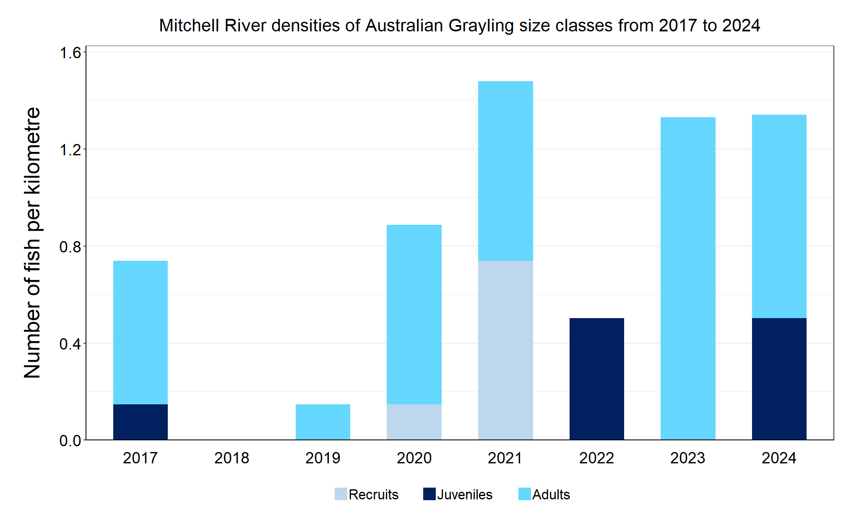

Figure 4. The densities of recruits, juveniles and adult Australian Grayling in the Mitchell River from 2017 to 2024

Figure 5. The size range percentage of Australian Grayling in the Mitchell River in 2024

We acknowledge and respect Victorian Traditional Owners as the original custodians of Victoria’s land and waters, their unique ability to care for Country and deep spiritual connection to it. We honour Elders past and present whose knowledge and wisdom has ensured the continuation of culture and traditional practices.

Logo© The State of Victoria Department of Energy, Environment and Climate Action 2024. This work is licensed under a Creative Commons Attribution 4.0 International licence. To view a copy of this licence, visit creativecommons.org/licenses/by/4.0/ ISSN 2981-9067 Online (pdf/word)