# Assessment of the 2019-2020 fires on the Southern Greater Glider and Yellow-bellied Glider in eastern Victoria

Regional Bushfire Recovery for Multiregional Species and Strategic Projects Program



 

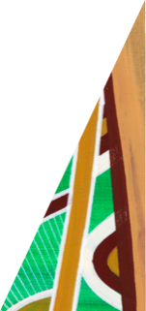

## Key Messages

* Densities of Southern Greater Gliders were lower in more severely burnt habitat
* The post-fire population estimate of Southern Greater Gliders across the 1.3 million ha fire footprint is 82,000 (95% CI 55,000-120,000)
* Relative abundances of Yellow-bellied Gliders were lowest where fire severity was highest
* Unburnt high-quality habitats have an important role as glider refugia from severe fire

June 2023

deeca.vic.gov.au

## Background

Over the 2019-2020 summer period, wildfires affected a significant proportion of south-eastern Australia, with over 9.5 million hectares burnt (Filkov *et al.* 2020).

In Victoria, 32-35% of modelled habitat for the hollow-dependent Southern Greater Glider *Petauroides volans* (herein referred to as Greater Glider) and Yellow-bellied Glider *Petaurus australis* is estimated to have been burnt (DELWP 2020). This is likely to have resulted in a reduction of critical foraging and denning habitat for these two threatened species.

## Project aims

* To estimate the abundance of the Greater Glider and Yellow-bellied Glider across the burnt area.
* To explore the relationship between abundances, pre-fire habitat suitability and 2019-2020 fire severity.

## Study area

This study focused on the 2019-2020 fire footprint in eastern Victoria (Figure 1).

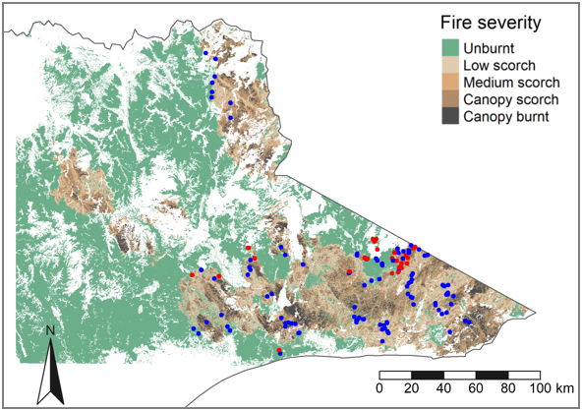

Figure 1: Study sites where Greater Gliders were detected (red dots) and not detected (blue dots) across mapped 2019-2020 fire severity.

## Site selection

Site selection and survey methods were determined by the ecology and behaviour of the Greater Glider, the main focus of this study.

A random sample of locations across the fire footprint (including from unburnt habitat within and adjacent to), was selected using stratified random sampling based on mapped fire severity from unburnt to high severity (Figure 1) and pre-fire habitat suitability for Greater Gliders (Figure 2). Suitability was determined using the model devised by Wagner *et al.* (2020).

Data from a total of 136 sites were included in our analysis: 38 from this study plus 98 from other post-fire (15 months +) studies (from ARI and concurrent work by the University of Melbourne, B. Wagner pers. comm.).

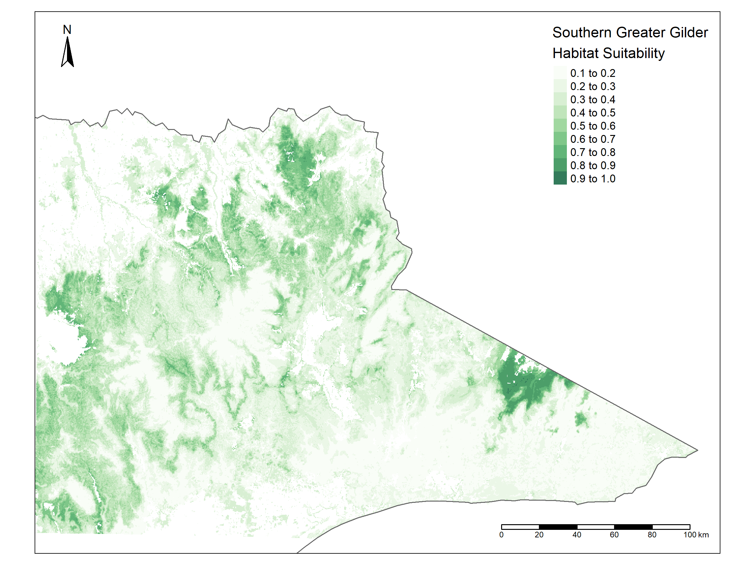

Figure 2: Southern Greater Glider habitat suitability model, grading from predicted low suitability (light green) to predicted high suitability (dark green). See Wagner et al. (2020) for details.

## Survey methods

At each site we installed a 500 m straight line transect off-track where possible. A total of 65 km of transects were surveyed between November 2021 and December 2022.

Spotlighting was conducted using a double observer, mark-recapture distance sampling method (Cripps *et al.* 2021). This enabled individual animal detection probabilities to be calculated and therefore allowed the density of Greater Gliders at the sites to be inferred.

As Yellow-bellied Gliders also occur within the study area, the opportunity was taken to collect data on this similarly affected species for little extra effort. Call playback for this species was done at 100 of the sites. In addition, all observations made (seen or heard) of Yellow-bellied Gliders during spotlighting of all sites were also recorded.

## Survey results

Greater Gliders were detected at 25% of all study sites (Figure 1, Table 1), while Yellow-bellied Gliders were found at 35% (Table 1).

Table 1: Number and proportion of sites where the two glider species were detected

| Species | No. sites detected | Proportion of sites |
| --- | --- | --- |
| Southern Greater Glider | 34 (n=136) | 25% |
| Yellow-bellied Glider | 35 (n=100) | 35% |

Both species were found in forest of all fire severity categories, including where the canopy had been severely burnt, but with higher proportional rates of occurrence in unburnt or less-severely burnt forest. This included an observation of a Southern Greater Glider feeding on post-fire epicormic growth.

## Modelling

The relationships between habitat suitability (Figure 2), fire severity (Figure 1) and the density of Greater Gliders were explored using a density surface model (Hedley and Buckland 2004). This approach was not possible for Yellow-bellied Gliders, as the available data did not provide a means of estimating the absolute density of animals in the areas around the transects. For this species we inferred the relationships between habitat suitability, fire severity and relative abundance (number detected per unit length of transect) using Generalized Additive Models. Habitat suitability was based on an existing pre-fire habitat suitability model for this species (Figure 3).

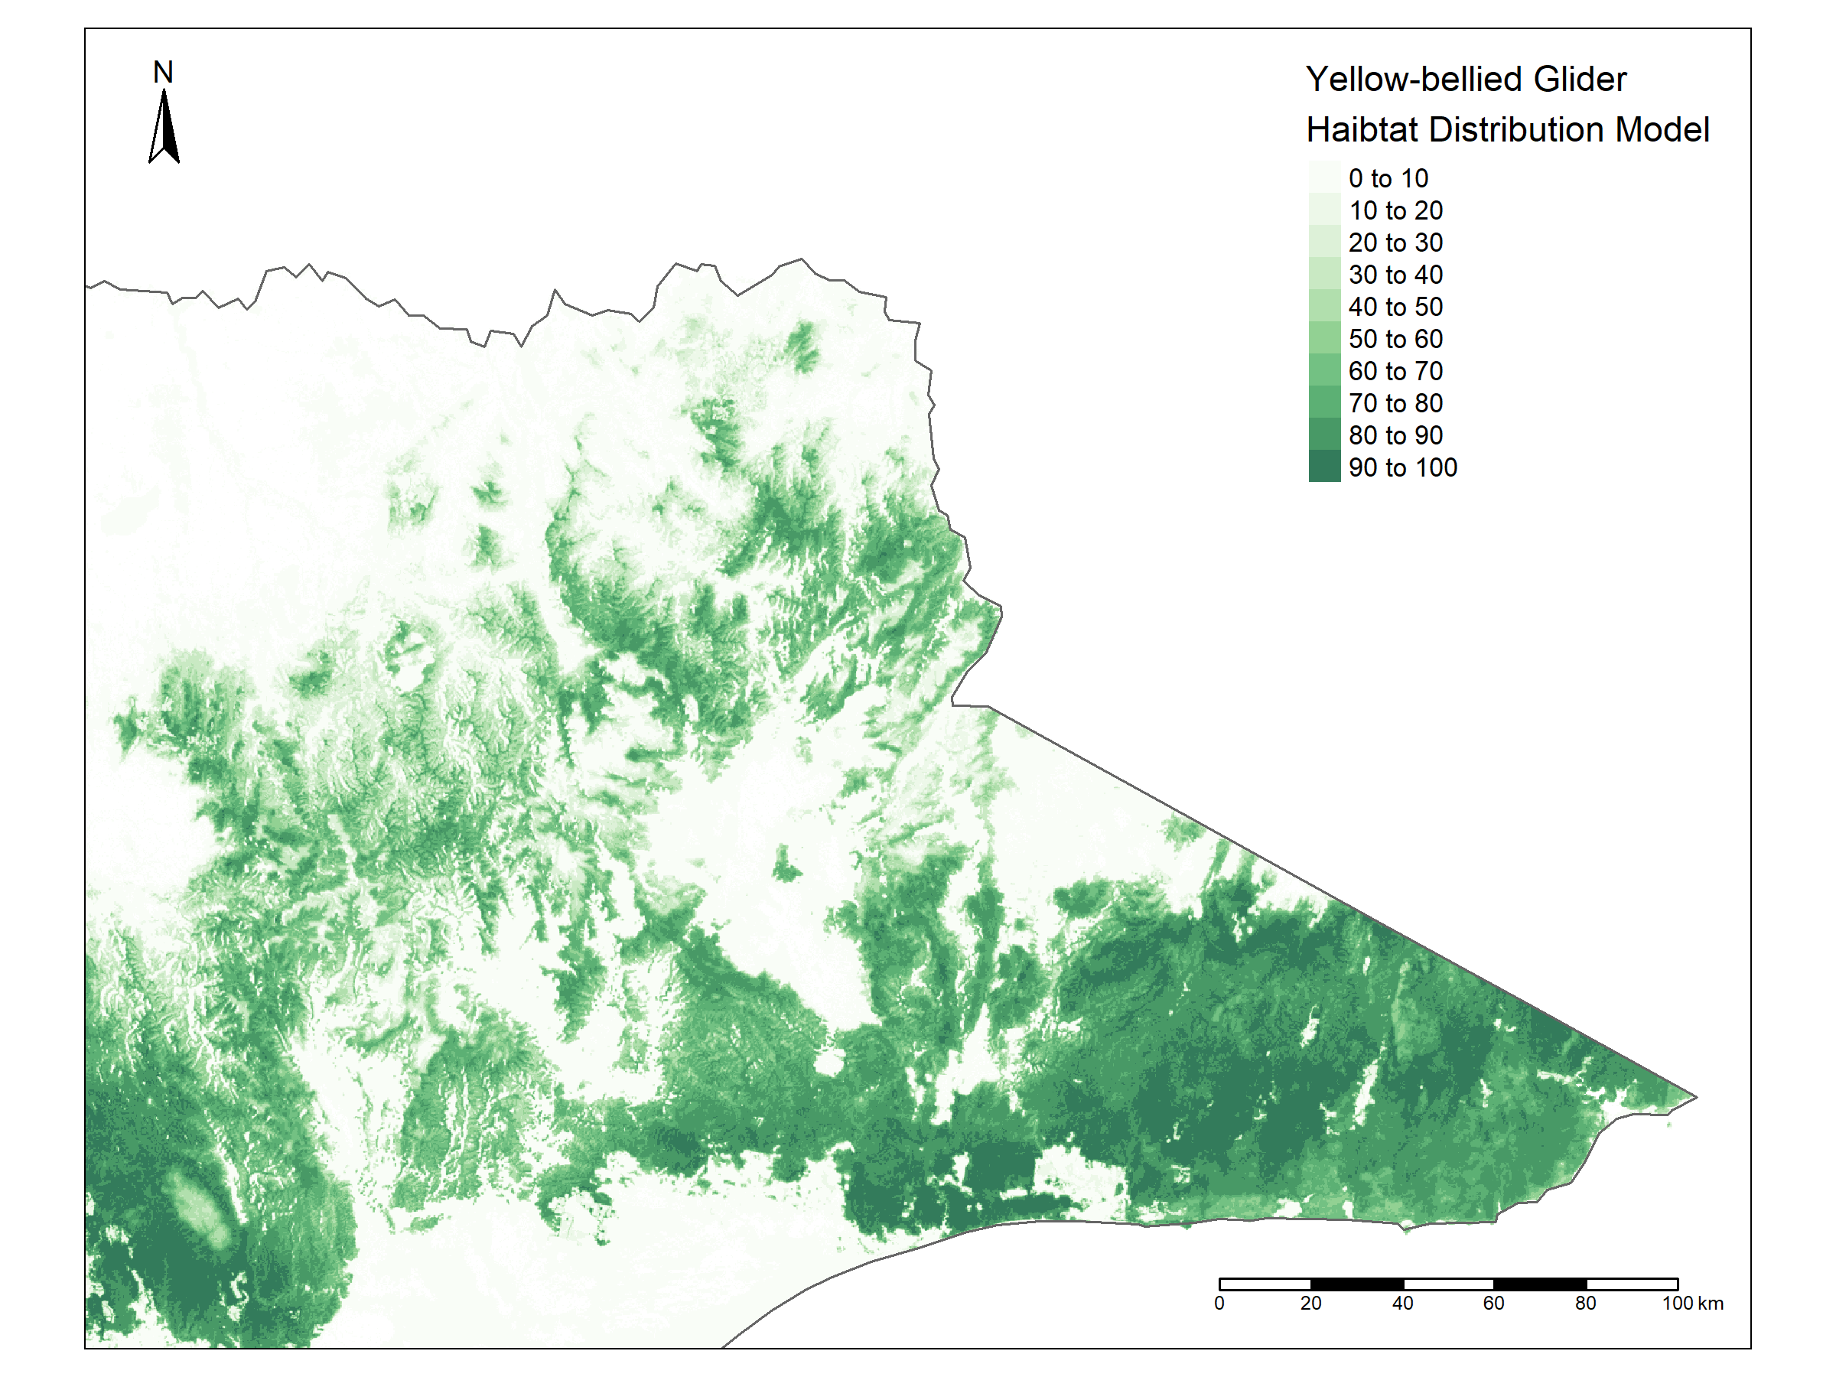

Figure 3: Yellow-bellied Glider habitat suitability model, grading from predicted low suitability (light green) to predicted high suitability (dark green).

## Response to fire severity – Greater Glider

Densities of Greater Gliders were much lower where fire severity was highest. There was also an interaction between predicted habitat suitability and fire severity: where habitat suitability was low, the proportional reduction in glider density was greater as fire severity increased, compared to where habitat suitability was high (Figure 3).

Figure 3: Modelled Greater Glider density against increasing fire severity from unburnt (2) to totally burnt (6) at three levels of habitat suitability.

The model was used to predict Greater Glider density across the burnt area (Figure 4). Predicted densities varied substantially across the fire footprint, with large areas of very low density, particularly in the south. Small areas with relatively high predicted density, particularly in the far east of the study area near the border of NSW, broadly correspond to areas with high predicted habitat suitability (see Figure 2).

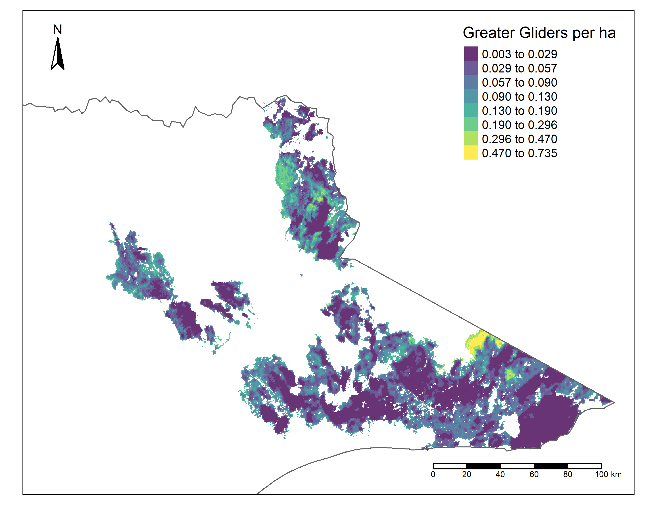

Figure 4: Predicted Greater Glider density within the fire footprint.

The predictions of the model were used to estimate the total population of Greater Gliders within the fire footprint at the time of the surveys. There were an estimated 82,000 (95% CI 56,000 – 120,000) Greater Gliders within the 1.3 million ha fire footprint.

## Response to fire severity – Yellow-bellied Glider

Yellow-bellied Gliders were similarly found to be at very low abundances where fire severity was highest, and at higher abundances where fire severity was lowest.

There were large areas of high relative abundance particularly across the south of the study area (Figure 5); in general, the predicted high and low abundances matched corresponding areas of high and low habitat suitability (see Figure 3).

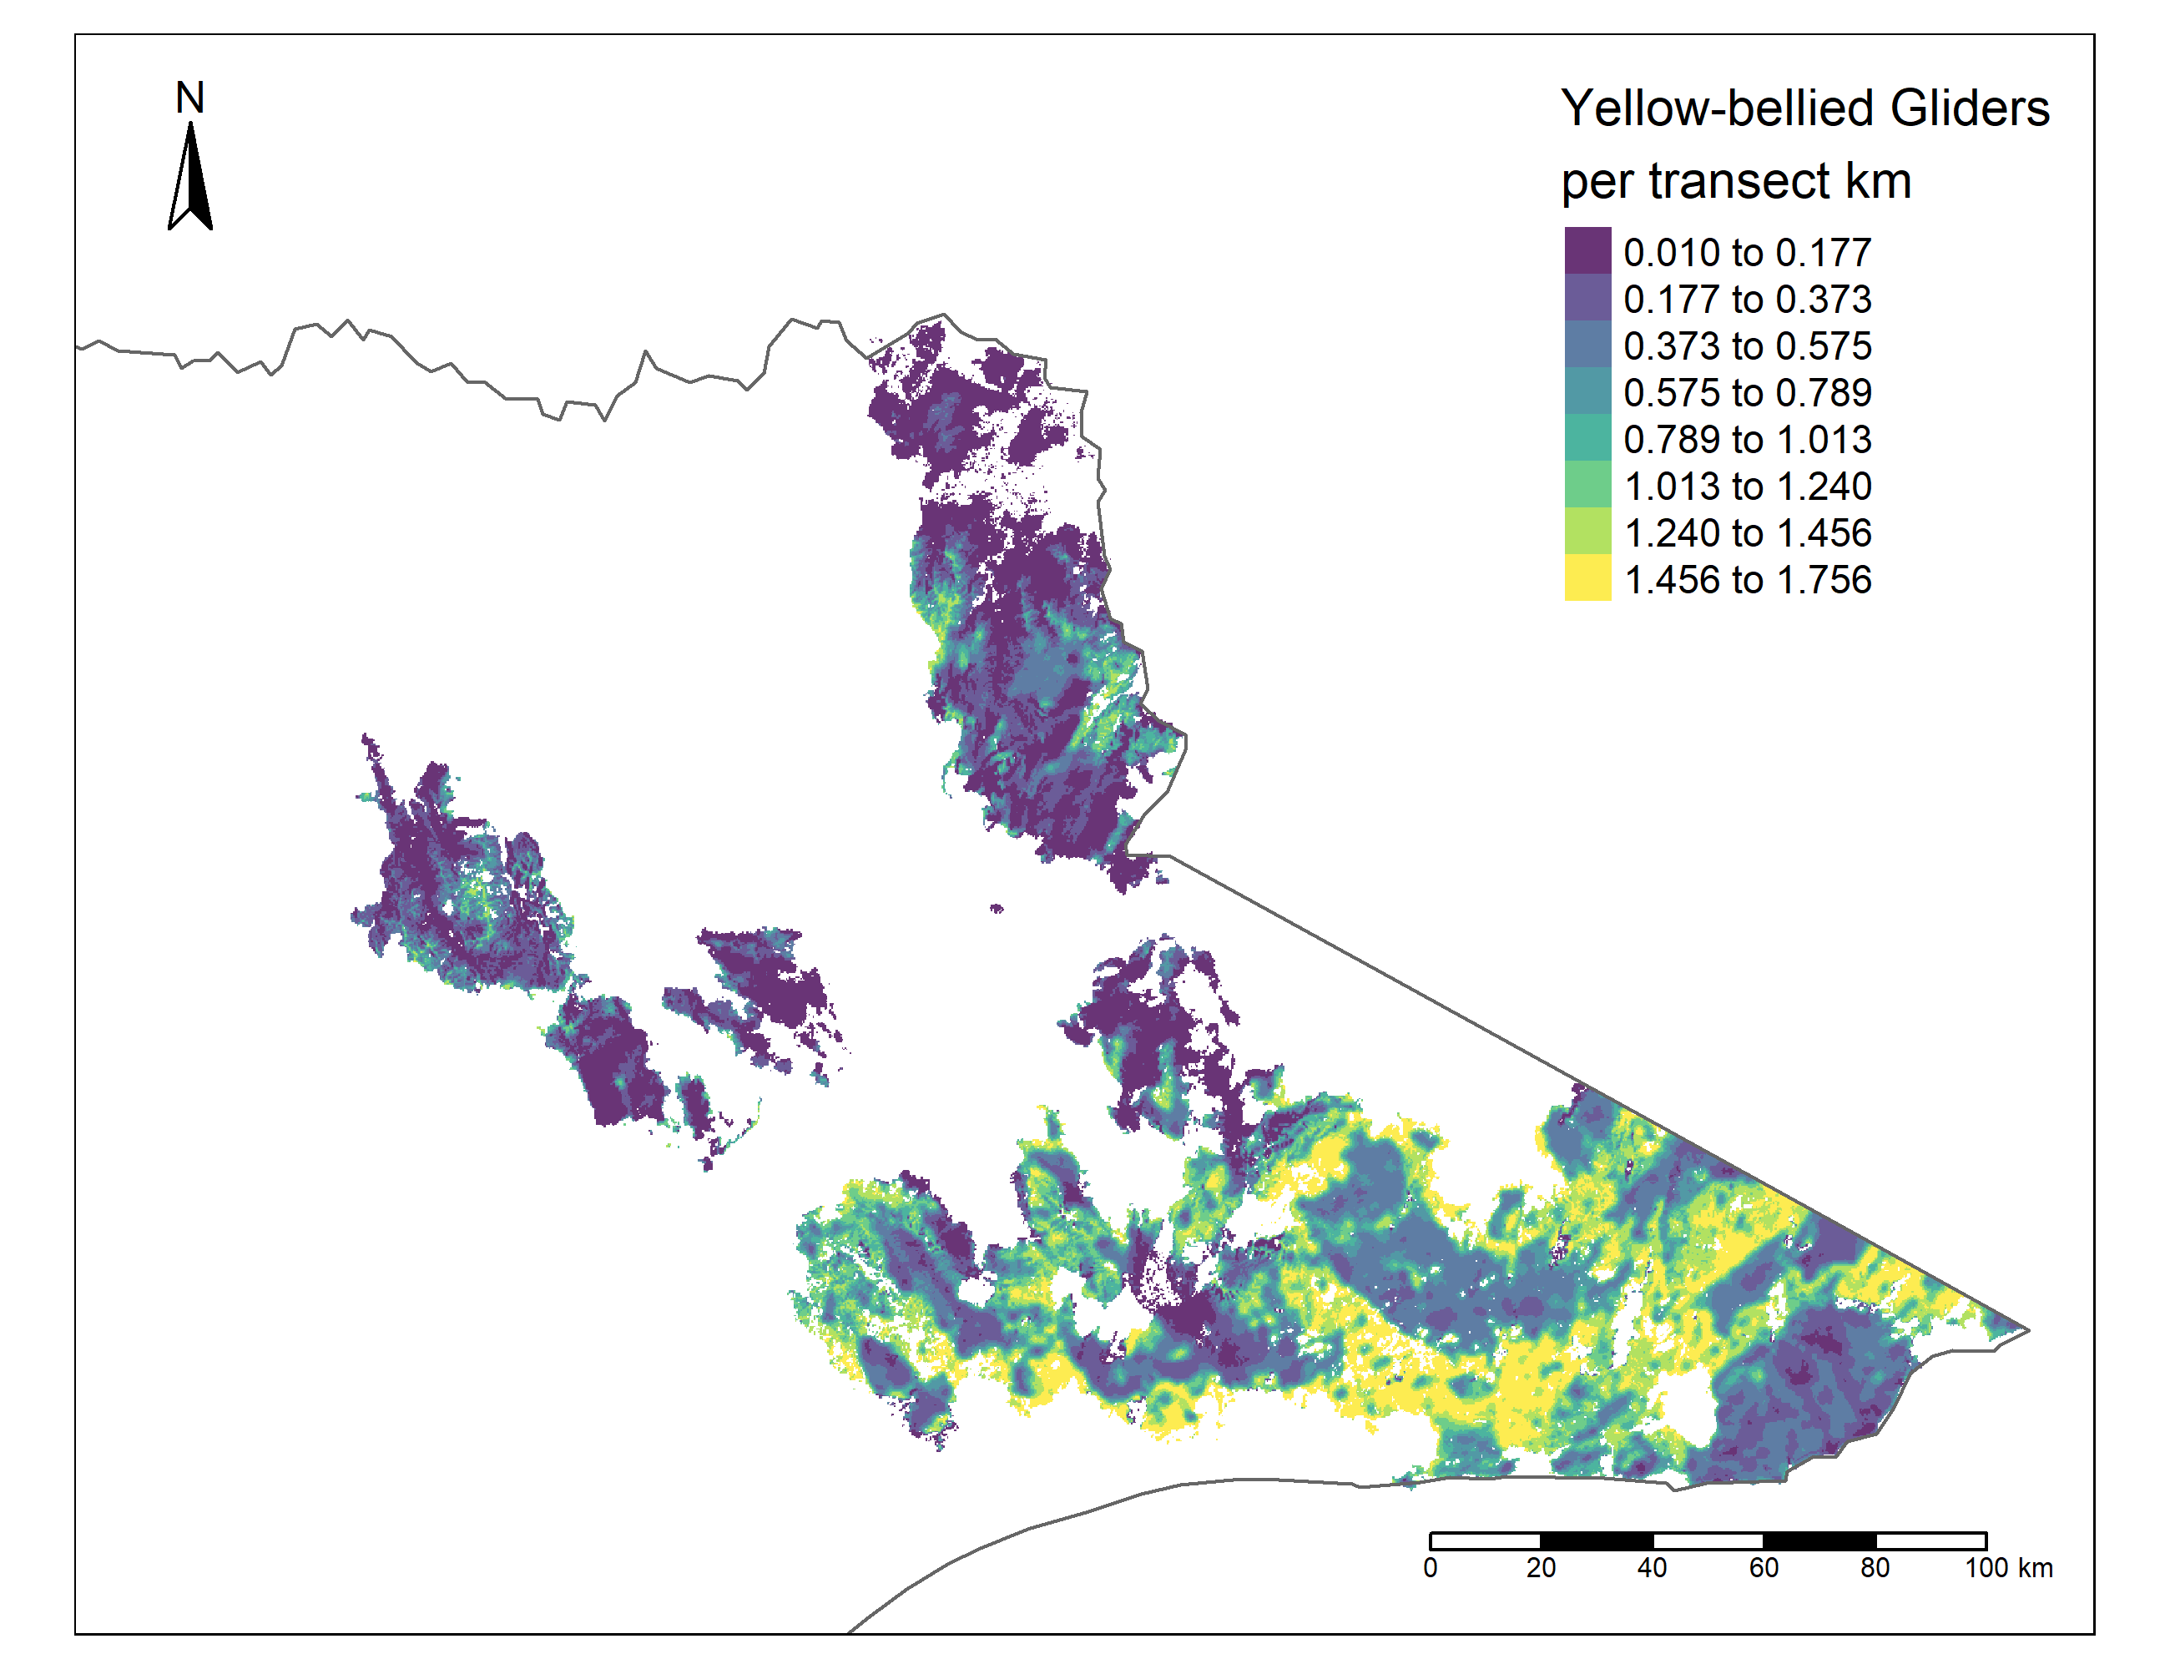

Figure 5: Predicted Yellow-bellied Glider relative abundance from spotlight surveys within the fire footprint.

## Conclusions

Our analysis of post-fire survey data shows that the 2019-2020 bushfires have likely reduced Greater Glider density, particularly in areas subjected to high-severity fire. Similar results have been shown elsewhere in the species’ range (May-Stubbles *et al.* 2022). Although there are a few areas of relatively high predicted glider density (up to 0.725 gliders per ha), the average density across the entire fire footprint is low (0.062 gliders per ha). This result stands in contrast to estimates of density obtained using identical survey methods in the Strathbogie Ranges (0.959 gliders per ha) (Cripps *et al.* 2021) which is considered a key population in Victoria.

These results identify areas of high-quality habitat which were also either unburnt or burnt at low severity. Such areas are likely to be of high importance for the persistence of Greater Glider populations in this extensively burnt landscape. These refugial areas may also provide source populations for post-fire recolonisation of burnt areas.

The impact of the fires on Yellow-bellied Glider abundance was similar, with the highest relative abundances being observed in areas with high pre-fire habitat suitability and low fire severity.

With bushfires predicted to increase in frequency and severity because of projected climate change, this study highlights the importance of unburnt high-quality habitat as refugia for threated species.

## Acknowledgements

This project received grant funding from the Australian Government, through the Regional Bushfire Recovery for Multiregional Species and Strategic Projects Program.

Arthur Rylah Institute for Environmental Research (ARI) project team: Jemma Cripps, Michael Scroggie, Phoebe Macak, Louise Durkin, Jenny Nelson, Amanda Bush, Tom Schneider. Additional field work by Wildlife Unlimited.

University of Melbourne collaborators: Ben Wagner and Craig Nitschke (developed the Southern Greater Glider habitat suitability model and provided additional survey data).

Fire severity mapping supplied by the Department of Energy, Environment and Climate Action. Yellow-bellied Glider habitat distribution model developed by Graeme Newell and Matt White (ARI).

Accessibility

If you would like to receive this publication in an alternative format, please telephone the DEECA Customer Service Centre on 136186, email [customer.service@delwp.vic.gov.au](mailto:customer.service@delwp.vic.gov.au), or via the National Relay Service on 133 677 [www.relayservice.com.au](http://www.relayservice.com.au).

© The State of Victoria Department of Energy, Environment and Climate Action June 2023

Logo

This work is licensed under a Creative Commons Attribution 4.0 International

licence. To view a copy of this licence, visit

creative commons.org/licenses/by/4.0/



We acknowledge Victorian Traditional Owners and their Elders past and present as the original custodians of Victoria’s land and waters and commit to genuinely partnering with them and Victoria’s Aboriginal community to progress their aspirations.

ISBN 978-1-76136-829-5 (pdf)

## References

Cripps, J.K., Nelson, J.L., Scroggie, M.P, Durkin, L.K., Ramsey, D.S.L. and Lumsden, L. (2021). Double-observer distance sampling improves the accuracy of density estimates for a threatened arboreal mammal. *Wildlife Research* **48**(6): 756-768.

DELWP (2020). Victoria’s bushfire emergency: biodiversity response and recovery. Version 2. Department of Environment, Land, Water and Planning, East Melbourne, Victoria.

Filkov, A.I., Ngo, T., Mathews, S., Tefler, S. and Penman, T.D. (2020). Impact of Australia’s catastrophic 2019/20 bushfire season on communities and environment. Retrospective analysis and current trends. *Journal of Safety Science and Resilience* **1**(1): 44-56.

Hedley, S.L. and Buckland, S.T. (2004). Spatial models for line transect sampling. *Journal of Agricultural, Biological, and Environmental Statistics* **9**: 181-199.

May-Stubbles, J.C., Gracanin, A, and Mikac, K.M. (2022). Increasing fire severity negatively affects greater glider density. *Wildlife Research* **49**(8): 709-718.

Wagner, B., Baker, S.B., Lumsden, L.F., Nelson, J.L., Cripps. J.K., Durkin, L.K., Scroggie, M.P. and Nitschke, C.R. (2020). Climate change drives habitat contraction of a nocturnal arboreal marsupial at its physiological limits. *Ecosphere* **11**(10): e03262.

**For further information contact Phoebe Macak (phoebe.macak@deeca.vic.gov.au)**

Banner Photo: severely burnt forest in eastern Victoria [Jemma Cripps], Southern Greater Glider [Justin Cally]