***ARI Aquatic Quarterly Update – Influence***  ***Autumn 2024***

**About Us**

The Applied Aquatic Ecology section aims to generate and share knowledge, through world-class, applied, ecological research. This research supports and guides sustainable ecosystem policy and management to ensure healthy, resilient ecosystems. We work collaboratively with national, state and local agencies, research institutes, universities, interest groups and the community.

**Our focus:**

* To undertake high quality, relevant ecological research.
* To interpret research outcomes and communicate these effectively to key stakeholders.
* To guide and support sustainable ecosystem policy and management.

**This update provides three examples of projects which help managers.**

They provide:

* Valuable insights into waterbird breeding and demonstration of the ecological value of environmental water.
* An assessment of the adaptability of herbaceous riparian plants to different soil moisture levels, showing how impacts of reduced natural flow variability can affect plant growth and survival.
* Demonstration of catchment-scale benefits to Common Galaxias through the installation of a fishway.

[www.ari.vic.gov.au](http://www.ari.vic.gov.au) Subscribe to any of ARI’s communications at [www.tiny.cc/ARIsubscribe](http://www.tiny.cc/ARIsubscribe)

***Monitoring highlights significant breeding of waterbirds***

**Issue:** Wetlands are declining worldwide and a key management approach to maintain and rehabilitate wetland ecology is by returning water to rivers and wetlands, including through providing environmental water. Monitoring the ecological responses of birds to watering events, including environmental watering, helps demonstrate outcomes of this management action and inform operational and strategic watering decisions.

**Action**: During summer-autumn 2023 waterbirds were surveyed at 30 wetlands across four catchment management authority (CMA) regions. Data collected from waterbird surveys at an additional four wetlands was also assessed. These wetlands were mostly inundated via a major flood event, including 15 that have previously received environmental water; 17 that have not received environmental water; and two wastewater treatment plants to provide regional context for waterbird numbers and assess patterns of seasonality. Surveys involved waterbird counts, documentation of breeding activity and estimation of the extent of different structural habitat types.

**Results:** A total of 58,803 waterbirds of 62 species were recorded across all surveys. This included one species nationally threatened under the EPBC Act 1999 and 12 species threatened in Victoria under the FFG Act 1988. The most striking result was the extent of waterbird breeding, especially by dispersed nesting species with precocial* young (ducks, swans, grebes and coots). This far exceeded the amount of breeding recorded during previous surveys in 2016–2020. This result demonstrates that inundation conditions in the landscape around wetlands, and not just the conditions at wetlands themselves, likely play a role in determining whether a wide range of waterbird species breed at these sites.

**Outcome:** This monitoring has provided valuable insights into waterbird breeding which supports wetland managers in making well informed decisions on water management. A priority for management of environmental water in the short term could be supporting recruitment of young from last year’s breeding event. This may be best achieved by prioritising continued inundation at a few key wetlands that can support the greatest numbers and diversity of waterbirds, such as Lake Cullen, rather than those where most breeding occurred in 2023.

**Next steps** Monitoring of waterbirds at wetlands is continuing in spring-summer 2023-2024, which will contribute further to our understanding of waterbird breeding, seasonality, abundance, movement patterns and habitat requirements at Victorian wetlands, particularly in relation to environmental watering and natural flooding.

**Funder:** This work was part of the Wetland Monitoring and Assessment Program for environmental water ([WetMAP](https://www.ari.vic.gov.au/research/wetlands-and-floodplains/assessing-wetland-response-to-water-for-the-environment)), funded by DEECA Water and Catchments.

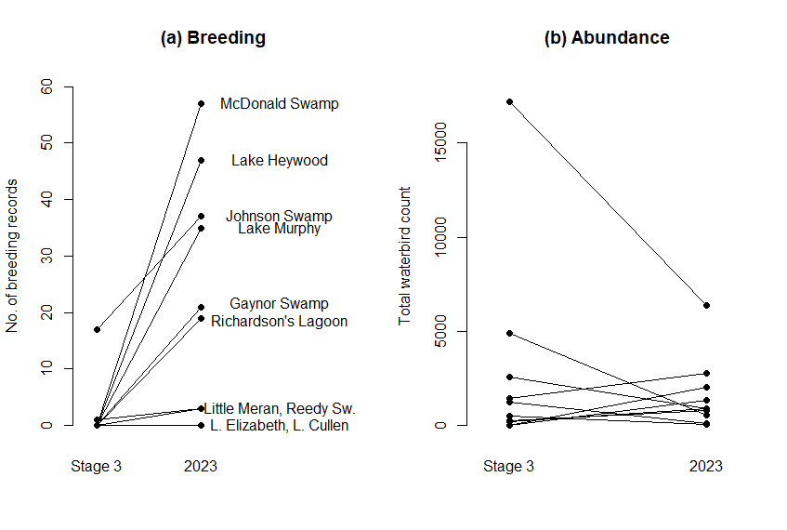**ARI contact:** DrNyil Khwaja \**hatched or born in an advanced state and able to feed and* move independently *almost immediately.*

Figure 1. Comparison of (a) waterbird breeding activity and (b) waterbird counts between the 2023 surveys and matched surveys from WetMAP Stage 3 (2016–2020).

***The influence of soil moisture on riparian plant roots along regulated rivers***

**Issue:** River ecosystems of regulated rivers are threatened by water extraction and flow regime alteration in the context of climate change and increasing human populations. The root systems of riparian plants on regulated rivers may suffer from lower soil moisture due to lack of natural flow variability.

**Action**: Data was collected from the highly regulated Campaspe River system to assess how soil moisture influences the root system of a herbaceous riparian plant, Hollow Rush (*Juncus amabilis)*. Plants were dug out along a soil moisture gradient, with root depth, belowground space occupation, root mass fraction and mean fractal dimension used to evaluate root structural dynamics in relation to bank position and soil moisture.

**Results:** It was found that reduced soil moisture at higher bank elevations changes the root architecture rather than the root biomass relative to shoot biomass of *J. amabilis*, with plants tending to root deeper, occupy more belowground space at low root density and exhibit reduced root branching. This means that plant roots spread out to find water but could not increase plant biomass without elevated flows to provide more soil moisture.

**Outcome:** These findings indicate how lower soil moisture levels and reduced river flows at higher bank elevations impact riparian plant growth in regulated waterways. Rainfall is insufficient to support many riparian plants in these systems, so invasion by terrestrial plants is common and detrimental to riparian ecosystem condition. Releasing environmental flows in spring and briefly in summer provides water resources to deeper parts of the root systems, and for longer, than rainfall and are important for sustaining riparian plants through their peak growth periods. Drier systems or years with lower rainfall will be sensitive to timing and duration of flows that provide soil moisture and riparian communities will contract to narrow bands at the water margin without elevated environmental flows to promote herbaceous riparian plant recruitment, health, and function in regulated rivers.

**Next steps:** This work provides quantitative published data to use for environmental water management and planning, where there are flow management objectives to provide water resources to support riparian vegetation, as outlined in documents such as FLOWs studies and Environmental Water Management Plans. It also provides increased rigor to support flow recommendations in rivers.

**Funder:** This work was part of the Victorian Environmental Flows Monitoring and Assessment Program ([VEFMAP](https://www.ari.vic.gov.au/research/rivers-and-estuaries/assessing-benefits-of-water-for-the-environment)), funded by DEECA Water and Catchments.

**ARI contact:** Dr Chris Jones

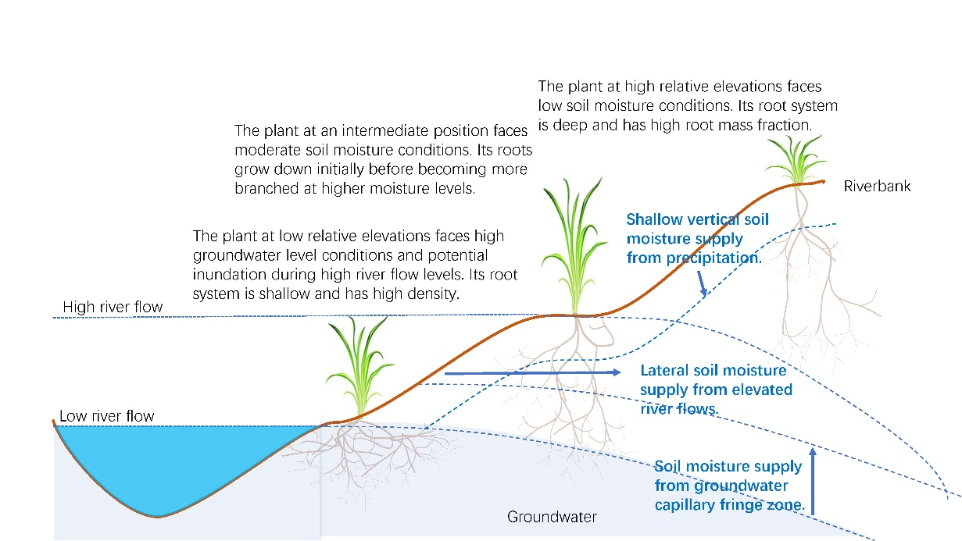[Deng et al.](https://link.springer.com/article/10.1007/s11258-023-01373-7) (2024) Soil moisture influences the root characteristics of a herbaceous riparian plant along a regulated river. Plant Ecology.

Figure 2. An illustration of a riverbank cross section indicating the potential relationships between river flow, groundwater, rainfall precipitation and the root system characteristics of a herbaceous riparian plant.

***Fishways provide catchment-scale improvements to fish in the Yarra River catchment***

**Issue:** The occurrence of instream barriers is a major threat to riverine fish populations, with a common remediation technique being fishway construction. Demonstrating the effectiveness of this technique on affected fish populations is required to rationalise or improve management practices. Determination of the catchment-scale impacts to fish populations following fishway construction (rather than only measuring if fish are using the fishway) has not been studied in-depth in Australia. This leaves a knowledge gap regarding the long-term ecological benefits of fishways.

**Action:** This work investigated the catchment-scale impacts of the installation of two fishways at the Dights Falls weir in the Yarra River on the diadromous Common Galaxias (*Galaxias maculatus*)population using a before-after-control-impact (BACI) monitoring design. From 2012 - 2017 (excluding 2016) sampling was conducted in March and April at 20 sites located upstream of the barrier and four unaffected by the barrier (control). The 2012 sampling was undertaken before either fishway was installed, providing important pre-construction fish population data.

**Results:** It was found that there were catchment-scale improvements to Common Galaxias upstream of the barrier, with an increase in relative abundance and shift in size structure resulting from the installation of the two fishways. By 2017, there was an increase in the relative abundance of Common Galaxias in all five geographic areas of the study (as far as 90 km upstream of the new fishways) with mean catches increasing by 7.6 - 28.1 times the values observed in 2012 (prior to the instalment of the fishways). This included a shift to higher proportions of small fish upstream of the fishway complex, demonstrating the continued passage of small individuals through Austral spring and summer and resembling the distribution observed at control sites.

**Outcome:** This study demonstrates the benefits of the installation of fishways to fish communities at a catchment-scale. It also provides further evidence of the effectiveness of installing fishways as a management tool to mitigate the effects of instream barriers. It highlights the importance of not limiting surveys to just post fishway construction. Pre-construction data, both upstream and downstream, is crucial in gaining an understanding of the catchment-scale ecological benefits of fishways; and is often overlooked during the fishway conception planning phase.

**Funder:** Melbourne Water

**ARI contact:** Frank Amtstaetter

[Amtstaetter et al](https://www.tandfonline.com/doi/full/10.1080/00288330.2023.2287200). (2023) Fishways provide catchment-scale improvements to Common galaxias (*Galaxias maculatus*) upstream of a barrier in south-eastern Australia. New Zealand Journal of Marine and Freshwater Research.

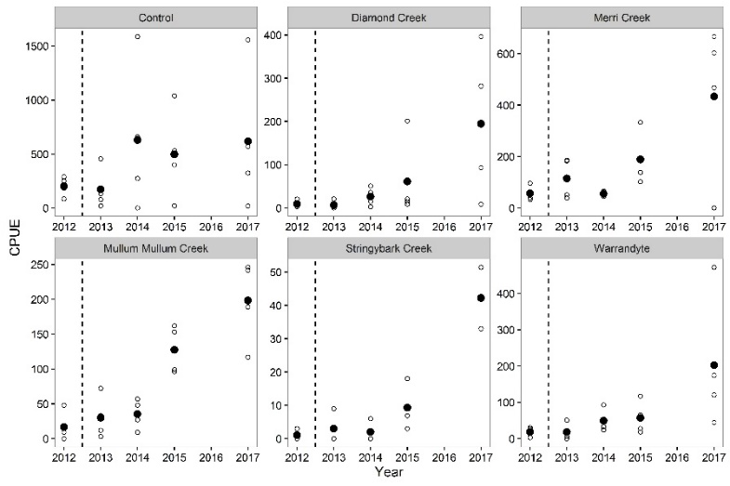

Figure 3. Mean catch-per-unit-effort (fish per hour; solid circles) of Common galaxias captured in geographic areas of the Yarra River upstream of Dights Falls and at control sites, 2012-2017. Data from 2012 represent pre-treatment results. Open circles represent the data for each site.

Logo© The State of Victoria Department of Energy, Environment and Climate Action This work is licensed under a Creative Commons Attribution 4.0 International licence. To view a copy of this licence, visit [http://creativecommons.org/licenses/by/4.0/](http://creativecommons.org/licenses/by/3.0/au/deed.en) ISSN 2653-8334 Online (pdf/word)