




Measuring Plant Populations in Victoria
A manual for estimating threatened plant population size in the field

A. Muir, M. Kohout, T. McLaren and M. White
November 2024

Arthur Rylah Institute for Environmental Research: Technical Report Series No. 375
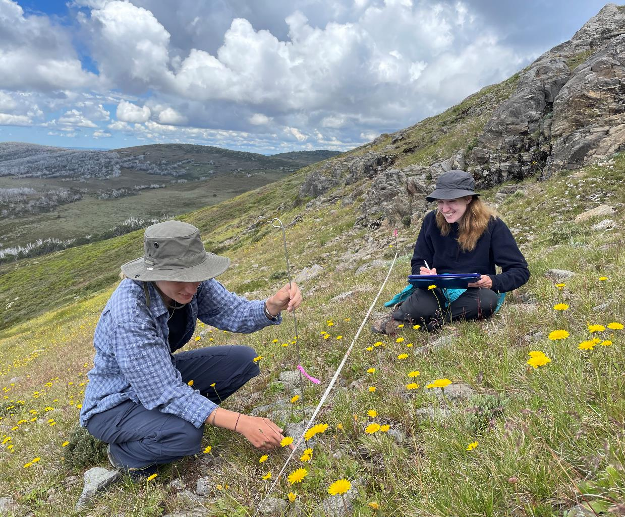




Insert your own photo here just by deleting this photo and pasting yours here and then moving into place by clicking on the layout option then set as ‘In front of text’. If the ribbon at the right doesn’t show up, right click on the photo and then ‘Send to Back’
Arthur Rylah Institute for Environmental Research
Department of Energy, Environment and Climate Action
PO Box 137, Heidelberg, Victoria 3084
Phone (03) 9450 8600
Website: www.ari.vic.gov.au
Citation: Muir, A., Kohout, M., McLaren, T. and White, M. (2024). Measuring plant populations in Victoria – a manual for estimating threatened plant population size in the field. Arthur Rylah Institute for Environmental Research Technical Report Series No. 375. Department of Energy, Environment and Climate Action, Heidelberg, Victoria.
Front cover photo: Monitoring snowpatch herbfields at Mt Nelse for long term changes (John Morgan).
ISBN 978-1-76136-590-4 (pdf/online/MS word)


We acknowledge and respect Victorian Traditional Owners as the original custodians of Victoria’s land and waters, their unique ability to care for Country and deep spiritual connection to it.
We honour Elders past and present whose knowledge and wisdom
has ensured the continuation of culture and traditional practices.
DEECA is committed to genuinely partnering with Victorian Traditional Owners and Victoria’s Aboriginal community to progress their aspirations.
© The State of Victoria Department of Energy, Environment and Climate Action. February 2024.
Creative Commons
This work is licensed under a Creative Commons Attribution 4.0 International licence, visit the Creative Commons website (http://creativecommons.org/licenses/by/4.0/).
You are free to re-use the work under that licence, on the condition that you credit the State of Victoria as author. The licence does not apply to any images, photographs or branding, including the Victorian Coat of Arms, and the Victorian Government, the Department and the ARI logos.
Disclaimer
This publication may be of assistance to you but the State of Victoria and its employees do not guarantee that the publication is without flaw of any kind or is wholly appropriate for your particular purposes and therefore disclaims all liability for any error, loss or other consequence which may arise from you relying on any information in this publication.
Accessibility
To receive this document in an alternative format, phone the Customer Service Centre on 136 186, email customer.service@delwp.vic.gov.au, or contact National Relay Service on 133 677. Available at DEECA website (www.deeca.vic.gov.au).

Measuring plant populations in Victoria

A manual for estimating threatened plant population size in the field

Annette Muir, Michele Kohout, Tess McLaren and Matt White

Arthur Rylah Institute for Environmental Research
Department of Energy, Environment and Climate Action
123 Brown Street, Heidelberg, Victoria 3084

Date

Arthur Rylah Institute for Environmental Research
Technical Report Series No. 375

Acknowledgements
This project was instigated and guided by Adrian Moorrees (formerly DEECA).
We are grateful to Fiona Sutton, Rob Dabal, Claire Moxham, Andrew Geschke (Arthur Rylah Institute), Marty Lockett (Parks Victoria) and Warren Tomlinson (Nillumbik Council) for their helpful inputs to the contents of this report.
Our thanks to the many people who attended an online workshop in May 2023, which formed the framework for this manual.
Photo credits: all photos taken by Michele Kohout and Annette Muir, unless otherwise indicated.

Contents
Acknowledgements ii
1 Introduction 7
1.1 What is monitoring? 7
1.2 What is the purpose of this manual and who is it for? 8
1.3 How to use this manual 8
2 Gather information 9
2.1 Conservation status of the target species 9
2.1.1 National 9
2.1.2 Victorian 9
2.1.3 Local 9
2.2 Population locations for the species 9
2.2.1 Plant databases 10
2.2.2 Recovery Plans and Action Statements 10
2.2.3 Knowledgeable people 10
2.2.4 Site inspections 11
2.3 Life-cycle information about the species 11
2.3.1 Life form 11
2.3.2 Reproductive strategy 13
2.3.3 Age-classes and longevity 13
2.4 Threats to the species 14
3 Choose monitoring methods 15
3.1 What to monitor 15
3.1.1 Resources – funding and expertise 15
3.1.2 Plant populations 16
3.2 Sub-sampling populations 16
3.2.1 Representative sample of a population 16
3.2.2 Sampling patterns 17
3.3 Measurement methods 17
3.3.1 Clonal and non-clonal plants 17
3.3.2 Units of measurement 18
3.3.3 Population size estimates 18
3.3.4 Complete Count 18
3.3.5 Density 19
3.3.6 Frequency 19
3.3.7 Cover 19
3.4 Plot shapes, sizes and numbers 20
3.4.1 Plot shape 20
3.4.2 Plot size 20
3.4.3 Plot numbers 21
3.5 Life stage monitoring 21
3.5.1 Life stage estimates 21
3.5.2 Marking and monitoring individual plants 21
3.5.3 Tree canopy health 21
3.6 Timing 21
3.6.1 Time-series data 21
3.6.2 Monitoring frequency 22
3.6.3 General guidelines 22
4 Collect data 23
4.1 Field planning 23
4.1.1 Who will do the monitoring 23
4.1.2 Access to sites and permits 23
4.1.3 Site marking 23
4.2 Field equipment 24
4.2.1 Marking plots and measuring plants 24
4.2.2 Preventing spread of diseases and weeds 24
4.3 Field survey datasheets 25
4.3.1 Mandatory data fields 25
4.3.2 Recommended data fields 25
4.4 Setting up and marking plots 25
4.4.1 Marking survey boundaries 25
4.4.2 Marking plants 26
4.5 Photo-points 27
4.5.1 General guidelines 27
4.6 Complete population counts 28
4.7 Density 28
4.8 Frequency 29
4.9 Cover 29
4.9.1 Plant cover in plots 29
4.9.2 Line intercepts 30
4.9.3 Point intercepts 30
4.10 Life stage measurements 31
4.10.1 Life-stage estimations 31
4.10.2 Demographic study 31
5 Data management 32
32
5.1 Data collection and metadata 32
5.1.1 Excel worksheets 32
5.2 Databases 32
5.2.1 Victorian Biodiversity Atlas 32
5.2.1 Threatened Species Index 32
5.3 Re-evaluate monitoring purpose 33
5.3.1 Data summaries 33
5.3.2 Communicating results 33
Glossary 34
References 35
Appendices 37
Appendix 1: Monitoring practitioners’ workshop 37
Appendix 2: Measurement methods – advantages and disadvantages 38
Appendix 3: Research permits 39
Appendix 4: Example datasheet 40

Tables
Table 1. Monitoring methods – expertise and time needed. 15
Table 2. Plant life-form characteristics and suitable monitoring methods. 18
Table 3. Plot sizes by life-form and measurement type. 21

Figures
Figure 1. (a) Ongoing monitoring of threatened plant populations in grasslands; (b) once-off assessment of threatened rainforest plants after bushfires. 7
Figure 2. The entire distributions of two species: (a) a widespread but sparsely occurring threatened species – Buff Hazelwood; (b) a highly localised threatened species – Enfield Grevillea. 10
Figure 3. Examples of different life-forms: (a) tree – Snow Gum; (b) tall shrub – Pomaderris; (c) small shrub – Handsome Flat-pea; (d) forb – Hoary Sunray, (e) grass – Spear-grass; (f) graminoid – Tufted Lily, (g) fern – Hard Water-fern; (h) geophyte – Tiger-orchid; (i) scrambler – Native Clematis. 12
Figure 4. (a) A plant that germinates from seed after fire (obligate seeder) – Hairpin Banksia; (b) a plant that resprouts after fire (resprouter) – Betka Bottlebrush. 13
Figure 5. Juvenile, mature and senescent life-stages. 13
Figure 6. (a) Weed invasion effects on threatened grasslands; (b) effects of grazing exclusion on native vegetation. 14
Figure 7. Example of sub-sampling a plant population – several plots located within one site 16
Figure 8. (a) non-clonal plants which have germinated from seed (Clustered Poranthera - Poranthera corymbosa and Saw Banksia – Banksia serrata); (b) clonal plants joined by underground rhizomes (Tasman Flax-lily – Dianella tasmanica and Star Plantain – Plantago glacialis). 17
Figure 9. Visual estimate of percentage foliage cover 19
Figure 10. Two cover estimate methods: (a) subplot and (b) point intercept. 20
Figure 11. Hygiene kit for preventing the spread of Phytophthora. 24
Figure 12. (a) Setting up a plot using a compass to determine direction of 20 m tape measure; (b) recording latitude and longitude of plot corner with a GPS. 25
Figure 13. Locating individual plants using two tape measures, then recording X-Y coordinates. 26
Figure 14. (a) Pins with flagging tape to temporarily mark plants; (b) numbered metal discs to permanently mark plants. 26
Figure 15. Sequence of photo-points over several years before and after a fire. 27
Figure 16. Example plot set up for a complete population count. 28
Figure 17. Example plots set up for density counts. 28
Figure 18. Example plots and transects set up for frequency measurements. 29
Figure 19. Example plots set up for cover measurements. 29
Figure 20. Example transect set up for line intercept measurements. 30
Figure 21. Example transect set up for point intercept measurements. 30
Figure 22. (a) Seedling life-stage; and (b) mature life-stage (seed pods) of Enfield Grevillea (Grevillea bedggoodiana). 31
Figure 23. Example of a column chart, showing change in population density of a species following fire. 33

- Introduction
This manual provides standardised, repeatable methods for basic plant monitoring in the field. Following these methods can ensure our plant monitoring data are consistent and sharable.
It is designed for citizen scientists and non-specialists but is still applicable to anyone with capacity to collect plant monitoring data useful for biodiversity conservation.
For more information, visit https://www.ari.vic.gov.au/research/field-techniques-and-monitoring/plant-monitoring-manual

1.1 What is monitoring?
To protect plants and ecosystems that are important to us, we need to understand them. Monitoring is an essential tool for increasing this understanding. Monitoring can tell us what plant species are present and how many there are within a defined area. It can range from one-off population snapshots to repeated assessments that measure change over time, as well as responses to management interventions (Figure 1).
A great deal of effort goes into monitoring threatened plants, and we want to know that our hard work generates meaningful results for conservation. Consistent and repeatable methods are important to ensure that data are comparable over time and can be shared with others. Monitoring data provides critical information for both Victorian and national databases, which decision makers routinely refer to for land management and biodiversity protection decisions.

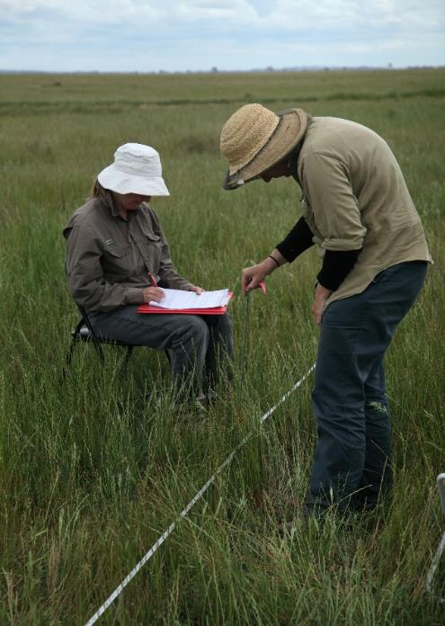
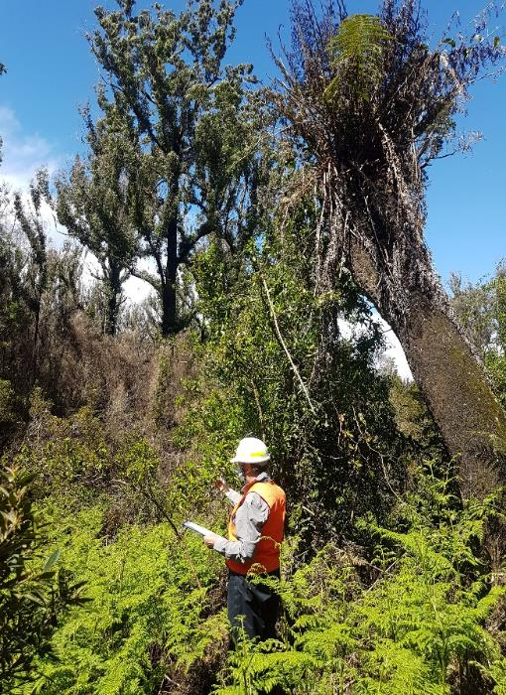
b.
a.
Figure 1. (a) Ongoing monitoring of threatened plant populations in grasslands; (b) once-off assessment of threatened rainforest plants after bushfires.

1.2 What is the purpose of this manual and who is it for?
This manual provides a standard for plant monitoring methods to produce consistent data, suitable for both professional and citizen scientists. It draws heavily on more comprehensive guidelines on plant monitoring (Elzinga et al. 1998, Barker 2001, Duncan and Coates 2006 in the References). It has also been informed by participants from Victorian government, non-government and volunteer organisations who attended an online workshop in 2023 (Appendix 1).
The manual will help you in choosing appropriate methods for assessing plant populations in different scenarios. Its scope is largely restricted to assessing the numbers and extent of plant populations and assessing change in a population through time.
Descriptions are not included of more complex monitoring methods that require statistical analysis for evaluation of the impacts of management actions or disturbance events, or detailed plant life-stage monitoring. These can be found in reports and online sources listed in the References at the end of this manual. A glossary of terms used in the manual is also found there.

1.3 How to use this manual
The following steps will guide you through the manual.





STEP 1: Gather Species Information
STEP 2: Choose Monitoring Methods
STEP 3: Collect Field Data
STEP 4: Manage and Share Data

- Gather information
The first step in developing a monitoring program is to assemble information about your target plant species. This will identify the important knowledge gaps that may affect its persistence and management. Understanding its distribution, abundance, habitat, life cycle and threats will help decide on suitable monitoring methods. Documenting this information will be useful to pass on to others who continue the monitoring.

2.1 Conservation status of the target species
The conservation status of the species can help determine the threats relevant to monitoring the target species. Threatened plants are recognised under various legislation at State and National levels.
In Victoria, the most relevant are:
- Environment Protection and Biodiversity Conservation Act 1999 (EPBC Act). https://www.dcceew.gov.au/environment/biodiversity/threatened/species
- Flora and Fauna Guarantee Act 1988 (FFG Act). https://www.environment.vic.gov.au/conserving-threatened-species/threatened-list

2.1.1 National
At the National level, each EPBC listed species has an entry in the Species Profile and Threats Database (SPRAT). This includes information on the species biology, ecology, distribution and conservation advice. https://www.environment.gov.au/cgi-bin/sprat/public/sprat.pl

2.1.2 Victorian
Many threatened species in Victoria are not on the EPBC Act list, but are listed under the FFG Act.
Some of these have Action Statements. https://www.environment.vic.gov.au/conserving-threatened-species/action-statements
Many species will have spatial models of their likely occurrence in NatureKit (go to ‘I want to’ then ‘Add habitat maps’). https://www.environment.vic.gov.au/biodiversity/naturekit

2.1.3 Local
Locally or regionally important species, which are not listed as threatened under state or national legislation, can also be targets for monitoring. Reasons may include:
- population decline at a local or regional level
- impacts on species by current or proposed management regimes (grazing, fire, flood etc.)
- importance as a food or habitat resource for threatened fauna
- cultural importance for Traditional Custodians.

2.2 Population locations for the species
Victorian threatened plant species may occur at a single location or at multiple locations and potentially across multiple states. Examples are shown in Figure 2. Monitoring of threatened or locally significant species should focus on the most important populations, according to size or threats.

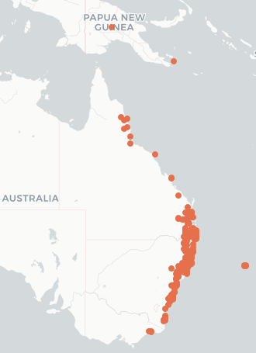
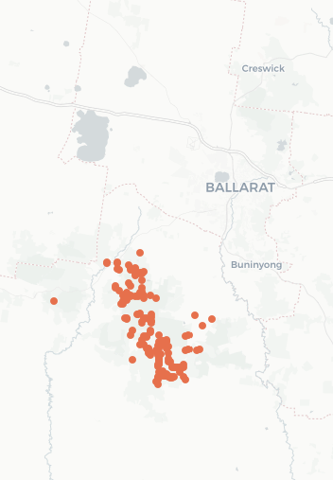
b.
a.
Figure 2. The entire distributions of two species: (a) a widespread but sparsely occurring threatened species – Buff Hazelwood; (b) a highly localised threatened species – Enfield Grevillea.
Maps from Atlas of Living Australia. https://www.ala.org.au/

2.2.1 Plant databases
Location data for plant species can be found in the following databases. This always includes observation date, and latitude and longitude. Some records include number of individuals, extent of populations, and location descriptions. Data collected before the widespread use of GPS in the 1990’s are likely to be imprecise.
- Victorian Biodiversity Atlas. https://vba.biodiversity.vic.gov.au/vba
- VicFlora. https://vicflora.rbg.vic.gov.au
- Atlas of Living Australia. https://www.ala.org.au
Species for which the publication of detailed locality information is likely to increase threats to a population (e.g. orchids) will not have the accurate location of important populations identified. Precise locality information is securely held on Victoria government systems (see VBA website).

2.2.2 Recovery Plans and Action Statements
Distribution data will also be presented in the National Recovery Plan for the species, as well as identification of the Important Populations, which are critical to the ongoing survival and recovery of the species. https://www.dcceew.gov.au/environment/biodiversity/threatened/recovery-plans
Action Statements contain similar information for Victorian threatened species. https://www.environment.vic.gov.au/conserving-threatened-species/action-statements

2.2.3 Knowledgeable people
Considerable information can be obtained from individuals who have detailed or long-term knowledge about the species. These could include:
- researchers, who have written scientific articles about the species
- staff at DEECA, National Herbarium of Victoria, Catchment Management Authorities and Parks Victoria, who may have unpublished information on the plant species
- local stakeholders (Trust for Nature, land managers, landholders, Landcare groups, Field Naturalists, Friends groups, or specialist groups such as Australasian Native Orchid Society).

2.2.4 Site inspections
Once the known populations have been identified it will be useful to visit some or all known populations and familiarise yourself with both the species and the sites. While on site, collect a basic set of population and site information that will help later decisions about monitoring methods:
- accurate coordinates recorded on a GPS device
- the approximate size of the population (number of plants)
- the area of occupancy of the population (total area occupied)
- the age-classes in the population (juvenile, mature or senescent)
- the habitat and vegetation type in which it occurs.
It is also important to establish the current land status of each site and the responsible land manager and/or landholder.

2.3 Life-cycle information about the species
Life-cycle information will be very useful in the field detection of your target species and the selection of monitoring methods. This includes:
- life form – tree, shrub, forb, grass, geophyte, fern, etc. (Figure 3)
- reproductive strategy – e.g. obligate seeder, resprouter, seed-bank, seed dispersal (Figure 4)
- typical longevity – e.g. annual, biennial, perennial
- environmental conditions necessary for sprouting, flowering or fruiting
- age-class distribution in the population – juvenile, mature or senescent (Figure 5)
- flowering time.

2.3.1 Life form
The size of your monitoring plots, the measurement techniques and timing of monitoring will all be influenced by the life-form of your target species.
For example, plot size would be larger for a tree species than for a grass and you could count individual trees, whereas it would be more feasible to measure the area covered by a grass species. For geophytes (plants with underground storage organs) the timing of monitoring will be dependent on when the above-ground parts are visible.
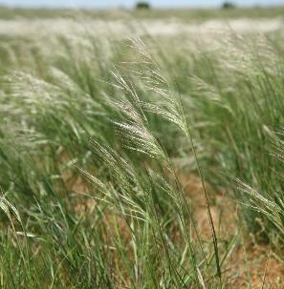
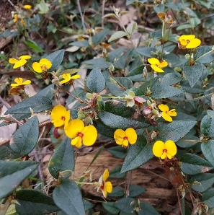
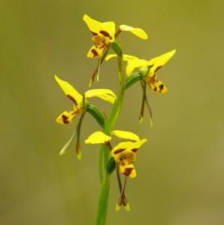
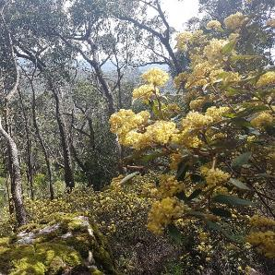
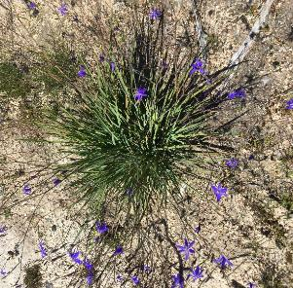
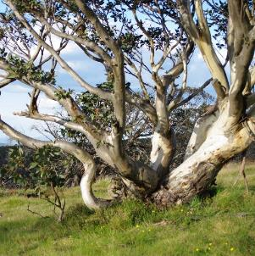
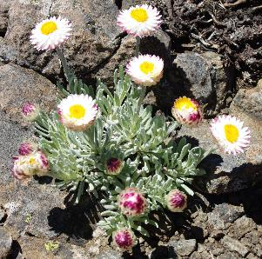
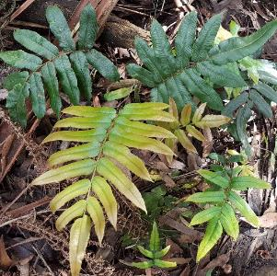
Grass
Small shrub
Geophyte
Tall shrub
Graminoid
Tree
Forb
Fern

c.
b.
a.

e.
d.
f.

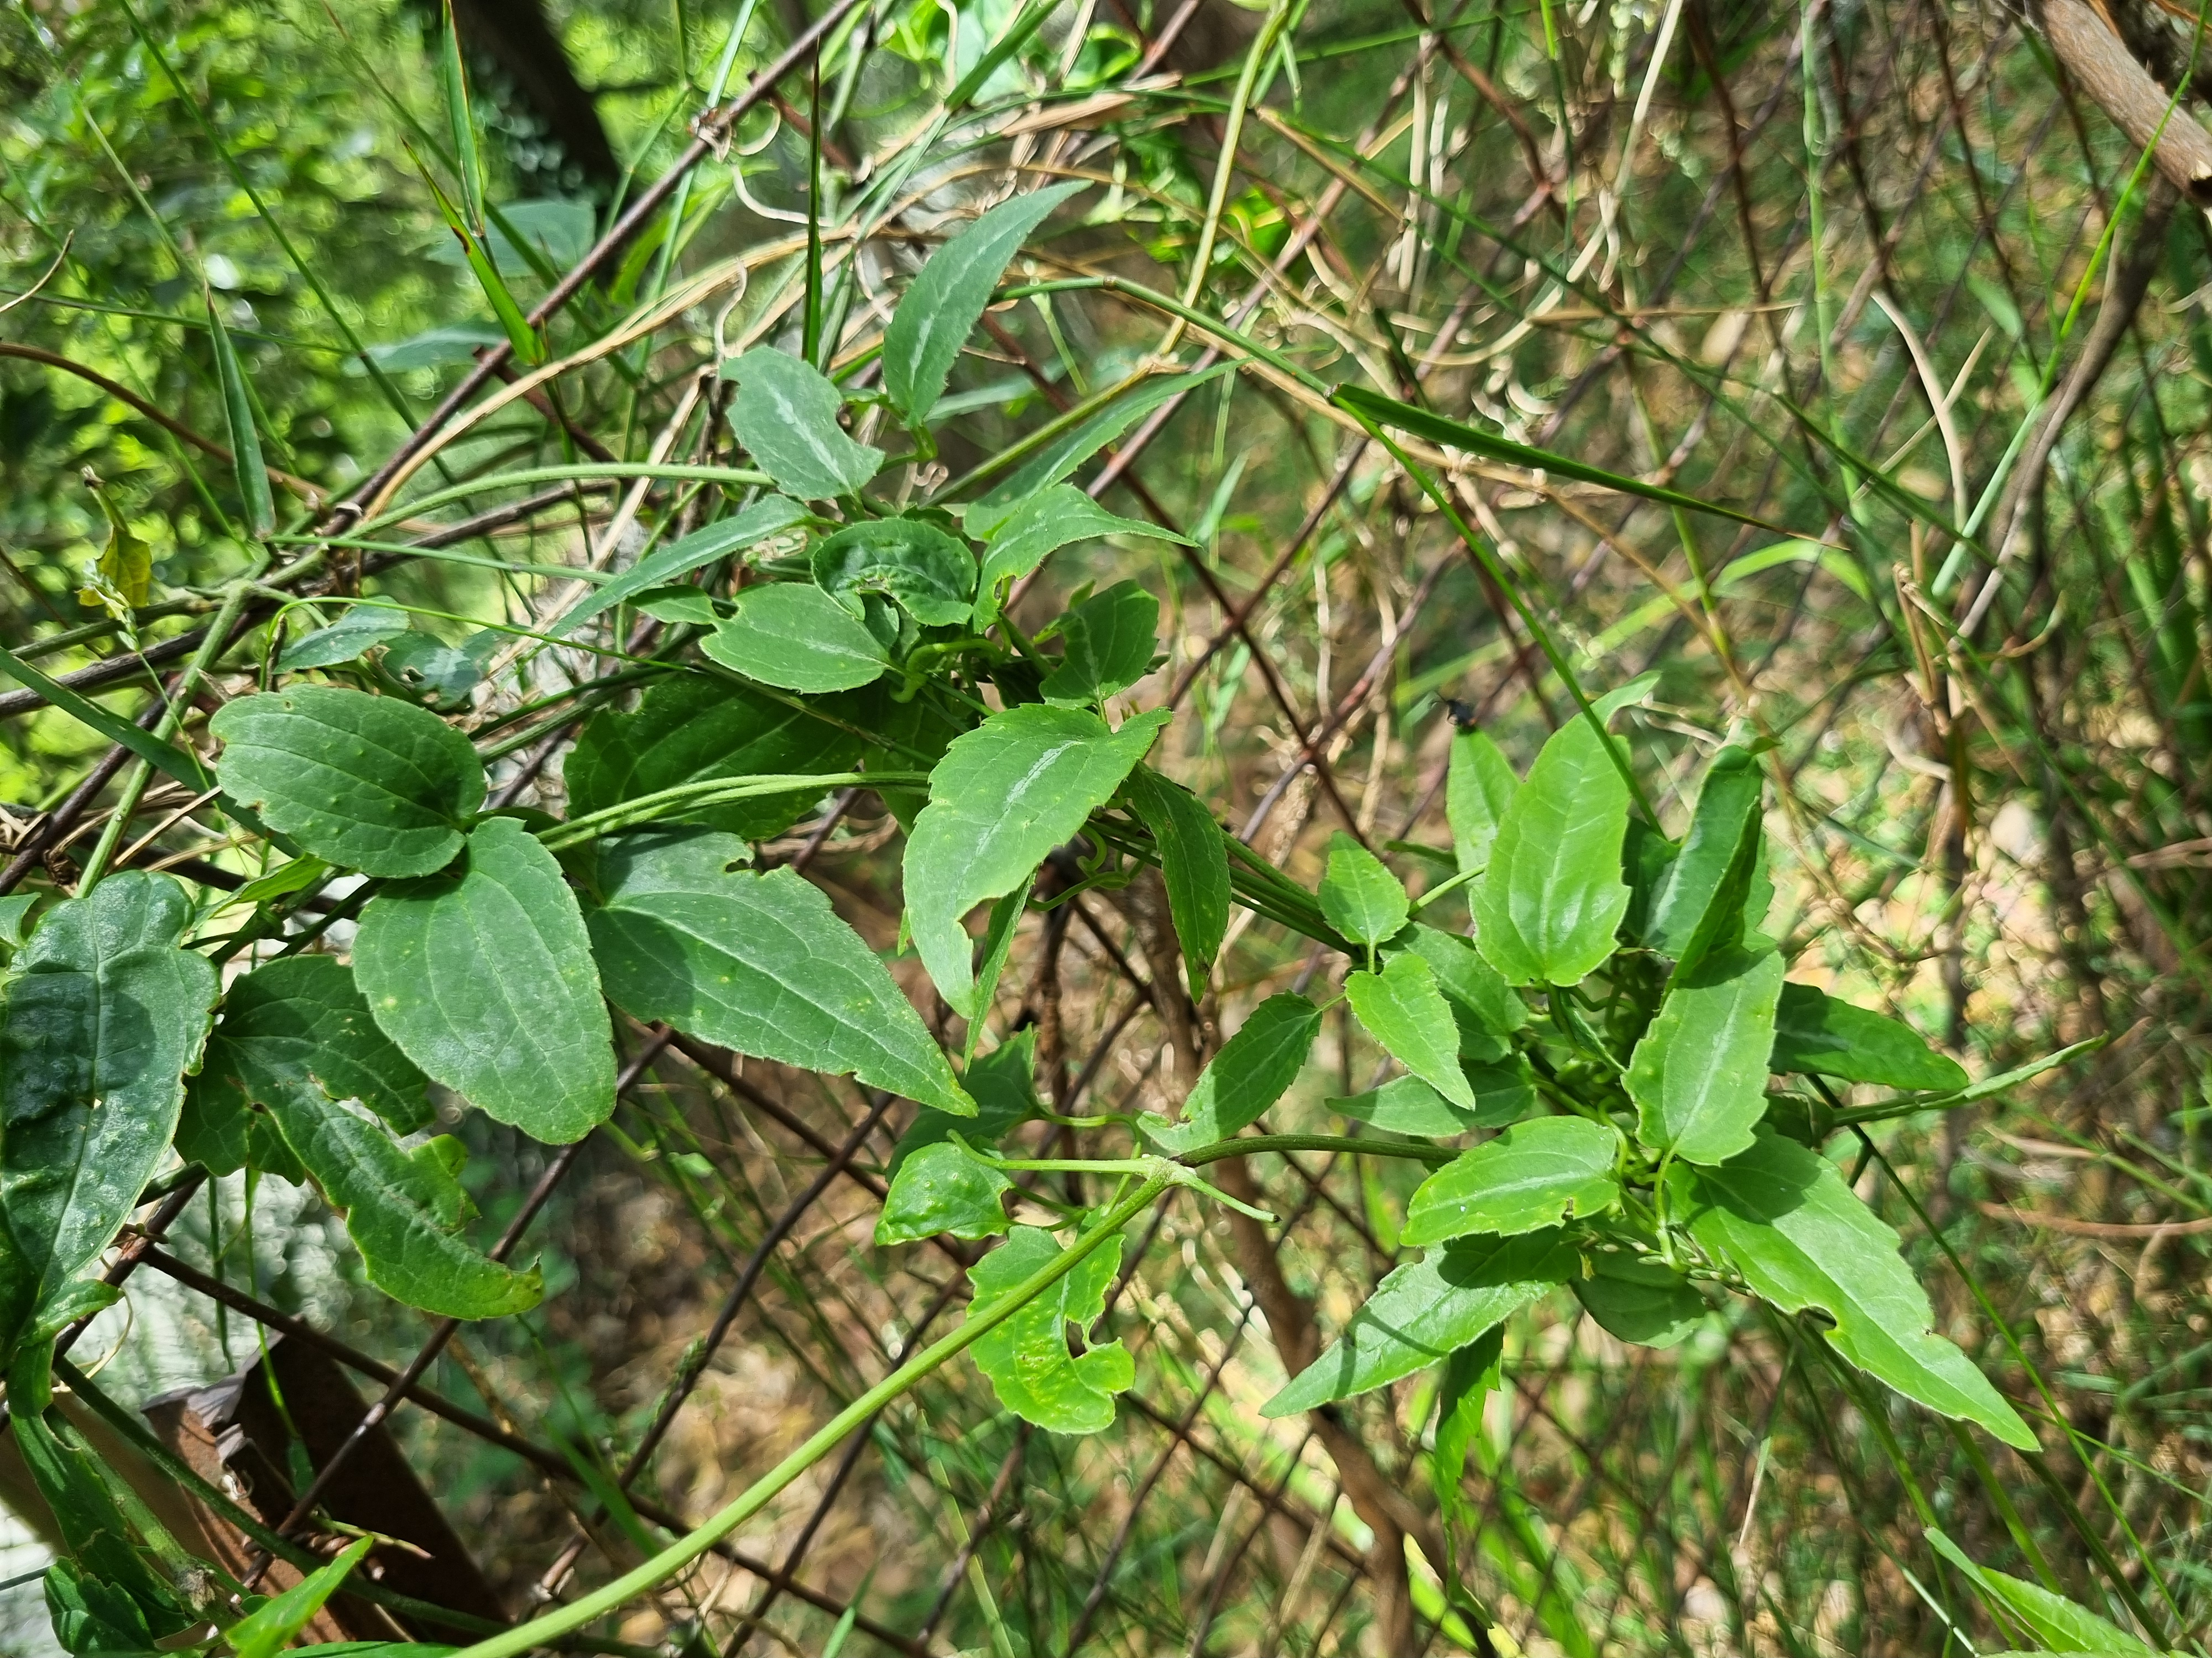

i.
h.
g.

Scrambler

Figure 3. Examples of different life-forms: (a) tree – Snow Gum; (b) tall shrub – Pomaderris; (c) small shrub – Handsome Flat-pea; (d) forb – Hoary Sunray, (e) grass – Spear-grass; (f) graminoid – Tufted Lily, (g) fern – Hard Water-fern; (h) geophyte – Tiger-orchid; (i) scrambler – Native Clematis.

2.3.2 Reproductive strategy
The life cycle characteristics of the species, such as whether it germinates from seed or resprouts from parent plants after fire, will also help guide your monitoring design.
For example, you could measure what proportion of plants germinate from seed or resprout. You could monitor the number of years after a fire that the new plants take to produce seed (reproductive maturity).
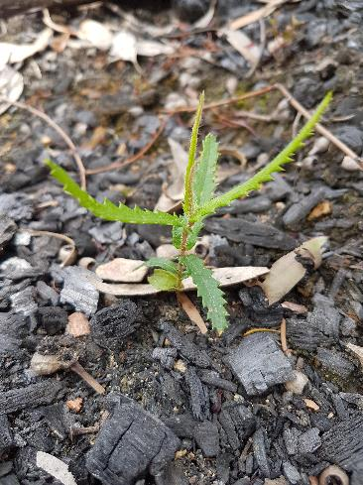
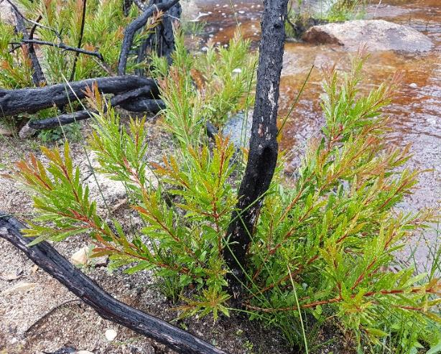
a.
b.
Figure 4. (a) A plant that germinates from seed after fire (obligate seeder) – Hairpin Banksia; (b) a plant that resprouts after fire (resprouter) – Betka Bottlebrush.

2.3.3 Age-classes and longevity
Measuring the proportions of plants which are juvenile (not yet producing seed), mature (producing seed) or senescing (dying back) helps to assess the health of a population.
Whether a species is long or short lived will inform how often you should carry out the monitoring.

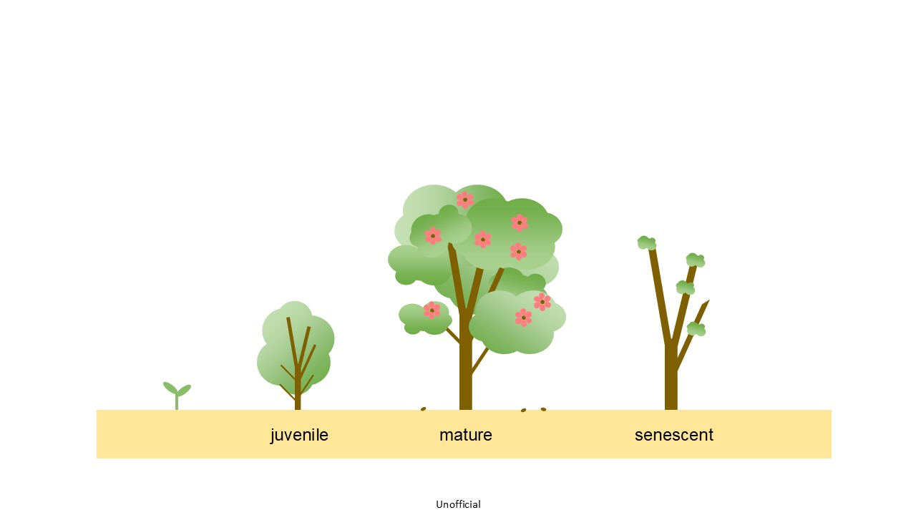
Figure 5. Juvenile, mature and senescent life-stages.

2.4 Threats to the species
Species vary in their sensitivity to threats depending on their biological characteristics and the environmental conditions they grow in. For example, some species are vulnerable to decline if they experience frequent fires, whereas others may decline if there are no fires. The timing of fires may then influence when you undertake your monitoring.
The current threat status and necessary recovery actions to alleviate the threats are determined and presented in the Recovery Plan or Action Statement (if these are available for the species).
Examples of common threats include:
- Weed invasion (Figure 6)
- Inappropriate fire regime – exacerbated by climate change
- Grazing by herbivores – introduced/ native, vertebrate/ invertebrate (Figure 6)
- Vegetation clearing – urban development, agriculture, timber production
- Climatic extremes such as drought – exacerbated by climate change
- Biomass accumulation – thick ground vegetation
- Changed water regime
- Soil disturbance – erosion, earthworks, agriculture, road maintenance, recreational activities
- Plant and pest-borne disease
- Invertebrate-caused dieback and exacerbation of plant stress during drought
- Loss of pollinators
- Low population size – inbreeding depression, genetic drift
- Pollutants and contaminants – e.g. fill and waste
- Nutrients– e.g. fertiliser
- Illegal collection.

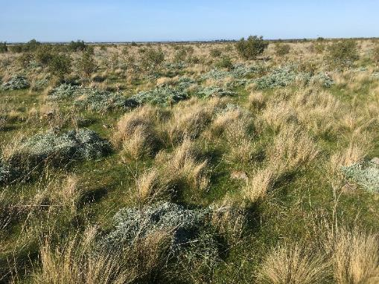
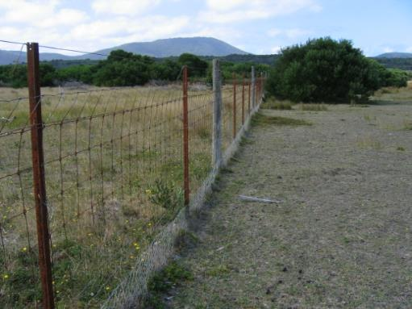
b.
a.
Figure 6. (a) Weed invasion effects on threatened grasslands; (b) effects of grazing exclusion on native vegetation.

- Choose monitoring methods
Your choice of monitoring methods will be influenced by: the questions about the species the monitoring intends to answer; the size and number of populations; its life-form and life history characteristics; and the anticipated budgets, timeframe and capabilities of the people who will carry out the monitoring.

3.1 What to monitor
Different types of monitoring can be grouped into the following broad categories:
- Population monitoring
  - inventories of the size of plant populations, which if repeated over time, can track changes in population size
- Demographic monitoring
  - collecting data on the life-stage or reproductive capacity of plants, which can help model population viability
- Experimental monitoring
  - quantifying the response of plant populations to threats or management actions.

3.1.1 Resources – funding and expertise

The level of funding, time and expertise available will play a large role in deciding on the monitoring approach for your species and site/s (see Table 1).
Quick – Qualitative methods
- Population size estimates and life stage estimates.
- Do not require statistical knowledge.

More time-consuming – Quantitative methods
- Sub-sampling populations and counting plants.
- Do require statistical knowledge.
- Yield repeatable, reliable and ultimately more useful data.

This manual focuses on how to make inventories of plant populations, and some simple life stage measurements. You will find information in Section 4 on the following methods: complete counts; population size estimation; sub-sampling of a population; life-stage estimations. Sources of information on the design and implementation of more detailed types of monitoring can be found in the References.

Table 1. Monitoring methods – expertise and time needed.
Monitoring type | Methods | Sampling design & Statistics | Time needed
Inventory | Population size estimates | No | Low
 | Complete count | No | Medium
 | Representative sample of portion of population | Yes | Medium
Demography | Life stage estimates | No | Low
 | Marking and monitoring individuals | Yes | High
Experimental | Replicated treatment and control plots | Yes | High

3.1.2 Plant populations
There may be multiple populations within the distribution of a species. Your project may be focussed on estimating the size of one population, a subset of populations, or all known populations.
A population is the number of individuals of the same species that live in a particular geographic area, with the capability of interbreeding. The size of a plant population can vary widely depending on factors such as environmental conditions, pollen and propagule dispersal, and competition. For example, a species with small seeds and no structures to assist widespread dispersal by wind, water or animals could have distinct populations one kilometre apart (Keith 2000).
Before setting up your monitoring, it is useful to establish the area covered by the target species at the site/s you wish to monitor. A parallel traverse method is a systematic way of searching an area and can be adjusted depending on the size of the target species and the density of the vegetation it occurs in. Suggested distances between parallel searches are: 20-40m for trees; 10-20m for tall shrubs; 10-15m for small shrubs; 5-10m for ground layer plants (DPIE 2020 in the References).

3.2 Sub-sampling populations
The best approach is to count all the individuals within the population/s you are focussed on, because this gives you the most accurate measure of population size. However, if there are too many plants or the area is too large or difficult to navigate/search, you will need to take a representative sample of the population/s of interest, and then estimations of population size can be made (Figure 7).
It can be helpful to look at comparable studies of similar species and use these as guides to your sampling design. (See Barker 2001 and Elzinga et al. 1998 in the References; Glossary for definitions of the terms used in this section).

3.2.1 Representative sample of a population
Sampling a subset of a plant population results in an estimate of the population size, which has some error associated with it.
The number of sub-samples generally increases where:
- There are high levels of difference or variation between sub-samples.
- We wish to estimate a variable (e.g. the size of the population) to a high level of accuracy.
- Determine the difference in some measurement between one or more locations or periods or treatments.
Sub-samples should be representative (for example, if the population occurs across multiple habitat types, they should all be represented) and independent (taking two sub-samples from the same patch but one from every other patch will mean that the first patch may unduly influence the results). Seek expert advice on a sampling design that is statistically powerful enough, to usefully estimate the variable of interest (e.g. the size of the plant population or the number of viable seeds within the population at a particular time).
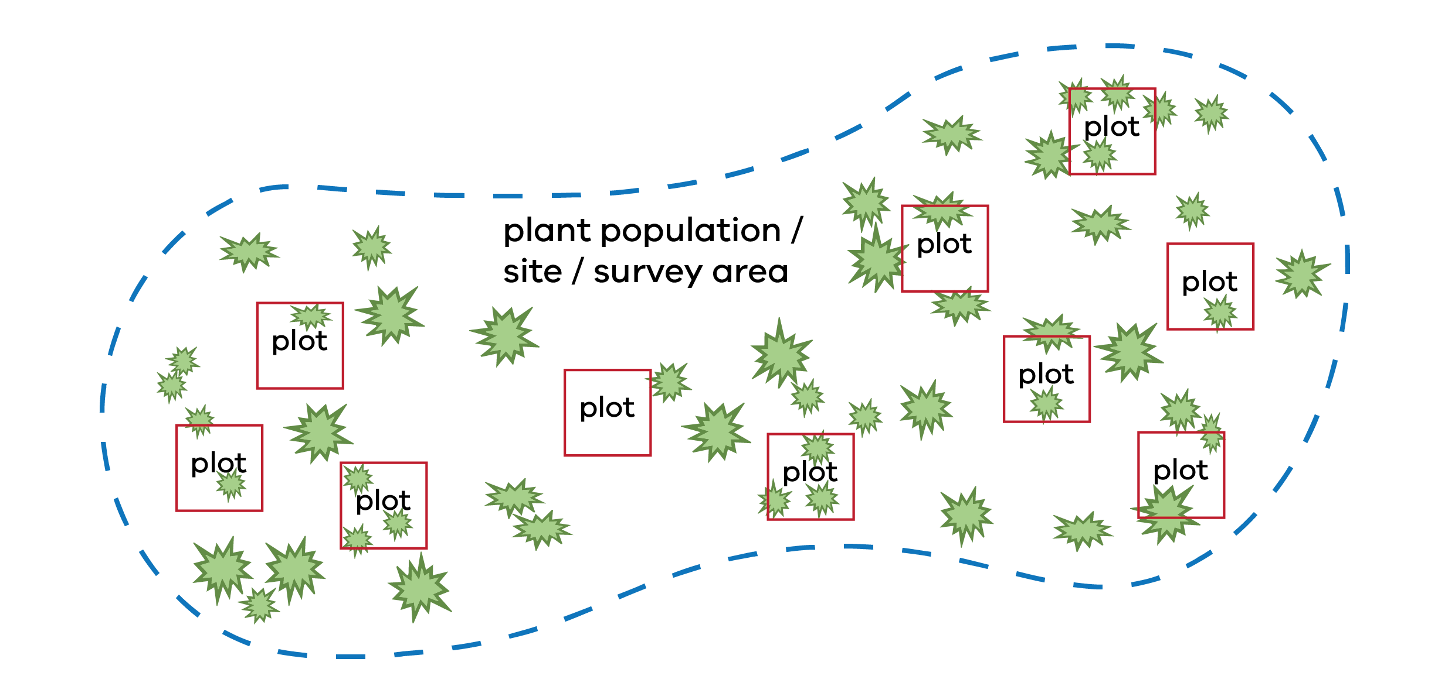
Figure 7. Example of sub-sampling a plant population – several plots located within one site

3.2.2 Sampling patterns
The arrangement of plants in a population can influence your choice of plots set up. Plants can be scattered without a predictable pattern, clustered in groups, or related to particular environmental conditions at a site.
It is very important that your sampling plots are distributed randomly and dispersed throughout the monitoring site. Within a population, random distribution of plots can be achieved in two main ways:
- Grid – divide the study site population into a grid, then use a random number generator to select coordinates for a subset of grids.
- Line – establish a line through the population, then use a random number generator to determine the distances along the line and at right angles to the line for the plots.
In addition, it may be necessary to stratify your sampling. Plots are located within areas of the site that have a consistent and distinctive set of environmental conditions related to where the target species grows.

3.3 Measurement methods
Your choice of measurement methods will be influenced by the monitoring objectives and by the characteristics of the target species.

3.3.1 Clonal and non-clonal plants
Plants which can be distinguished as individuals, such as trees and shrubs, are more easily counted by observers. Clonal plants with underground stolons or rhizomes, including many grasses, herbs, graminoids and ferns, are more difficult to measure (Figure 8). Field investigation or discussion with people that have knowledge of the species may be helpful in determining what to measure when plants are clonal. Annuals and geophytes, which appear seasonally or when weather conditions are suitable, can only be monitored at certain times of year and may not appear in some years.
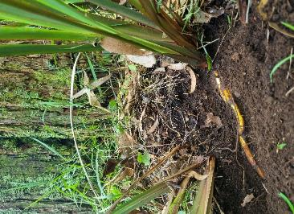
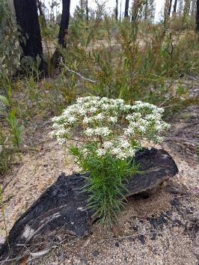
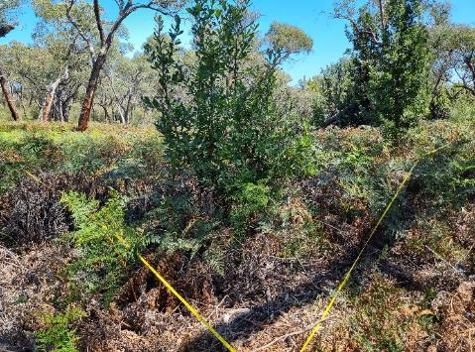
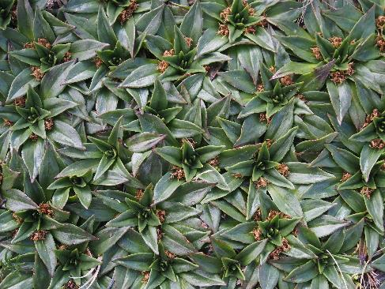
a. Non-clonal
b. Clonal
a. Non-clonal
b. Clonal

Figure 8. (a) non-clonal plants which have germinated from seed (Clustered Poranthera - Poranthera corymbosa and Saw Banksia – Banksia serrata); (b) clonal plants joined by underground rhizomes (Tasman Flax-lily – Dianella tasmanica and Star Plantain – Plantago glacialis).

3.3.2 Units of measurement
Commonly used units of measurement for plant species include:


Density – counts of individuals over fixed areas or plots.
Collating, storing and analysing the data from your monitoring, as well as communicating your results, are essential steps in contributing to conservation outcomes for the target species.
Collating, storing and analysing the data from your monitoring, as well as communicating your results, are essential steps in contributing to conservation outcomes for the target species.

Frequency (occupancy) – proportion of plots with the species present versus absent.
Cover – area of a species, within plots, along transects or at ‘point’ intercepts.

Using different methods can be useful; counting individuals as well as determining foliage cover enables you to get an understanding of both the density and dominance of the species.
Suitable methods for different lifeforms are suggested in Table 2. The advantages and disadvantages of these methods are summarised in Appendix 2. Guidance on how to carry out these methods in the field is in sections 4.6 – 4.9.
Table 2. Plant life-form characteristics and suitable monitoring methods.
 | Density –  individual plants per area | Frequency – % plots plants are present | Cover – % cover of plants in plots | Cover – line intercept | Cover – point intercept
tree
large shrub
small shrub – individual
small shrub – clonal
forb – individual
forb – clonal
graminoid – individual
graminoid – clonal
geophyte
fern
scrambler

3.3.3 Population size estimates
- A visual estimation of plant population size within a defined area, grouped into classes such as 0-10, 11-50, 50-100, 101-500.
- The categories need to be standardised and unambiguous, so the method can be used reliably by various observers over time.

3.3.4 Complete Count
- A complete count of all plants in a population.
- This is most suitable for plants that can be recognised by all observers as individuals, such as trees, shrubs and other non-clonal plants (Figure 8).

- The method is only feasible for small numbers of plants in a small area (e.g. <50 plants or < 0.1 ha), unless you have enough resources to count larger numbers of plants and/or larger areas.

3.3.5 Density
- A count of plants in a number of plots within a population.
- The total number of plants for each plot is divided by the total number of plots to give an average number of individuals per plot, and the number of plants per area (m² or ha.) is then estimated for the site.
- This is most suitable for plants that can be recognised by all observers as individuals, such as trees, shrubs and other non-clonal plants.
- Example – Zimmer et al. 2012 in References

3.3.6 Frequency
Collating, storing and analysing the data from your monitoring, as well as communicating your results, are essential steps in contributing to conservation outcomes for the target species.
Collating, storing and analysing the data from your monitoring, as well as communicating your results, are essential steps in contributing to conservation outcomes for the target species.
- The percentage of possible plots within a sampled area occupied by the target species.
- A simple presence / absence value of the species is recorded in each plot, and the frequency of the species is then calculated as the percentage of plots in which it was recorded.
- This method is suitable for any plant life-form.

- Example – Muir et al. 2015 in References

3.3.7 Cover
The projection of vegetation on the ground as viewed from above or overhead when measuring tree canopy, which can be measured in several ways:
- Visual estimate of percentage foliage cover in plots (Figure 9).
- Belt transects where percentage foliage cover is recorded in smaller subplots, then added together (Figure 10).
- Line intercepts which measure how much of a plant species intersects a horizontal line.
- Point intercept methods where the number of times a plant species intercepts a set of vertical lines is counted (Figure 10).
- Example – MSA? in References
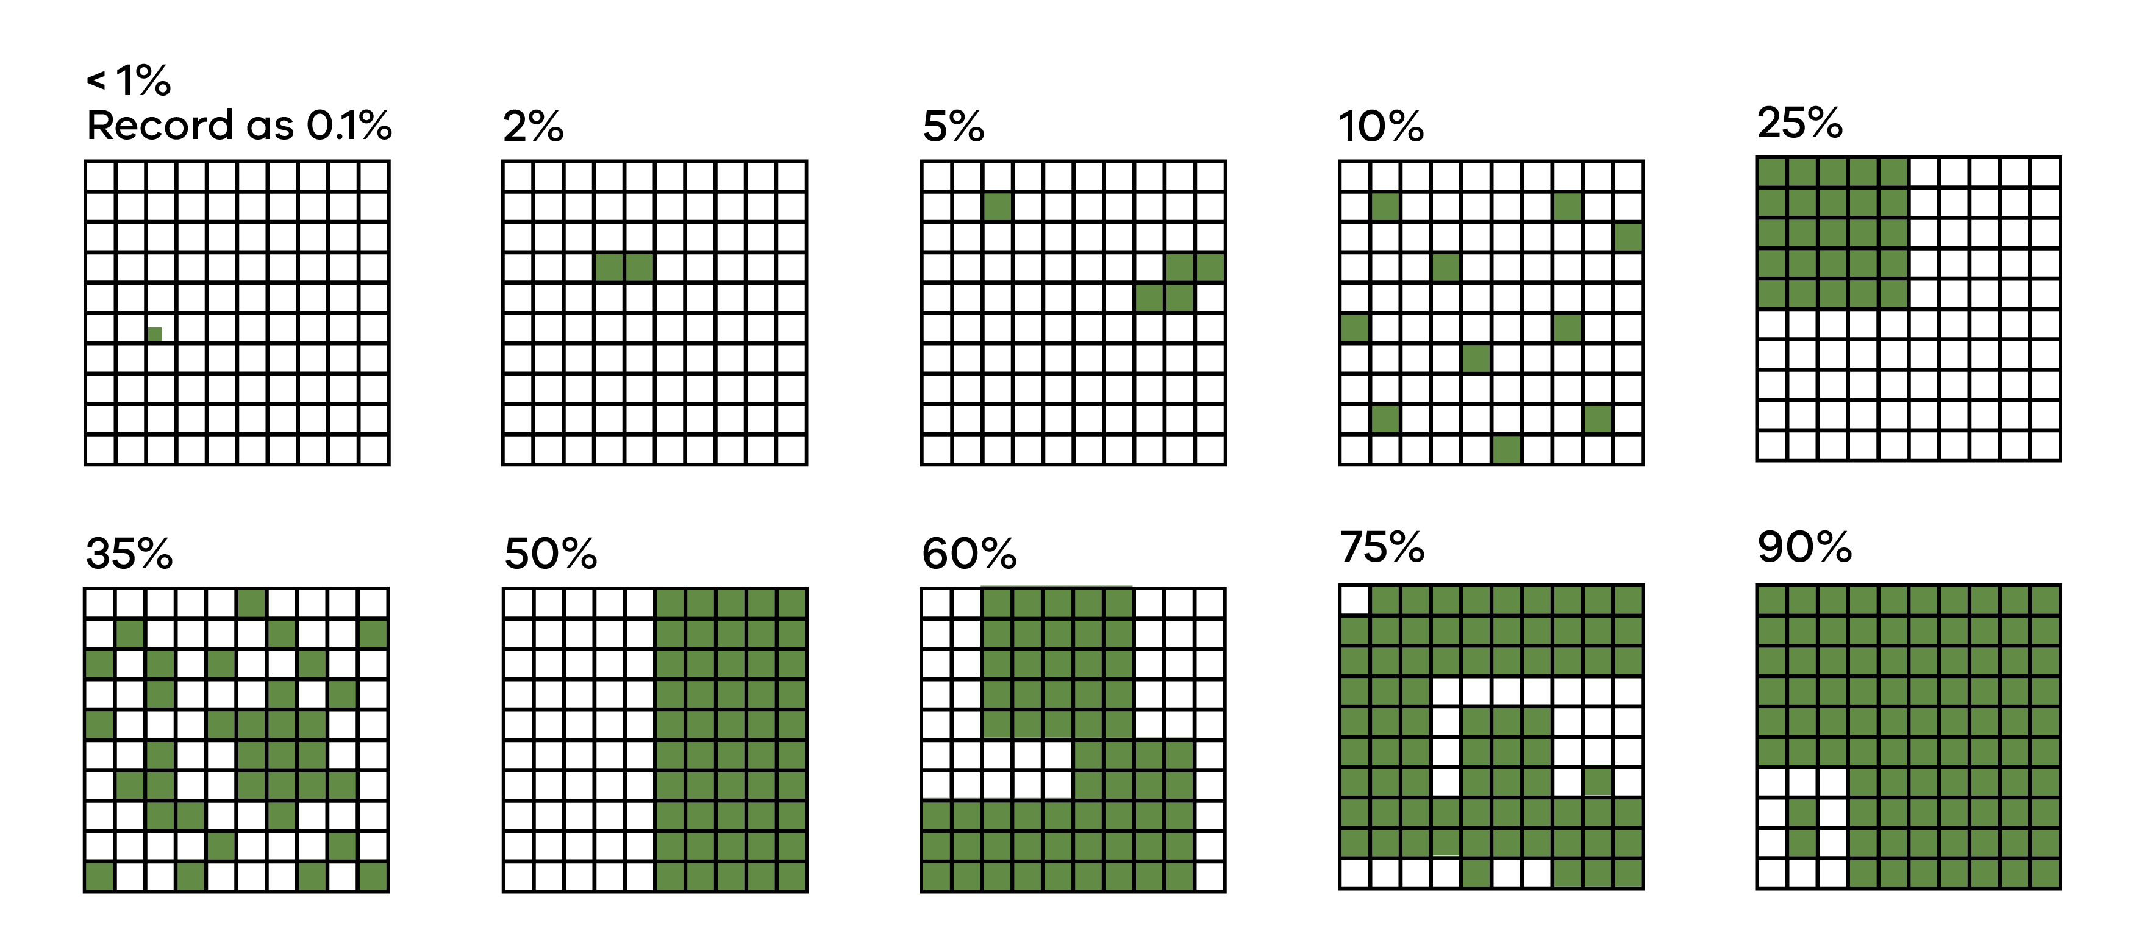
Figure 9. Visual estimate of percentage foliage cover
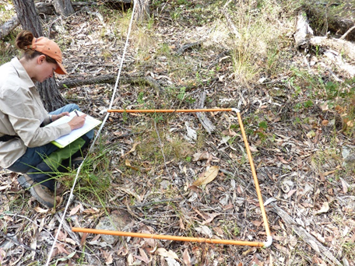
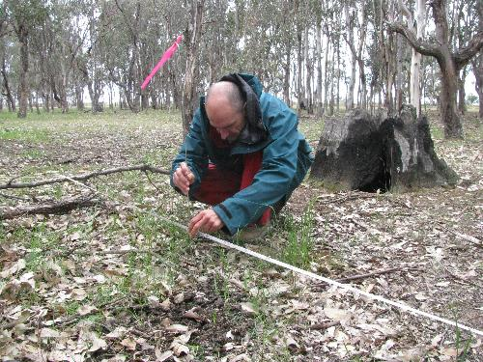
a.
b.
Figure 10. Two cover estimate methods: (a) subplot and (b) point intercept.

3.4 Plot shapes, sizes and numbers
A plot is a defined area that is surveyed for the target plants. Multiple plots will make up a study design, and each should be of a consistent size and use a consistent survey method within the same study.
The shape, size and number of plots will be dependent on the typical size and arrangement of the target plants, the variation between plots, the spatial extent of the population and constraints of the site.

3.4.1 Plot shape
- The most efficient shape of a plot at most sites will be a square.
- Narrow plots may be more appropriate if your target plants are confined to linear features, such as riverbanks or lake verges.
- Line and point intercepts use single lines.

3.4.2 Plot size
The optimum plot size for sampling plants maximises the accuracy of the data recorded balanced against the time and effort required to collect it. Your choice of plot size will be influenced by:
- the size of the species being monitored – e.g. grass species compared to tree species.
- the density of the species at the site – scattered individuals will likely require larger plots than densely occurring individuals.
- the measurement methods to be used – density, frequency, cover.
- minimising disturbance to plants by assessors entering the plots.
Commonly used plot sizes by life-form and measurement type are summarised in Table 3 (Barker 2001, Duncan & Coates 2006, DPIE 2020).
Density
The size of the plot should be small enough so that plant numbers are feasible to count in a reasonable time, but large enough to avoid having too many plots with no plants present.
Collating, storing and analysing the data from your monitoring, as well as communicating your results, are essential steps in contributing to conservation outcomes for the target species.
Collating, storing and analysing the data from your monitoring, as well as communicating your results, are essential steps in contributing to conservation outcomes for the target species.
Frequency
Selection of plot size should ensure that the species is not recorded in every plot. Frequency plots are generally smaller than plots for density or cover measures.
Cover
The size of the plot should be small enough so that it is possible to estimate plant cover in a reasonable time, but large enough to avoid having too many plots with no plants present.
Line and point intercepts
The length of transects will vary depending on the size of your target plant and how far apart they are growing.

Table 3. Plot sizes by life-form and measurement type.
Measurement units | Life form | Plot size
Density (number in plots) | Trees (forest or woodland) | 400 m² (eg. 20m x 20m)
 | Tall shrubs (shrubland or forest) | 25 m² (eg. 5m x 5m)
 | Small shrubs (heathland, woodland) | 5 m² (eg 2.5m x 2.5m)
 | Annuals, perennial herbs (grassland) | 1 m² (1m x 1m)
Cover (% in plots) | Trees (forest or woodland) | 400 m² (eg. 20m x 20m)
 | Tall shrubs (shrubland or forest) | 25 m² (eg. 5m x 5m)
 | Small shrubs (heathland, woodland) | 5 m² (eg 2.5m x 2.5m)
 | Annuals, perennial herbs (grassland) | 1 m² (1m x 1m)
Frequency (presence in plots) | Trees (forest or woodland) | 1 m²
 | Tall shrubs (shrubland or forest) | 1 m²
 | Small shrubs (heathland, woodland) | 1 m²
 | Annuals, perennial herbs (grassland) | 1 m²

3.4.3 Plot numbers
Replication of plots is needed so that patterns observed across the whole population are revealed, and not just in one part. The number of plots will depend on the variability of the populations at the site, the measurement methods (density, frequency, cover) and the level of accuracy or change we wish to detect.
The number of plots is often difficult to determine without statistical advice. It can be helpful to look at comparable studies of similar species and use these as guides to your sampling design.

3.5 Life stage monitoring
Recording life stage information for your target species may be incorporated into the field data collection in the plots used for population size measurements.

3.5.1 Life stage estimates
Within each plot, the percentage of the population or number of individuals that are seedlings, non-reproductive adults, reproductive adults, and senescent (dying) is estimated (Figure 5, see section 4.10 for details).

3.5.2 Marking and monitoring individual plants
A complete demographic study involves permanently marking individuals and taking accurate measurements of dormancy, stems, flowers, fruits, seedlings, damage, etc. This is beyond the scope of this manual, but more information can be found in Elzinga et al. 1998, Coates et al. 2006, Muir and Cassettari 2024 in the References.

3.5.3 Tree canopy health
Where a tree species is the species of interest, estimates of overstorey canopy cover can be used as an indicator of the health of the individual tree. Monitoring this parameter over time indicates the trajectory in the health of the canopy of the individual tree. This is beyond the scope of this manual, but more information can be found can be found in Farmilo et al. 2021 in the References.

3.6 Timing
How often you undertake monitoring is important to consider. Monitoring plant populations over multiple years is preferable because plant populations vary in response to fires, grazing, competition from other plants, climatic fluctuations, etc.

3.6.1 Time-series data
Time series data can be pooled to assess population trends over time. Population trajectories are a very useful source of information in prioritising conservation actions and interventions.
Data you collect can also contribute to State and National databases, such as the Threatened Species Index. https://tsx.org.au

3.6.2 Monitoring frequency
The frequency of sampling should respond to the frequency of changes that are anticipated to affect the numbers of plants. Deciding on how often and in what season monitoring is undertaken should be tailored to the life cycle traits of the subject species and the environmental context of the populations.
For example, it would not be cost effective or useful to annually monitor long lived trees in stable ecosystems such as rainforests compared to annuals in dynamic ecosystems such as grasslands. Some species only sprout or flower in response to specific environmental conditions (eg. fire, inundation), and so monitoring can only be undertaken when conditions allow detection of these species.
If effort is limited, less frequent monitoring may allow for more species/populations to be monitored.

3.6.3 General guidelines
- Data collected in at least two different years is needed for estimating trends, rather than a single monitoring event.
- A ‘time-series’ even with missing years remains useful, if regular or frequent monitoring is not possible.
- Where multiple factors (temperature, moisture, herbivory, disturbance, disease etc) change between years, several more years of monitoring may be required to understand the effect of each factor.
- When repeat surveying across multiple years, attempt to replicate each survey using the same methods, in the same season or similar weather conditions.
- Plan to monitor annuals and geophytes at the times of year when they are present above-ground.
- Undertake monitoring after a critical disturbance such as fire or flood, to understand population trends and identify potential management needs.
- Monitoring a mixture of disturbed and undisturbed plots will help distinguish the effects of disturbance from other background effects (e.g. climate).

- Collect data

Your choice of monitoring methods will help you plan your monitoring and data collection. Make sure you have determined: who will be doing the monitoring, site access and permits, equipment, weed and disease control protocols and set up your data sheets. Instructions on how to carry out each of the survey methods is provided in this section.

4.1 Field planning
Documentation of species identification, accurate locations, methods instructions, data collection sheets, field equipment and relevant permits is vital. This will ensure that the monitoring can be continued accurately over time by various people.

4.1.1 Who will do the monitoring
Before collecting data in the field, you will need to determine what level of expertise is needed and how many people are available. It is important to train the observers to ensure the correct plant species is identified and there is consistency of data collection methods.

4.1.2 Access to sites and permits
You can use MapShare Vic to identify public land managers of locations in Victoria. https://mapshare.vic.gov.au/mapsharevic
Check if permission is needed to access sites and carry out monitoring activities. A very useful starting point is the Park Connect webpage (https://www.parkconnect.vic.gov.au/scientific-research-permit). There is a Pre-Application Checklist on the Park Connect webpage to find out which permit you may need, and from which government agency.
On land managed by Parks Victoria, any activity beyond that undertaken by normal park visitors may require a Research Activity Access Agreement, and should be registered through Park Connect to ensure surveys are not conflicting with other park events (such as planned burns, pest animal control, weed control), and so that Parks staff are aware of your presence in the park in case of flood, fire or other problems. As part of this process, Parks Victoria will engage directly with the Traditional Owner group(s) to assess potential impacts to cultural values.
Access to private land will need to be negotiated with landholders and managers.

4.1.3 Site marking
Recording the locations of your sites on a map is essential. Also draw the extent of the population, so it is clear what proportion is covered by your sampling sites. This will enable later estimations of population size.
Marking your monitoring plots so that they can be found again accurately can be difficult. Permanent stakes are ideal as measurements can be more accurately repeated, but approvals may be needed to install stakes into the ground for cultural heritage and environmental reasons. Staking can harm fragile habitats such as peatlands, and galvanized stakes or wire should never be used as the release of zinc alters soil chemistry and kills susceptible plants.
See Appendix 3 for details of permits and how to apply for them.



4.2 Field equipment

4.2.1 Marking plots and measuring plants
The following list of equipment needs to be organised before starting field work:
- Metal stakes (where allowed) and mallet: to mark plot corners or transect ends.
- 50 metre tapes: to establish transects, left in place during monitoring.
- 20 metre tapes: to establish plots during monitoring.
- Metal tent pegs: to temporarily secure tape measures.
- Compass: to determine transect bearings and to establish plots.
- GPS device: to record latitude and longitude of start point or corners.
- Flagging tape: to help identify boundaries of plots and locations of individual plants.
- 1m x 1m frames: for small plots.
- Metal pins: for point measurements.
- Field survey datasheets or mobile app: to record observations, multiple copies (see section 4.3).
- Botanical field guides: relevant to the species, region and vegetation type.

4.2.2 Preventing spread of diseases and weeds
We can inadvertently spread weed seeds and serious soil-borne diseases like Phytophthora cinnamomi when carrying out monitoring. It is essential to protect the plants we are trying to conserve by following these procedures:
- Make sure that your boots, equipment and tools are clean before entering bushland (Figure 12).
- Remove mud and soil with a brush and a sharp tool.
- Remove weed seeds from boots and socks.
- In areas suspected of having Phytophthora, disinfect boot soles and equipment by spraying with 20% Phytoclean / 80% water or 70% methylated spirits / 30% water.
- Ensure your boots and equipment are dry after treatment.
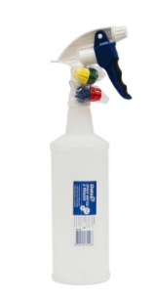


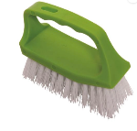
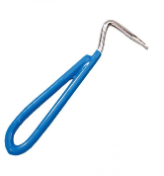
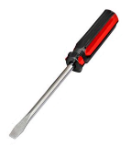

Figure 11. Hygiene kit for preventing the spread of Phytophthora.
Images: Wild Otways Initiative. https://otways.ccma.vic.gov.au/phytophthora


4.3 Field survey datasheets
A standardised datasheet is necessary to record your observations systematically. An example datasheet is in Appendix 4. Apps for mobile devices, such as Survey123 and Proofsafe, can make data collection more efficient in the field.

4.3.1 Mandatory data fields
- date
- assessors’ names
- unique plot identification number
- site location description (land tenure, nearest track, other physical features).
- latitude and longitude (one corner of each plot, ends of transects, other boundary markers)
- photo-point identification
- population measurement data (see sections 4.6 – 4.10 for details).

4.3.2 Recommended data fields
- habitat – aspect, topography, soils, geomorphological features.
- other plant species associated with the target species.
- population demographics – life stages (e.g. seedling, juvenile, adult), health status (alive, senescent, dead), reproductive output (e.g. presence, abundance, vegetative).
- disturbance or threats – fire, grazing, weeds, etc.

4.4 Setting up and marking plots
Finding your plots and plants again is essential so that you can monitor changes to the populations over multiple visits and take accurate measurements. This starts with carefully setting up your plots or transects.

4.4.1 Marking survey boundaries
When laying out a plot or transect, start points need to be established either permanently with metal stakes (if permitted) or temporarily with pegs. Use a compass to establish bearings for your tape measures, and a GPS to record latitude and longitude of start points (Figure 13).

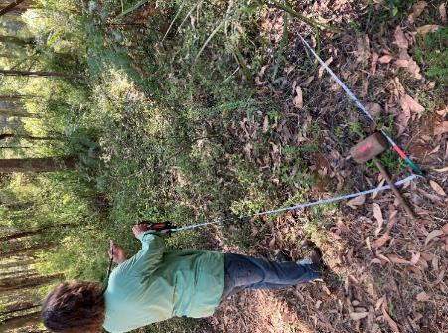
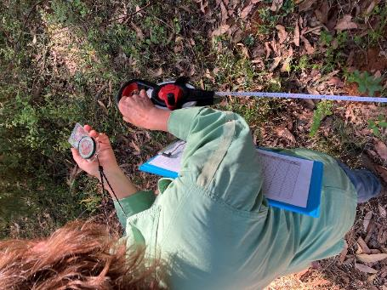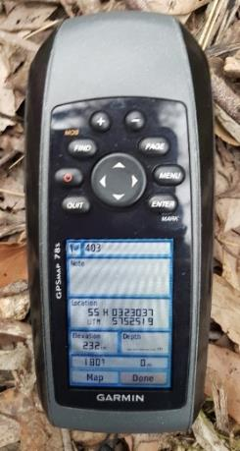
b.
a.
Figure 12. (a) Setting up a plot using a compass to determine direction of 20 m tape measure; (b) recording latitude and longitude of plot corner with a GPS.

4.4.2 Marking plants
To help find plants in your monitoring plots in subsequent years a temporary grid could be set up using tape measures, and then the locations of individual plants or small plots recorded as X-Y coordinates (Figure 14). To assist with counting individual small plants, these could either be marked temporarily using flagging tape and metal pins, or more permanently with metal disks pinned into the ground (Figure 15).

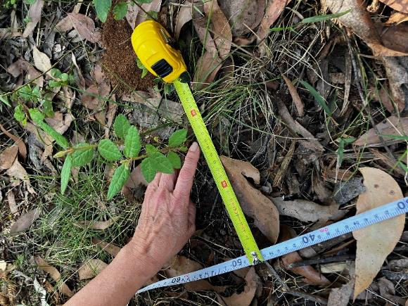
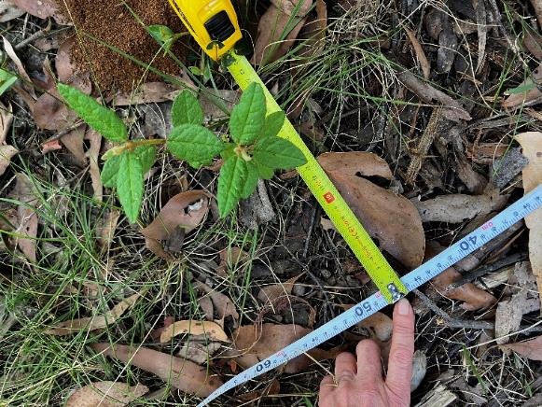
Figure 13. Locating individual plants using two tape measures, then recording X-Y coordinates.

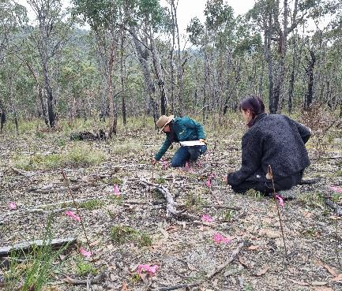
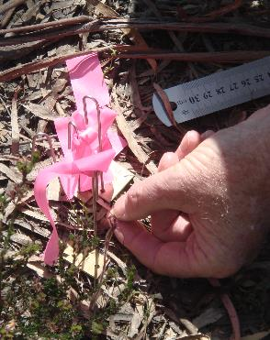
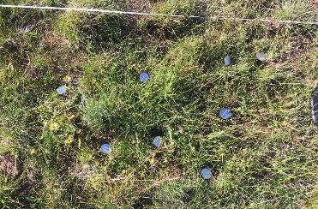

b.
a.
a.

Figure 14. (a) Pins with flagging tape to temporarily mark plants; (b) numbered metal discs to permanently mark plants.


4.5 Photo-points
Standardised photos from set points at your monitoring sites are very useful to:
- assist in returning to sites (include features such as distinctive trees).
- illustrate potential changes in the population (plant details like flowering, insect damage etc).
- illustrate potential changes at the site (structural and potentially compositional change).

4.5.1 General guidelines
The following general guidelines are commonly used for photo-points (Figure 16):
- Choose a photo-point at one corner of a plot or one end of a transect.
- If possible, choose a south-facing photo-point to avoid sun glare.
- Firstly, take a photo of the datasheet with the plot number and date written on it.
- Then, orient the photo towards the centre of the monitoring plot, or along the transect.
- Take a landscape site photo, capturing about 2/3 ground and mid-layer, and 1/3 canopy upper layer or sky.
- Record the photo ID, in a standard format (e.g. Plot number, Reserve name, Treatment, Year).
- In subsequent years, this site photo should be used to realign the photo.
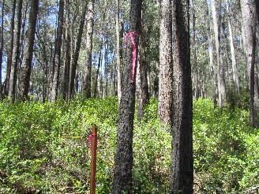
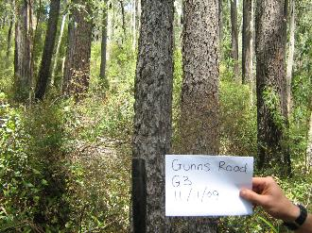
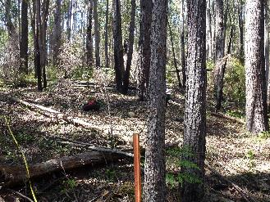

Figure 15. Sequence of photo-points over several years before and after a fire.

4.6 Complete population counts
The following procedures will help achieve accurate and repeatable measures of your target species.
- Mark the boundaries of the target species population (Figure 17).
- Use two observers to carry out the count (take an average of both counts to reduce observer error).
- Search the area systematically (e.g. parallel lines).
- Place temporary markers on each plant (e.g. flagging tape).
- Count the total number of the target plants.
- If there are large numbers, you could count in categories (e.g. 1,2,3,4,5,6,7,8,9, 10-19, 20-29, 30-39, 40-49, 50-75, 76-100, 100-150, 150-200, etc).
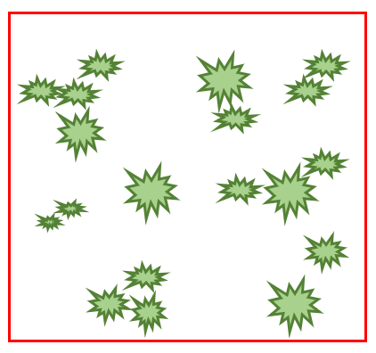

Figure 16. Example plot set up for a complete population count.

4.7 Density
- Set up plots (Figure 18; see section 3.7 for size, shape, number and arrangement).
- Mark the corners of the plots in which you will count the target plants.
- Use two observers to carry out the count (to reduce observer error).
- Count all plants rooted in each plot.
- Place temporary markers on each plant (e.g. flagging tape).
- If there are large numbers, you could count in categories (e.g. 1,2,3,4,5,6,7,8,9, 10-19, 20-29, 30-39, 40-49, 50-75, 76-100, 100-150, 150-200, etc).
- Calculate number of plants per area (m² or ha.): average number of plants per plot divided by the area of a plot.
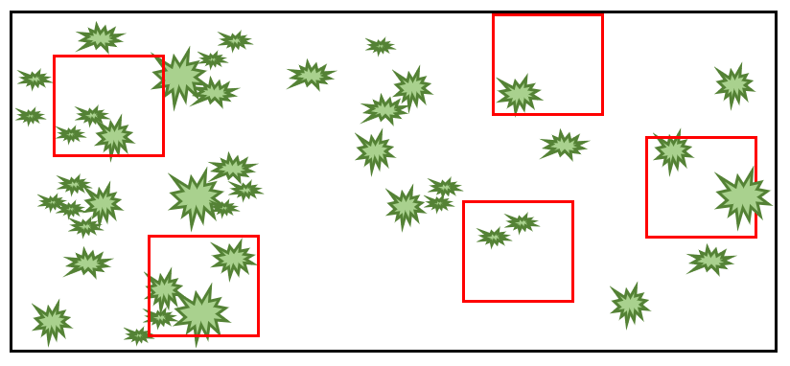
- To get a population estimate for count categories across the site, use the centre of the range for each plot, then use the same calculations as for count data.
- $density of species=\left(\frac{total number of plants }{number of plots}\right)/plot area$
Figure 17. Example plots set up for density counts.
Collating, storing and analysing the data from your monitoring, as well as communicating your results, are essential steps in contributing to conservation outcomes for the target species.
Collating, storing and analysing the data from your monitoring, as well as communicating your results, are essential steps in contributing to conservation outcomes for the target species.

4.8 Frequency
- Set up plots (Figure 19; see section 3.7 for size, shape, number and arrangement).
- Mark the corners of the plots in which you will count the target plants.
- Record a simple presence / absence value of the target species in each plot across the site.
- Frequency of the threatened species is then calculated as the percentage of plots in which it was recorded.
- $frequency of species=\left(\frac{number of plots with plants present}{number of plots} \right)×100$
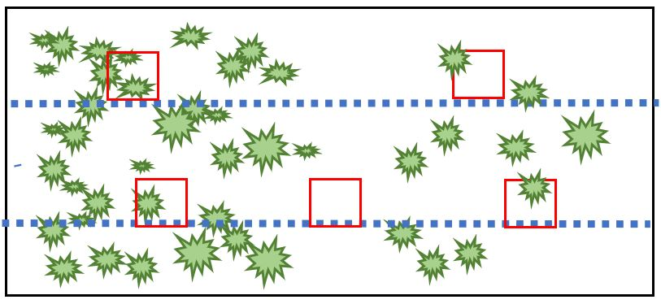

Figure 18. Example plots and transects set up for frequency measurements.

4.9 Cover

4.9.1 Plant cover in plots
- Set up plots (Figure 20; see section 3.7 for size, shape, number and arrangement).
- Mark the corners of the plots in which you will count the target plants.
- Use two observers to carry out the count (to reduce observer error).
- Looking from above, determine the percentage live plant cover of the threatened species in each plot.
- Estimate in increments of 1% if cover is below 5%, and then in increments of 5% thereafter (see Figure X for guide to estimating % cover).
- Percentage cover value for each plot can then be added, and divided by the number of plots to give an average cover value for the population.
- $\% cover of species=\frac{total \% cover of plants in plots}{number of plots}$

Figure 19. Example plots set up for cover measurements.

4.9.2 Line intercepts

- Set up a tape measure along a transect through a ‘representative’ area of the population (Figure 21).
- Record the beginning and end point for each time a target plant intercepts the line, then calculate the total distance of the intercept.
- Lines are best used to estimate basal or canopy cover of trees and large shrubs, but foliage cover can be measured for plants with large leaves.
- The cover of the species is calculated as the proportion of the total transect length.
- $\% cover of species=\left(\frac{total distance of plants}{distance along line}\right)×100$
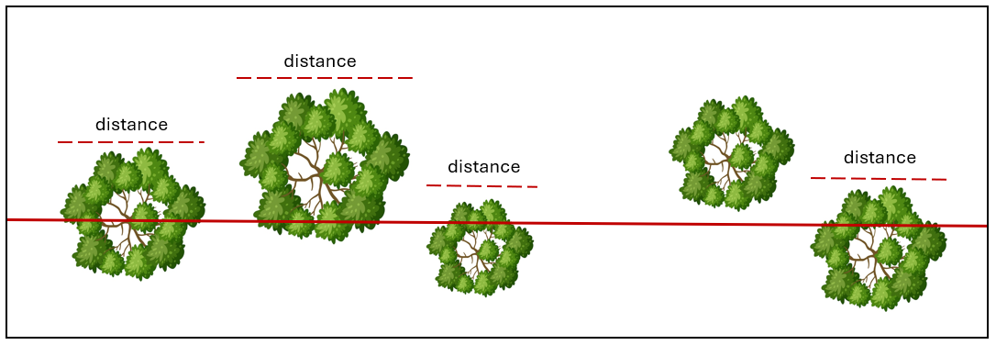
Figure 20. Example transect set up for line intercept measurements.
Modified from Elzinga et al. 1998

4.9.3 Point intercepts
- Set up a tape measure along a transect through a ‘representative’ area of the population (Figure 22).
- Assessment points are made using a narrow metal pin, at regular intervals along the tape.
- Each time the target species touches this point, a ‘hit’ is recorded.
- It is generally easier to determine if a point hits the base and foliage of a plant, rather than the canopy, so it is best suited to smaller plants.
- The cover of the species is calculated as the proportion of the total number of hits.
- $\% cover of species=\left(\frac{number of hits of plants}{total number of points}\right)×100$
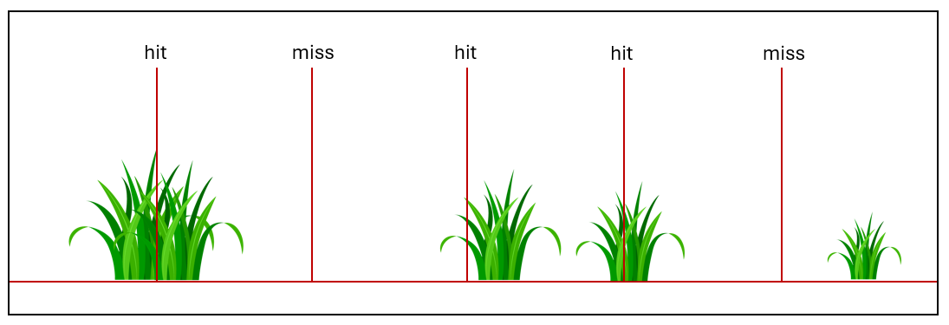
Figure 21. Example transect set up for point intercept measurements.
Modified from Elzinga et al. 1998

4.10 Life stage measurements
This method describes how to estimate the percentage of the population or number of individuals that are seedlings, non-reproductive adults, reproductive adults, and senescent (dying). It is different to a complete demographic study, which involves permanently marking individuals and taking accurate measurements of dormancy, stems, flowers, fruits, seedlings, damage, etc (e.g. Elzinga et al. 1998, Coates et al. 2006, Zimmer et al. 2012, Muir and Cassettari 2024 in the References).

4.10.1 Life-stage estimations
Choose a time to monitor when flowers or fruits will be present on the target species at your site, which may require more than one visit in a season. Within a plot, record the percentage of individuals of the target species that are in each of the following life-stage categories:
- seedlings – recently germinated within the last 6-24 months (Figure 23)
- juvenile – a plant that is not reproductively mature (no evidence of seeds)
- mature – a plant that is reproductively mature, with evidence of flowers, fruit or seed (Figure 23)
- senescing – a plant that is dying (>50% dead), or completely dead
- ensure that the data for the species add to 100%.
Following a disturbance event (such as fire), it is also useful to record the percentage of plants that have regenerated from seed or have resprouted from plant bases or stems.

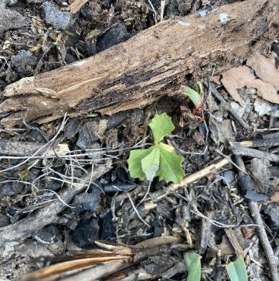
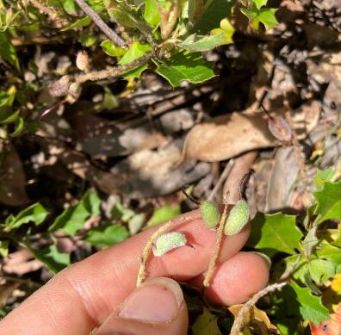
b.
a.
Figure 22. (a) Seedling life-stage; and (b) mature life-stage (seed pods) of Enfield Grevillea (Grevillea bedggoodiana).
Photos: Irena Cassettari

4.10.2 Demographic study
Demographic studies are often used to assist the conservation management of threatened orchids and other plants. Details on these methods are beyond the scope of this manual, but an example from Nillumbik Council and the Bend of Islands conservation committee is outlined below.
Monitoring translocated Wine-lip Spider-orchid (Caladenia oenochila)
- Monitoring takes place each year between April and November.
- Translocated plants were laid out in a grid, tagged and mapped.
- New recruits are recorded each year in this grid.
- Leaf emergence counts and length measurements are done monthly.
- Counting of flowers is done on the same day each year.
- Seed capsules on each plant are recorded, to determine success of natural or hand pollination.
- Tracking of pest invertebrates.
- Data management
Collating, storing and analysing the data from your monitoring, as well as communicating your results, are essential steps in contributing to conservation outcomes for the target species.

5.1 Data collection and metadata
Collation of your monitoring data in a systematic way is an essential step after completing your field monitoring.
Storing data in an electronic format allows data to be shared with others, including people who will continue the monitoring and land managers.
MS Excel is a widely used application for storing data in spreadsheets.

5.1.1 Excel worksheets
For each Excel workbook, it is useful to divide the data into several worksheets:
Site information
- General site and plot data (e.g. reserve name and location, map of monitoring plots).
Metadata
- Description of all the data fields and your methods.
Monitoring data
- Use separate worksheets for each year.
- Put each variable in a separate column (e.g. number of plants, presence of seeds).
- Put each plot in a separate row.
- Never have multiple fields or values in one column.
- After transferring your data from field sheets to the electronic spreadsheets, it is very important to check for any errors.

5.2 Databases
Using consistent data fields enables pooling of your data with other datasets, to inform trends for the species at a state-wide or national level.

5.2.1 Victorian Biodiversity Atlas
Contributing your observations to the Victorian Biodiversity Atlas (VBA) is one of the important ways you can influence conservation outcomes. This data can be used to track whether populations of threatened plant species are increasing or decreasing over time. In addition, data from surveys on public land in Victoria are required to be uploaded to the VBA.
Links and detailed instructions can be found at:
https://www.environment.vic.gov.au/biodiversity/victorian-biodiversity-atlas
Data from individual plots for some methods can be uploaded manually. However, for most monitoring data ‘batch uploads’ using standard Excel templates are recommended. Information on your methods and site location maps can be added in PDF formats.
Assistance with your specific requirements can be provided by contacting: vba.help@deeca.vic.gov.au

5.2.1 Threatened Species Index
The Threatened Species Index (a national database) brings together monitoring data from throughout Australia. This enables better understanding of change in the relative abundance of threatened and near-threatened species at national, state and regional levels.
Instructions on data upload and management, and minimum requirements for data submission are on the TSX website: https://tsx.org.au/tsx-resources/

5.3 Re-evaluate monitoring purpose
A final step in the monitoring process is to consider whether the data you have collected has answered your monitoring questions.

5.3.1 Data summaries
It is useful to summarise your data using simple descriptive statistics, such as column charts (example in Figure 24). Changes in the density of plants at your monitoring sites can provide insights into the trajectories of populations. Note that for cover estimates, large differences are needed to show changes in populations.
Further expert advice will be needed for more complex analyses, to infer effects on plant populations from management change or threat abatement.

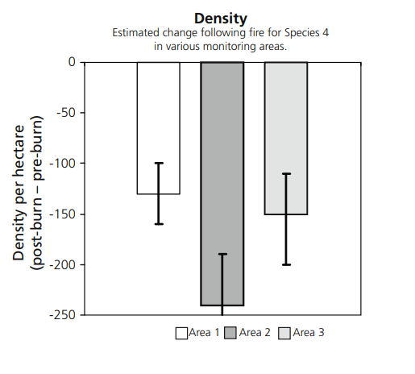
Figure 23. Example of a column chart, showing change in population density of a species following fire.
from Cawson and Muir 2008.

5.3.2 Communicating results
Communicating the results of your monitoring is an important part of the monitoring process. This would include agencies and groups involved in monitoring the plant species, those involved in management decisions, and the wider botanical and general community. Sharing your monitoring outcomes will help maintain enthusiasm for ongoing monitoring, reveal new issues to investigate, support funding applications, and provide evidence for management actions.
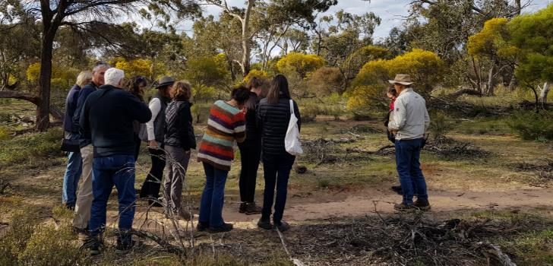
Photo: Andrew Geschke

Glossary
adapted from Commonwealth of Australia (2013)
Annuals – plants that usually germinate, reproduce (flower and set seed), and die in one year or season.
Belt transect – long rectangular plot, where plant measurements can be made in sections.
Canopy cover – percentage of the ground that would be shaded by a vertical projection of foliage and branches in the tallest plant layer, typically comprising trees.
Clonal – a group of genetically identical individual plants, that have grown in a single location, all originating vegetatively from a single ancestor.
Foliage cover – a vertical projection of leaf area; estimated as the shadow cast if the sun was directly overhead.
Forbs – herbaceous flowering plants that are not graminoids (grass, sedge or rush), typically dicots without woody stems.
Geophytes – herbaceous plants with tuberous underground organs filled with stored foods (bulbs, corms, rhizomes, stem tubers, root tubers).
Germination – the process by which a seed begins to sprout and grow into a seedling.
Graminoids – herbaceous plants with a grass-like form, having elongated stems with long, blade-like leaves.
Juvenile – plants in an early stage of growth, which have not yet flowered or set seed.
Mature – plants that have produced seeds, and hence have the capacity to reproduce.
Obligate seeders – plants that die after a disturbance such as fire and can only regenerate from seed; if these disturbances are too frequent plants cannot reach maturity and populations may decline.
Perennials – plants that usually live for more than two years.
Plot – a standard area within which plant attributes are sampled in the field.
Population trajectories – the direction or trend in size or health of a population of plants.
Recruitment – regeneration of plants following seed fall and germination, and includes seedlings, saplings and other advanced regrowth.
Resprouters – plants that have the capacity to regenerate from vegetative growth after a disturbance such as fire, from dormant buds under the bark or from their base or roots.
Rhizome – a creeping plant stem (not a root) growing beneath the surface, consisting of a series of nodes with roots commonly produced from the nodes and producing buds in the leaf axils.
Seed-bank – seeds that are dormant yet capable of germination and establishment if the right conditions appear; they may be on the plants in persistent fruit or in the soil.
Senescent – plants that are aging and approaching end-of-life.
Shrubs – woody plants of relatively low height, having several stems arising from near the base and lacking a single trunk.
Stolon – a stem or branch that grows along the ground surface, taking root at its nodes or else growing down to the ground surface, rooting on contact.
Sub-sample – a representative part of the population that is being measured.
Threatened species – species that are in danger of becoming extinct if the causal factors continue to operate. There are a number of different classifications of threat level depending on whether the species is listed internationally, nationally or at a state level. Terms such as rare, vulnerable, endangered, critically endangered and presumed extinct indicate the level of threat.
Transect – a linear sampling unit at a predetermined start point, using a predetermined compass bearing, that is established using a tape measure.

References
Cawson, J. and Muir, A. (2008). Flora monitoring protocols for planned burning: a user’s guide. Department of Sustainability and Environment, Melbourne. https://www.ffm.vic.gov.au/__data/assets/pdf_file/0013/21091/Report-74-Flora-Monitoring-Protocols-for-Planned-Burning_-A-Users-Guide.pdf
Barker, P. (2001). A technical manual for vegetation monitoring. Resource Management and Conservation, Department of Primary Industries, Water and Environment, Tasmania. https://nre.tas.gov.au/conservation/publications-forms-and-permits/publications/a-technical-manual-for-vegetation-monitoring
Coates, F., Lunt, I.D. and Tremblay, R.L. (2006). Effects of disturbance on population dynamics of the threatened orchid Prasophyllum correctum and implications for grassland management in south-eastern Australia. Biological Conservation 129: 59–69. https://doi:10.1016/j.biocon.2005.06.037
Commonwealth of Australia (2013). Vegetation Assessment Guide. https://www.dcceew.gov.au/sites/default/files/documents/vegetation-assessment-guide.pdf
DPIE (2020). Surveying threatened plants and their habitats. NSW survey guide for the Biodiversity Assessment Method. State of NSW and Department of Planning, Industry and Environment. https://www.environment.nsw.gov.au/-/media/OEH/Corporate-Site/Documents/Animals-and-plants/Biodiversity/surveying-threatened-plants-and-habitats-nsw-survey-guide-biodiversity-assessment-method-200146.pdf
Duncan, M. J. and Coates, F. (2006, unpubl.). Monitoring Nationally Threatened Flora in Victoria. Department of Sustainability and Environment, Victoria.
Elzinga, C.L., Salzer, D.W. and Willoughby, J.W. (1998). Measuring and Monitoring Plant Populations. Department of the Interior, Bureau of Land Management, USA. https://www.researchgate.net/publication/270034471_Measuring_and_Monitoring_Plant_Populations
Farmilo, B., Wadawurrung Traditional Owners Aboriginal Corporation, Jackson, A. and Moxham, C. (2021). Grassy Eucalypt Woodlands Cultural Burning Rapid Monitoring Program (2020-2023): Monitoring and Evaluation Framework. Published Client Report for the Corangamite Catchment Management Authority. Arthur Rylah Institute for Environmental Research, Department of Environment, Land, Water and Planning, Victoria. https://www.ari.vic.gov.au/__data/assets/pdf_file/0036/662985/ARI-Technical-Report-364-Grassy-Eucalypt-Woodlands-Wiyn-Murrup-Monitoring-Program.pdf
García, M.B., Silva, J.L., Tejero, P. and Pardo, I. (2021). Detecting early-warning signals of concern in plant populations with a Citizen Science network. Are threatened and other priority species for conservation performing worse? Journal of Applied Ecology 58:1388–1398. https://doi: 10.1111/1365-2664.13890
IUCN Standards and Petitions Committee (2024). Guidelines for Using the IUCN Red List Categories and Criteria. Version 16. https://www.iucnredlist.org/documents/RedListGuidelines.pdf
Keith, D.A. (2008). Sampling designs, field techniques and analytical methods for systematic plant population surveys. Ecological Management and Restoration 1, 125-139. https://doi.org/10.1046/j.1442-8903.2000.00034.x
Menges, E.S. and Gordon, D.R. (1996). Three levels of monitoring intensity for rare plant species. Natural Areas Journal 16: 227-237. https://doi/full/10.5555/19971600202
Muir, A. and Cassettari, I. (2024). Factsheet. Enfield Grevillea - optimal fire regimes: pre- and post-burn monitoring. A joint project between Arthur Rylah Institute for Environmental Research and Grampians Region Bushfire and Forest Services Division. Department of Energy, Environment and Climate Action, Victoria. https://www.ari.vic.gov.au/__data/assets/pdf_file/0035/729575/Enfield-Grevillea-Fire-Regimes-Fact-Sheet-2024.pdf
Muir, A., MacHunter, J., Bruce, M., Moloney, P., Kyle, G., Stamation, K., Bluff, L., Macak, P., Liu, C., Sutter, G., Cheal, D., & Loyn, R. (2015) Effects of fire regimes on terrestrial biodiversity in Gippsland, Victoria: a retrospective approach. Arthur Rylah Institute for Environmental Research, Heidelberg, Victoria, for Department of Environment, Land, Water and Planning, Melbourne, Victoria. https://www.ari.vic.gov.au/__data/assets/pdf_file/0032/54959/Effects-of-fire-on-terrestrial-biodiversity-in-Gippsland-ARI-DELWP-2015.pdf
Threatened Species Recovery Hub. Factsheet: A Threatened Plant Index for Victoria (accessed January 2023). https://tsx.org.au/wp-content/uploads/2020/11/3.1-TPX-Vic-Plants-Findings-Factsheet.pdf
Terrestrial Ecosystem Research Network. Wild Orchid Watch (accessed January 2024). https://www.tern.org.au/citizen-science-projects/#wow
University of Idaho (2009). Line Intercept Techniques to estimate cover. https://www.webpages.uidaho.edu/veg_measure/Modules/Lessons/Module%208(Cover)/8_4_Lines.htm
University of Idaho (2009). Point Intercept Techniques to estimate cover. https://www.webpages.uidaho.edu/veg_measure/Modules/Lessons/Module%208(Cover)/8_3_Points.htm
University of Idaho (2009). Principles of Vegetation Measurement & Assessment and Ecological Monitoring & Analysis – Sampling Designs. https://www.webpages.uidaho.edu/veg_measure/Modules/Lessons/Module%202(Sampling)/2_5_Sampling_Designs.htm
Wild Otways Initiative. Phytophthora cinnamomi (dieback) management in the Otways – Hygiene management guidelines (accessed January 2024). https://otways.ccma.vic.gov.au/phytophthora
Zimmer, H., Cheal, D., Johnson, G. and Lunt, I. (2012). Black Cypress-pine Callitris endlicheri fire-sensitive vegetation recovery following high intensity bushfire. Black Saturday Victoria 2009 – Natural values fire recovery program. Department of Sustainability and Environment, Heidelberg, Victoria. https://www.ari.vic.gov.au/__data/assets/pdf_file/0024/34971/VBRRA-P10-web.pdf

Appendices

Appendix 1: Monitoring practitioners’ workshop
An online workshop held in May 2023 as part of the development of this manual brought together a diverse range of organisations (government, non-government, and volunteer) to discuss their current monitoring activities and the most useful methods to include in this manual. There was broad agreement that the focus should be on simple methods suitable for citizen scientists and non-specialists, which could measure whether individual populations are increasing or decreasing through time. However, participants also felt that more complex methods for assessing the effectiveness of the management of threatened species populations, and monitoring multiple populations of one species, would be useful for some organisations.
The workshop captured information on various monitoring methods used by different organisations and groups. The most common approaches (presence or absence of a species, measuring a population size) were the ones that required the least specialist expertise. Less common were methods such as: monitoring the effects of fire or weed management using multiple ‘treatment’ and ‘control’ plots; demographic studies involving marking individual plants and recording life-cycle attributes through time; and monitoring species in the same plots over many years at multiple sites.
Data storage and sharing was the most difficult issue facing many participants. Suggested improvements to current biodiversity databases included: streamlined data uploads; easier access to their own data; a user-friendly interface; and connections to iNaturalist. There was support for an online interactive tool, which could include monitoring design, survey templates and data uploads. Mention was made of care needed with locations for sensitive species, particularly on private land.

Appendix 2: Measurement methods – advantages and disadvantages
 | Count | Density | Occupancy/Frequency | Cover
Definition | A complete count of all plants in a population. | The number of individuals or counting units of the target species in a defined area. | The percentage of plots within a sampled area occupied by the target species. | The foliage projection of a plant as viewed from above.
Advantages | - Absolute measure of population size in a defined area.  - Used to compare between years and sites.  - Calculating the number and arrangement of samples is unnecessary. | - Useful if individual plants can be distinguished.  - Effective in measuring recruitment or loss.  - Allows for comparison between sites, years and plot sizes.  - Population extent is usefully estimated. | - Useful if individuals or counting units are hard to define, such as rhizomatous or graminoid plants.  - Can be useful for annuals, biennials and some perennials that are too numerous to count individually, and/or density varies from year to year.  - Quick and quantitative.  - With sufficient sampling estimates the extent of populations. | - Useful if the counting unit is difficult to define.  - Repeatable and quantitative methods are available (point intercept and for some species line intercept).  - Can be related to biomass and, where other associated species are measured, local dominance.  - Plots of different sizes can be usefully compared.
Disadvantages | - Time consuming and expensive in dense or extensive populations.  - No good for clonal species (however this is an issue for all measures). | - Accuracy of the estimate will vary among sampling units of different shapes and sizes.  - Population size is estimated which may limit the utility in some instances (e.g. where we are interested in small changes in population size between monitoring efforts).  - No good for clonal species (however this is an issue for all measures). | - Frequency value for a species can vary if plot size is not constant as this measure is dependent upon plot size.  - Cannot estimate population size.  - May be insensitive to important population increases or losses.  - Biological significance of changes may be difficult to interpret. | - Cover estimates in plots have high error rate due to observer bias.  - Quantitative methods can be very time-consuming especially where the target taxon is uncommon and/or has generally low cover.  - Can be hard to compare results from different areas.  - Difficult to interpret cover changes as due to change in plant numbers.

Appendix 3: Research permits
(https://www.parks.vic.gov.au/get-into-nature/conservation-and-science/science-and-research/access-agreements-for-research-activities)
Research/ activity type | Permit issued under | Permit issued by
- Research in a State Forest | Forests Act 1958 | DEECA
- Removing an object for research  - Uncovering Aboriginal cultural heritage  - Researching an Aboriginal place or object  - Likely to harm Aboriginal cultural heritage | Aboriginal Heritage Act  2006 | First Peoples - State Relations  (formerly Aboriginal Victoria)
- Taking protected flora specimens, samples, seed or propagation material  - Researching in protected communities | Flora and Fauna Guarantee Act 1988 | DEECA

Appendix 4: Example datasheet
from Cawson and Muir 2008
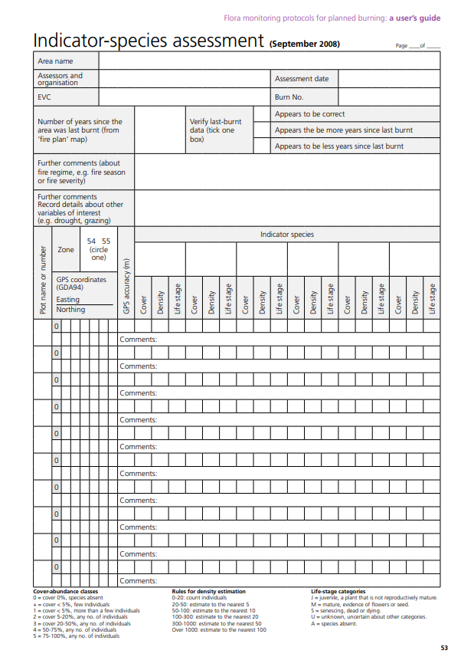

www.deeca.vic.gov.au

www.ari.vic.gov.au

