# The Nature and Community-led Approach

# to Disaster Resilience

**Story Library**

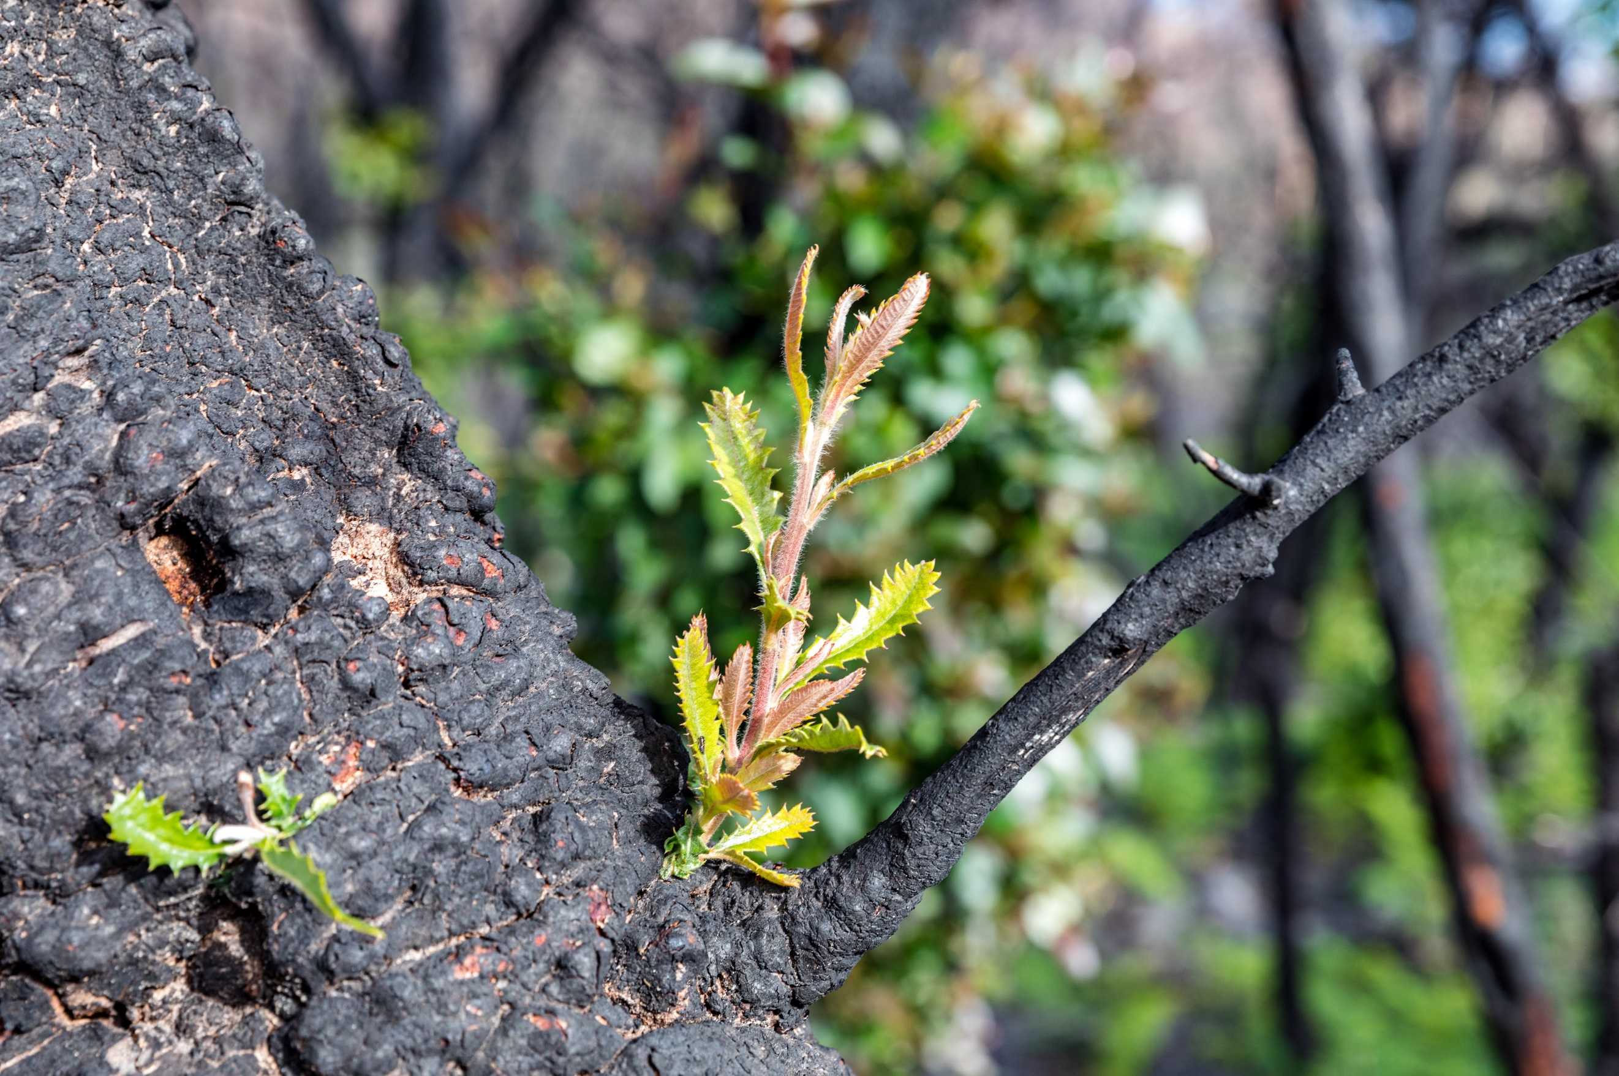

Arthur Rylah Institute for Environmental Research

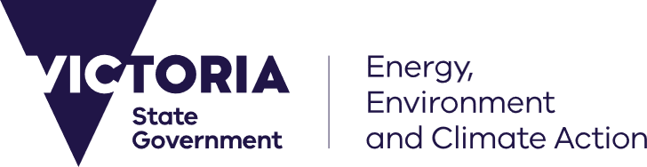

**Front cover photo**: Banksia resprouting in Cape Conran National Park (Andrew Geschke).

Edited by Nathan Ning

**ISBN** 978-1-76136-944-5 **(pdf/online/MS word)**

Stories compiled by Lee, K, Lamont, A., Whiteford, C., van Eeden, L., & Hames, F. (2024). The Nature and community-led approach to disaster resilience: Story Library. Published Report. Department of Energy, Environment and Climate Action, Heidelberg, Victoria.

© The State of Victoria Department of Energy, Environment and Climate Action October 2024.

Creative Commons

This work is licensed under a Creative Commons Attribution 4.0 International licence, visit the [Creative Commons website](http://creativecommons.org/licenses/by/4.0/) (<http://creativecommons.org/licenses/by/4.0/>).

You are free to re-use the work under that licence, on the condition that you credit the State of Victoria as author. The licence does not apply to any images, photographs or branding, including the Victorian Coat of Arms, and the Victorian Government, the Department and the ARI logos.

**Disclaimer**

This publication may be of assistance to you but the State of Victoria and its employees do not guarantee that the publication is without flaw of any kind or is wholly appropriate for your particular purposes and therefore disclaims all liability for any error, loss or other consequence which may arise from you relying on any information in this publication.

**Accessibility**

To receive this document in an alternative format, phone the Customer Service Centre on 136 186, email [customer.service@deeca.vic.gov.au](mailto:customer.service@delwp.vic.gov.au), or contact National Relay Service on 133 677. Available at [DEECA website](http://www.deeca.vic.gov.au/) (www.deeca.vic.gov.au).

**Acknowledgment of Country**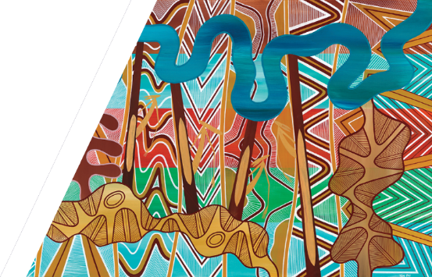

*We acknowledge and respect Victorian Traditional Owners as the original custodians of Victoria’s land and waters, their unique ability to care for Country and deep spiritual connection to it. We honour Elders past and present whose knowledge and wisdom has ensured the continuation of culture and traditional practices. We are committed to genuinely partner, and meaningfully engage, with Victoria’s Traditional Owners and Aboriginal Communities to support the protection of Country, the maintenance of spiritual and cultural practices and their broader aspirations in the 21st century and beyond.*

## **Caring for Country, Healing Country, Walking Together and Advancing Treaty**

For millennia, First Nations Peoples have embodied a way of being that encompasses Caring for Country, Healing Country and Walking Together.

Integral to the idea of Caring for Country is that nature needs people, and people need nature, and that people have a responsibility to manage country and that “if you look after Country, Country will look after you”.

Many Indigenous and other cultures conceptualise humans and nature as forming a single balanced and symbiotic relationship, and view humans and nature as connected, not separate entities. This symbiotic relationship incorporates human and nature wellbeing, and many people see their wellbeing and identities deriving from their relationships with both humans and nature.

These ideas of reciprocity and symbiosis form the basis of a nature-led community resilience (NLCR) approach.

We still have much to learn from vast Indigenous Knowledges.

This is a small selection of the fantastic work already being done in NLCR and accompanies the [NLCR Toolkit](https://www.ari.vic.gov.au/__data/assets/pdf_file/0013/723010/Nature-led-Community-Resilience-Toolkit.pdf). There are many more examples to be found in Victoria, Australia and further afield. Why not create your NLCR story?

This story library contains:

1. DJANDAK leading Connecting with Country in Bendigo
2. Nature connection walks and workshops boost individual and community wellbeing after flood
3. The fish are back and so are we
4. Creating Nature Play Trails to Grow Resilience
5. Sharing stories of nature recovery
6. River Warriors
7. The Sounds of Recovery
8. Sarsfield Snaps
9. Students leading habitat monitoring after fires
10. Friends of groups recovering with rainforests and rivers
11. Strengthening locals’ connections to native flora in the Kinglake Ranges
12. Managing for dry times in Hovell’s Creek
13. Solving the Greater Glider housing crisis
14. Biodiversity Bushfire Recovery Grants Program

We would like to acknowledge all those who shared their stories with us and the resilience in these communities, including the Foundation for Rural & Regional Renewal (FRRR) who connected us with many of those you’ll read about. We would also like to acknowledge Sharlee Dunolly-Lee and Simon Coverdale from DJANDAK, a Dja Dja Wurrung Enterprise, and Nina O’Brien and Brooke Williams from FRRR and Matt Humphrey from Berri Barmera Landcare for sharing and co-crafting the first two stories appearing in this collection

**Definitions and acronyms**

|  |  |
| --- | --- |
| Nature | The natural environment consists of land-based ecosystems such as grasslands and forests, aquatic ecosystems such as rivers and wetlands, and coastal and marine ecosystems such as mangroves and sea-grass meadows[1]. |
| Resilience | Recovery and resilience are often used interchangeably when considering NLCR, depending on the context of the community, disaster event and where communities are on their recovery journey. Resilience is an overarching objective and the outcome of good preparedness, response, and recovery activities. |
| Recovery | Recovery is the process of coming to terms with the impacts of a disaster and managing the disruptions and changes caused, which can result, for some people, in a new way of living. Being ‘recovered’ is being able to lead a life that individuals and communities value living, even if it is different to the life they were leading before the disaster event[2]. |
| Symbiotic relationship with nature | Our reciprocal and inextricable connection with the more-than-human world. |
| Knowledges | Multiple knowledge systems held by communities, practitioners, decision makers, and researchers[3], including Indigenous and Western knowledge systems. Braiding strands of knowledges together can create something stronger and richer[4]. |
| Social capital | The connection, reciprocity and trust among people and groups[5]. |
| Mitigation | Mitigation is about limiting the amount of climate change and its impacts1. |
| Adaptation | Adaptation is about adjusting to life in a changing climate or preparing for future changes1. |
| The new before | Expanded ongoing actions to connect people with nature extend beyond recovery, supporting the resilience and wellbeing of people and their local environment in the long term. |
| FRRR | Foundation for Rural & Regional Renewal |
| CMA | Catchment Management Authority |

Overview of the NLCR stories in this story library:

1. **DJANDAK leading Connecting with Country in Bendigo:** Djaara ways of knowing, caring and connecting with Country. This is an example of healing people and nature at Waanyarra Dum (frog ponds), through connecting, adapting, and preparing, so it is now a place that can support recovery following disasters.
2. **Nature connection walks and workshops boost individual and community wellbeing after flood:** Local Landcare ran biodiversity workshops to build capacity, nature connection, and highlight recovery and healing through floods. An example of a local organisation adapting ongoing nature connection activities to support recovery, reconnection, and nature-led community resilience following floods.
3. **The fish are back and so are we:** Local community rallied around local threatened species being monitored and relocated following bushfire, which became a powerful symbol of joint recovery. Interest emerged from the community, and NLCR activities were developed to support education, taking part in recovery efforts, and community events.
4. **Creating nature play trails to grow resilience:** A space to connect with nature and support programs for intergenerational connection.
5. **Sharing stories of nature recovery:** A forum for government, scientists, community groups, and research organisations to share stories about disaster impacts and recovery. This NLCR example also features examples of NLCR activities being undertaken.
6. **River Warriors:** Highlights NLCR activities being undertaken proactively before disasters, supporting climate adaptation actions in areas traditionally impacted by floods. Communities are involved in managing their local waterways, stabilising banks and restoring vegetation.
7. **The sounds of recovery:** A citizen science and capacity-building project highlighting a role for technical innovations in NLCR and support for communities to see and understand their local environment in new ways.
8. **Sarsfield Snaps:** An online platform and photography project led by young people to support their recovery and their community. Their photos told the visual story of local recovery, provided new ways of seeing, and reclaimed agency with something that cannot be destroyed by disaster.
9. **Students leading habitat monitoring after fires:** School students created and installed information sheets to help communities see nature’s recovery as they walk through fire-affected landscapes. A rare chance to see vegetation in a new way.
10. **Friends of groups co-recovery with rainforests and rivers:** Volunteers recovering from bushfire and COVID-19, working together to recreate wildlife corridors and restore environmental flows. Communities built connections, skills and knowledge of recovery beyond their property.
11. **Strengthening locals’ connections to native flora in the Kinglake Ranges:** One of many NLCR projects run in the Kinglake Ranges, highlighting a workshop building awareness of native flora and how to care for it. Following bushfire, the majority of residents were new to the area.
12. **Managing for dry times in Hovell’s Creek:** Another example of workshops supporting local residents and landholders, highlighting how they can be prepared for and adapt to different types of disasters. It demonstrates ongoing adaptation and resourcing, and how the program has built on prior activities and acquired further funding.
13. **Solving the greater glider housing crisis:** Another example of the community rallying around their local species, and of technical innovations in NLCR. After the destruction of hollow-bearing trees, the community developed, tested, installed, and monitored nest tubes. This was combined with community engagement through forest visits, school trips and volunteering.
14. **Biodiversity bushfire recovery grants program**: A government funding program delivered in the months following bushfire, supporting local restoration projects. Highlights how soon in recovery NLCR can be included to process, restore, and memorialise events, when guided by community.

**DJANDAK Leading Connecting with Country in Bendigo**

*Co-written with Sharlee Dunolly-Lee and Simon Coverdale, DJANDAK, a Dja Dja Wurrung Enterprise.*

*Dja Dja Wurrung (Djaara) ways of knowing, caring and connecting with Country are healing people and nature at Wanyarra Dum (frog ponds).*

**Location:**Bendigo, Victoria

**Disaster:** Flooding preparedness and resilience

**Funding/support:** North Central Catchment Management Authority (NCCMA); City of Greater Bendigo; Department of Energy, Environment and Climate Action (DEECA)

**Delivered by:** DJANDAK

**Phases of disasters:** Before (ongoing nature connection and climate adaptation) and after (opportunities for recovery through nature-community connection)

This project provides an example of a holistic approach to traditional land management. It combines contemporary design and technology with Aboriginal traditional cultural knowledge to increase site amenity and longevity for present and future generations.

**Healing Country to adapt to climate change and mitigate flooding**

The City of Greater Bendigo has a long history of storm and flash flooding since European colonisation in 1850[6]. Extreme weather and related disasters in the region have become more severe, linked to climate change with greater harm to Country. Bendigo and neighbouring shires have been continually hit with storms and floods in recent years (e.g. 2010, 2011, 2016, and 2021). In October and November 2022, Victoria was also hit by some of the most severe floods in recent memory.

Like many, Djaara (Dja Dja Wurrung People) are witnessing the disruptive impacts of floods. We see the harm to people and communities, landscapes, rivers and animal populations including the smallest creatures: the dragonflies, yabbies, lichens and fungi. More extreme weather makes it difficult to practice culture and heal Country. When cultural landscapes are eroded by floods, Djaara knowledge and wellbeing is harmed. Djaara apply the principles of sitting with, listening to and healing Djaara, Djandak (Dja Dja Wurrung Country) and our climate[7].

“*Floods are impacting us down here, it’s unhealthy. It’s not good for your wellbeing when you’re stressing about your family members and things like that…”* – Climate Change Strategy Wartaka Member1.

**Wanyarra Dum is healing Country**

Yaram Yaram Manya (the Bendigo Creek) is an important cultural place for Djaara and was once a chain of billabongs, a long way from the lineal urbanised creek we know today. Part of healing has meant Djaara leading the restoration of a chain of connected freshwater frog ponds.

DJANDAK (a Dja Dja Wurrung Enterprise) collaborated with the North Central CMA and other stakeholders to implement the frog pond works during the Wanyarra Dhelk (Good Waterhole) Reimagining Bendigo Creek Project in 2020[8]. This project included lots of engagement with Djaara community members to ensure it met their needs in connecting with Country, and information to inform communities about its significance.

For Djaara, like other First Nations cultures, thriving is intricately and inseparably connected with thriving Djandak (Dja Dja Wurrung Country) [9].

Wartaka (Djaara Advisory Group), DJANDAK staff and Landscape Architect, 26/09/23 (source: Sharlee Dunolly-Lee).

Floods can lead to storm water, sediment and pollutants washing downstream into Bendigo Creek, but the effects have been significantly reduced, since part of the creek has been restored. Floods and other periods of high flow lead to the frog ponds filling up with fresh water, replenishing the aquatic ecosystems they support. The ponds help to retain water in the system, rather than letting it wash quickly through, which helps clean and oxygenate the water and supports other species thriving at the site (e.g. frogs and birds). The site is still recovering from floods, but it is on the right path.

Wanyarra Dum is now a place of peace and rejuvenation. It provides opportunities for people and nature to come together, enabling the meaningful bond between them. These opportunities are particularly important and valuable as the site is within an urban setting with few other natural areas. It demonstrates what can be done when Traditional Owners lead and heal Country and heal people. For communities across Bendigo, connecting with and spending time in nature is important for general health and wellbeing. This is especially true for people living and working in urban and regional centres, where places like Wanyarra Dum can support regular recreation and enjoyment, and personal and community resilience, including from disasters.

“Everyone’s got Connection to Country, but it’s important to understand the Country and what it needs. And how to respect the Country as well.” (Trent Nelson, Dja Dja Wurrung Clans Aboriginal Corporation[10])

Community information board at Wanyarra Dum (source: Author).

**For more information:** [Site tour of Wanyarra Dhelk – Bendigo Creek](https://www.youtube.com/watch?v=QR1CfnLwi6Y)

**Acknowledgements:** We would like to acknowledge generous sharing and collaboration with Sharlee Dunolly-Lee and Simon Coverdale of DJANDAK for their deep insights, and for welcoming us to Wanyarra Dum. We would also like to acknowledge and extend our appreciation to the Dja Dja Wurrung People, the Traditional Owners of the land on which this project sits, and to pay our respects to leaders and Elders past, present and emerging for they hold the memories, the traditions, the culture and the hopes of all Dja Dja Wurrung People. We express our gratitude in the sharing of this land, our sorrow for the personal, spiritual and cultural costs of that sharing, and our hope that we may walk forward together in harmony and in the spirit of healing.

### **Nature connection walks and workshops boost individual and community wellbeing after flood**

*Co-written with Nina O’Brien and Brooke Williams, Foundation for Rural & Regional Renewal (FRRR) and Matt Humphrey, Berri Barmera Landcare.*

*Local Landcare have run biodiversity workshops to build capacity, nature connection, and highlight recovery and healing through floods*

### **Location:**Berri, South Australia

**Disaster:** Flood

**Funding/support:** Foundation for Rural & Regional Renewal (FRRR) through several donors. Strengthening Rural Communities Program – Prepare and Recover: “support projects that prevent and prepare for future climate-related impacts or recover from existing disasters in the medium to long term.”

**Delivered by:** Berri Barmera Landcare

**Phases of disasters:** Before (ongoing nature connection and helping communities understand the effects of disasters and climate change) and after (opportunities for recovery through ongoing and expanded nature/community connection activities and programs)

**Supporting communities sustaining nature connection after the floods through easy involvement in awe-inspiring experiences, and empowering action.**

In 2022, severe flooding impacted communities across Victoria and South-East Australia. Berri, on the north bank of the Murray River, just a few kilometres west of the South Australia-Victorian Border, was one of those towns affected.

The Murray flood event was the “largest since 1956, and the third highest flood ever recorded in South Australia, with an unprecedented number of impacted homes, shacks businesses and infrastructure…with approximately 4,000 hectares of agricultural land and 3,500 private residences affected over the course of the event.”[11]

“It’s hard to understate the impacts of these floods, which in many places follow years of drought, bushfires, COVID restrictions, and previous floods – and from which many are still recovering. The social and economic impact on many rural communities will be severe.” (Natalie Edgerton, CEO FRRR, [FRRR ready to support community-led flood recovery](https://frrr.org.au/blog/2022/03/02/frrr-ready-to-support-community-led-flood-recovery/))

Seeing these impacts and the needs in the community, the local Berri Barmera Landcare stepped in. *The Environmental Connection*, was a series of six community events “aiming to connect people affected by flooding to the positive environmental benefits of natural high-water events.” Attracting 118 attendees, the events included activities spanning plant identification, propagation and maintenance, supporting birdlife and beneficial insects/pollinators, discovery walk-and-talks, and tree planting.

Matt Humphrey, Chairperson of Berri Barmera Landcare, believes that maintaining connection with nature before, during, and after disasters is critical.

“It's as simple as a guided walk…somewhere they probably have already been, but going hey, did you see that thing's flowering or that's resprouting or these fish responding? It's giving them like a peek behind the curtains to the natural processes…so next time they'll keep an eye out for it…”

The intent is to combine connection with action: “it's that sense of wonder and awe…but it also gives people a sense of empowerment that they can do something.” This is core to NLCR where trauma-informed principles highlight the power of agency and safety, alongside emotion and connection to people and place.

Another crucial factor is making “the barriers to entry really low”, with no or low cost, and scheduling activities at convenient times and places, even if there may be more ideal sites further away: it’s only when you get people there that they can be engaged, learn, and feel awe. This is when Matt believes people are more likely to take further action, be interested in other events, and be receptive to more complicated messages about the environment.

Beyond the immediate event, using these activities to build long-term social capital is key, maintaining a sense of place and building understanding in the community so “they will withstand the disaster…If they don't have that, they'll just [dis]integrate and then people will just move away…You see it all the time… ‘I'm not gonna go through this again.’ Gonna flood? People sell…they move off the river…your community's broken…”

**The impact of NLCR in response and recovery**

Connection and concern for the environment can understandably take a back seat in disasters, at least initially, but then can provide a powerful force for positive renewal both on a personal and wider community wellbeing level. In Berri, being upstream meant that the floodwaters flowed through to other areas downstream, so it was not as badly affected as some places. Because people may be at different points in their recovery journey it is important to be sensitive with this messaging. This is why NLCR needs to be adapted to communities, disasters, the environment and the recovery context.

“So there was a lot of stress there for a while, but once it peaked and started to go down well, then you can kick in with the wonder…because you're not gonna flood your house…we've had this almost generational event like I've never seen the river that high. So how do we…excite people about that? For us, the flooding was an opportunity to further enhance people's connection with their local environment…. This is a natural system. This is what happens; you've gone through the pain of worrying about whether your house was gonna flood, but now you can actually enjoy the bit that you might not see for another 30 years.”

After participating, over 90% of attendees felt more connected to people and nature. For Matt, this is key because “it's that multiplying effect…so if we have 20 people at an event and they really love it and they enjoy it, they'll go and tell other people. So our message…multiplies out. But the impact is likely far greater with the thousands of people that listened to our radio interviews and read our printed and social media material and through the buzz that it created in our community”. 2 That is the compounding effect of nature-led community resilience in action.

**Insights to support others in NLCR**

* **“What we do here doesn't work where you are**…you have to know your community and that's the hard bit with disaster recovery…” Relevant local organisations who are trusted messengers will know what works and who to involve. This can mean people and organisations beyond the usual suspects, for example, business development networks and agronomists who know all the local landholders.
* **Build meaningful, enjoyable, awe-inspiring educational experiences** linked with action for deeper and new ways of connecting with nature. Provide a peak into a secret world, and link this with tangible actions to build agency, or plan future events to continue building knowledge, action, emotion, and community connection. This could include hands-on walk-and-talks, farm visits and more. Show communities where people are already doing it. This supports peer learning and building social capital. Working with local landholders where invited, “You take someone to someone else's property…. [see] what they're doing and they go. Yeah, I could do that.”
* **Reduce barriers to entry** by providing low-cost events at convenient times (i.e. after work hours) and locations (i.e. near town centres), attracting families or youth and older people that can bring others along.
* **“Have lots of projects in the back pocket and understand the messages that resonate**…We've done…guided walk stuff before…you definitely tailor it to, you know, talking about fish and floodplain response and those things.” This makes it easier to transition to recovery because the activities have been tried and tested, have buy-in in communities, and you have success stories to highlight with funders.
* **Often simple, low-cost and locally-driven initiatives that build on existing networks** and trust are the most effective way. Involving diverse members of the community to bring people together, share experiences, and improve wellbeing after a disaster.
* **Resourcing small, locally-based, not-for-profit organisations who play a critical role in this process, is really important**. The Berri Barmera project is a great example of the symbiotic relationship between people and nature post-disaster. While people support the environment to recover, the connection to nature supports people’s wellbeing at the same time, and helps people move forward in their recovery process.
* **Ensure regular communications during response and recovery, supported by pre-existing trusted relationships**. Link messaging about changes in the environment with broader community conversations, media outlets, or other programs/events. “One of the guys that works with us…he'll go on a garden section on the [ABC] Saturday morning every couple of weeks or so [to]…get this out to people that are your listeners.”

### **The fish are back and so are we**

*The community saw hope and strength in supporting nature’s recovery from the bushfires*

### **Location:**Marysville and Strath Creek, Victoria

**Disaster:** Bushfire

**Community groups:**Broad event across community groups

**Funding/support:** Victorian Government Recovery Funding

**Delivered by:** DEECA

**Phases of disasters:** After (early, medium-, long-term joint recovery of community and threatened species)

In 2009, when environmental teams visited wildfire-affected areas around Marysville to assess impacts to habitat and wildlife, and monitor regeneration, it sparked community interest. The community were offered the opportunity to learn about the impacted species, participate in recovery efforts, as well as connect with one another. Some people chose to help plant trees to support habitat recovery, and some joined in setting and checking fish larval drift nets to help identify critical spawning sites. Some of these events closely involved local Traditional Owners. They delivered presentations and talked with people about responsibilities for ‘Country’, and the concept that if we look after Country, Country looks after us. Read more about this [in research](https://www.researchgate.net/profile/Fern-Hames-2/publication/337857736_Watery_Places_Stories_of_Environmental_and_Community_Renewal_In_Eds_Campbell_Duffy_Edmondson_Located_Research_Regional_places_transitions_and_challenges/links/5def59bba6fdcc2837148795/Watery-Places-Stories-of-Environmental-and-Community-Renewal-In-Eds-Campbell-Duffy-Edmondson-Located-Research-Regional-places-transitions-and-challenges.pdf#page=295) and an [ARI report](https://www.ari.vic.gov.au/__data/assets/pdf_file/0030/34959/VBRRA-P31-web-v2.pdf).

*Barred Galaxias parade at Playspace opening, Marysville.*



***NLCR insights:***This NLCR example highlights the importance of having the right people being in the right place at the right time; critical actions for biodiversity sparked spontaneous community interest, which met where they were in their recovery journey. This fish species, which is Critically Endangered in the state, was frequently sighted through the local streams; it was identified as a potential rallying point for the community. It appears to have started with critical biodiversity recovery actions and ‘piggy-backed’ on existing community-owned and driven events, with NLCR as an ‘opt-in’ offering. The fish were rescued and relocated and brought back several years later; this mirrored residents’ journey relocating and rebuilding their homes.

### **Creating nature play trails to grow resilience**

*Through enhanced community nature space and programs for intergenerational connection*

**Location:**Wodonga, Victoria

**Disaster:** Floods

**Community groups:**Young people

**Funding/support:** FRRR Rebuilding Futures Program, partnering with Suncorp and AAMI. Funding to support Australian communities impacted by significant natural disasters, for remote, rural and regional not-for-profits (NFPs) in Victorian communities impacted by the flooding events that took place between October 2022 and January 2023. [Read more about this funding at FRRR.](https://frrr.org.au/blog/2023/11/02/over-300000-in-recovery-grants-awarded-in-flood-impacted-areas-of-victoria/)

**Delivered by***:* Parklands Albury Wodonga Limited

**Phases of disasters:** The new before

Devised as a way to increase and diversify the way that kids connect with nature after a disaster, this project has improved both local recreational infrastructure, and personal wellbeing for both children and families.

“…to build back better than before, making them even more resilient. These communities have been through a lot, and we know that recovery from severe weather events can sometimes take years. We also know that each community’s priorities during that recovery is different.” (Suncorp representative)

### [**Sharing stories of nature recovery**](https://www.youtube.com/playlist?list=PLI25liwKHjvVilUZ93hKC3xvWi0QifM4c)

**Location:**Sarsfield, Victoria

**Disaster:** Bushfire

**Community groups:**Featuring presentations from a range of community members; forum open to the broader communities

**Funding/support:** Victorian Government Recovery Funding

**Delivered by:** DEECA, Zoos Victoria; with GLaWAC, East Gippsland CMA, Friends of Mitta, Emergency Recovery Victoria, LaTrobe University, Federation University, Parks Victoria

**Phases of disasters:** After (early, medium-, long-term joint recovery valuing diverse local knowledges)

Following the catastrophic 2019–20 bushfires scientists, government and communities participated in a forum in East Gippsland, spending a day presenting and sharing stories of nature recovery with others in a fire-affected landscape. The aim was to support fire-impacted communities to learn about how nature was responding to the bushfires, and to lead citizen science projects that would benefit local plants, wildlife and habitats. Local stories are powerful in recovery, showing communities overcoming adversity. One community presenter held a tree as she spoke and focused on their desire to shift from observer to steward; another shared rich insights lifted from 40 years of diaries. These provide examples of the wealth and diversity of knowledge in the community, and the recognition of the value of local expertise and interest. Even though nature recovery may be slow and incomplete, it can still build a sense of hope and connection with others.

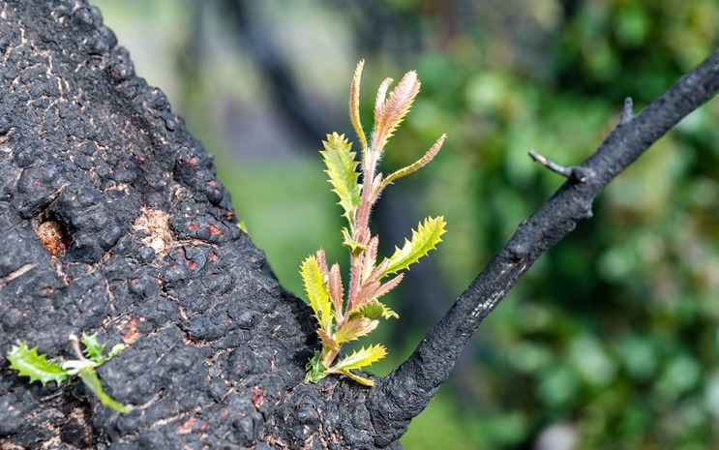

In one memorable story, Sarsfield resident Hilary Stripp took listeners along on the journey of the devastation following the fires, describing the unfamiliar new landscape, the small signs that things were changing, and nature recovering.

*“A tipping point, the green hoods come back everywhere and the delight is so rich and so deep because I know what it was, because of what it means to me and this is where it is like trauma and grief, like that point where you start to feel goodness again, when you start to love life again and it means so much because of where you’ve been, because of how deep and dark it was, and the people who kept pace alongside you who truly saw how bad it got.” (Hillary Stripp, Sarsfield resident, 2021).”*

[Recordings of each session are available on YouTube](https://www.youtube.com/playlist?list=PLI25liwKHjvVilUZ93hKC3xvWi0QifM4c)

***NLCR insights:***This NLCR example highlights the power of diverse communities and stakeholders coming together to share local stories. Some of the presenters had never spoken publicly before, creating a powerful and authentic shared experience. It integrates this with capacity building through sharing across scientific expertise, community-lived experiences, Traditional Owners, funders, and government/agencies. It was recorded so the presentations can still be referred to, revisited, and featured, supporting continued NLCR at no extra cost.

**River Warriors**

*A community-driven approach to capacity- and resilience-building of the Brunswick River Catchment*

**Location:**Brunswick Heads, NSW

**Disaster:** Flood

**Community groups:**Community volunteers

**Funding/support:** FRRR, collaboratively funded by donors ranging from private individuals to larger foundation. [Read more about this funding at FRRR.](https://frrr.org.au/blog/2023/06/19/grants-of-1-3m-boost-131-projects-in-remote-rural-regional-australia/)

**Delivered by:** Positive change for marine life

**Phases of disasters:** Before (ongoing nature connection and climate adaptation)

A project preparing for “future climate-related impacts by delivering a community-led riparian restoration program in the flood-impacted Brunswick River to stabilise riverbanks and restore wetland vegetation”. This was dedicated funding for “rural communities impacted by climate-related including recent bushfires, floods, and storms, to support local preparedness, recovery and resilience-building”.

### **The sounds of recovery**

*Enabling communities to lead bushfire recovery wildlife monitoring with ecoacoustics*

**Location:**Bairnsdale, Victoria

**Disaster:** Bushfire

**Community groups:**Citizen scientists

**Funding/support:** FRRR Strengthening Rural Communities

Prepare and Recover program. Collaboratively

funded by donors ranging from private individuals to larger foundations. [Read more about this at FRRR.](https://frrr.org.au/blog/2023/01/18/rural-groups-awarded-nearly-1-45-million/)

**Delivered by:** Museums Board of Victoria

**Phases of disasters:** After (citizen science capacity building for early, medium-, long-term recovery)

In Bairnsdale, this project is strengthening community capacity “to protect the environment from the effects of bushfires by monitoring recovery of threatened wildlife through a citizen science project.” This funding is for community-led initiatives “supporting the ongoing recovery from the 2019–20 Black Summer bushfires”. You can see the materials on the [Sounds Of Recovery – acoustic monitoring for conservation webpage](https://egcmn.org.au/index.php/sounds-of-recovery-acoustic-monitoring-for-conservation/#:~:text=Our%20%E2%80%98Sounds%20Of%20Recovery%E2%80%99%20project%20with%20Museums%20Victoria%20and%20the).

***NLCR insights:***This is a great example of a NLCR project that involves collaboration between a state-based organisation working alongside a local organisation, and community volunteers. It highlights how accessible technology, with supported skill development, can be used to rebuild people’s connections with the local environment, and undertake important conservation at the same time.

### **Sarsfield Snaps**

**Location:**Sarsfield, Victoria

**Disaster:** Bushfire

**Community groups:**Led by and centred around young people, drawing together whole communities

**Funding/support:** Victorian Government Recovery Funding, Zoos Victoria, DEECA, ERV

**Delivered by:** Community

**Phases of disasters:** After (visual story of early, medium-, long-term recovery)

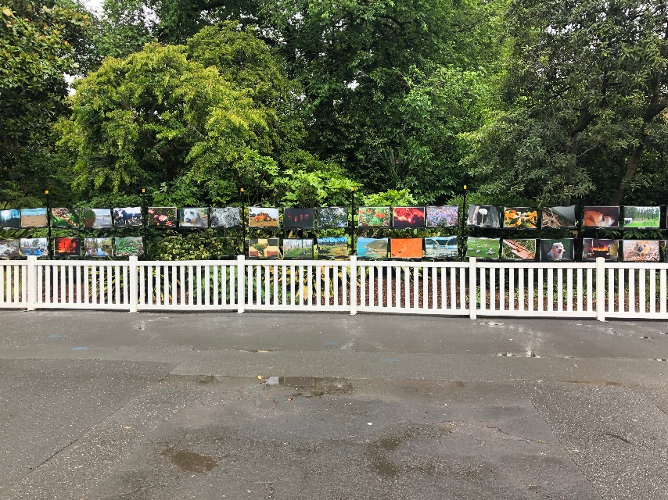Sarsfield residents were heavily impacted by the 2019–20 Black Summer bushfires. Sarsfield Snaps emerged as the community came together to “champion the voices of their youth in a time where they could easily be overshadowed. The project showcases the ongoing recovery of community, nature and ecology through the artistic perspective of local children.” (Sarsfield Community Association, Sarsfield Snaps Official Launch)

Zoos Victoria became aware of this work through existing local connections and offered to support the community when they were ready, going back out several times to sustain their engagement. Eventually this led to a Zoos Victoria exhibition and the project being featured at the *Sharing Stories of Nature Recovery Forum.*

“Following the fires, the photos we took captured what was happening around us. But it gave us a different perspective. And it let us show the younger perspectives that were here with us. With ages 3-to-16 taking the pictures. It leaves us with something we can keep, something that can’t be taken away in another fire. It tells us that we will always rise back up after we fall or break.” (young Sarsfield resident).



***NLCR insights:***This is an example of a community-led NLCR project that has been expanded and resourced through connecting with broader community events. It highlights the importance of meeting communities where they are, aware and empowered to follow up opportunities when they are ready, supported with sustained engagement. It gained support beyond the community after being exhibited and featured in other forums, highlighting opportunities for organisations to keep in mind if they are interested in amplifying local stories. It also highlights a process for communities to redefine their story and to rebuild their connections with the local environment.

### **Students leading habitat monitoring after fires**

### *School students creating and installing information sheets to help communities see nature recovery as they walk through fire-affected areas.*

**Location:**Pomonal, Victoria

**Disaster:** Bushfire

**Community groups:**Pomonal Primary School, Upper Hopkins Land Management Group, Project Platypus

**Funding/support:** Victorian Landcare Facilitator Program, Victorian Landcare Grants

**Delivered by:**Landcare

**Phases of disasters:** After (students leading community recovery)

In early 2024, devastating bushfires swept through Pomonal, dramatically impacting the landscape and destroying homes. Local school students took it upon themselves to monitor the recovery of the nature around their school, contacting Landcare just weeks after the fires!

By establishing a dedicated science corner, ongoing photography and monitoring of the landscape, and by taking part in important discussions on fire in the landscape, these students have been ‘enthusiastically’ building their resilience. Students installed their own ‘photo points’ to create stations where regular photos have been taken with the help of the local Landcare facilitator. These photos document the habitat’s recovery and will be on display for the community at the 2024 Pomonal Wildflower Show.

The Pomonal Primary School also hosted a massive fire ecology-themed field trip for its four sister schools in their regional school cluster. Here guest speakers taught students how “many plant species in the Grampians have evolved to rely on fire for their reproduction and growth. Post-fire, the landscape often witnesses the blooming of unique plant species that are visible only in the years immediately following such events. This transient ecosystem presents the students with a rare opportunity to observe and photograph these ephemeral botanical wonders.”

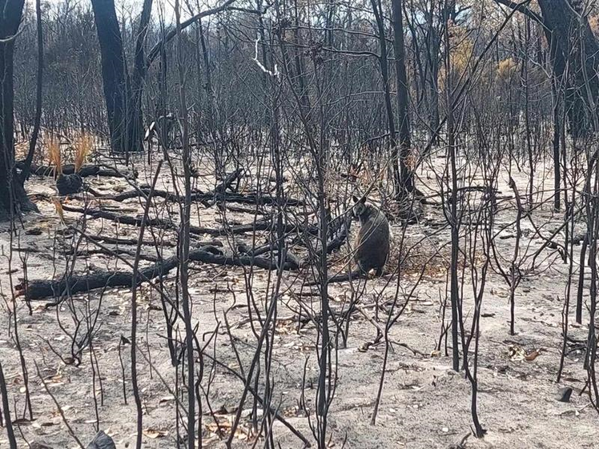

Burned landscape near Pomonal (source: Project Platypus).

Other activities during the field trip included having students collect their own burnt branch to create charcoal art, and displaying plant species photos along a heavily burnt area of native habitat to show the community what these tiny seedlings will become.

The students are not only learning valuable lessons about ecology and conservation, but also actively contributing to the restoration and preservation of their local environment.

[Read more on this story at Project Platypus](https://www.platypus.org.au/post/pomonal-students-monitoring-habitat-recovery-after-fires).

***NLCR insights:***This NLCR example highlights a context where action started in early recovery, with young people teaming up with local environment groups to lead the community in their recovery journey. It highlights the importance of watching and waiting, to see what actions nature needs to support its recovery (e.g. weeding, managing grazing damage). This combination of discussion, experience, and creative activities can help students build their self-efficacy, feelings of safety, allow them to reconnect with their dramatically changed local nature, and inspires hope through seeing recovery and images of what the new growth will become.

### **‘Friends of’ groups co-recovery with rainforests and rivers**

**Location:** East Gippsland, Victoria

**Disaster:** Bushfire

**Community groups:** Private landholders

**Funding/support:** DEECA, Parks Victoria, East Gippsland Shire Council

**Delivered by:** Friends of the Upper Nicholson Catchment Incorporated (FUNCI)

**Phases of disasters:** After (communities coming together for vegetation and wildlife recovery)

In 2019, catastrophic bushfires between Clifton Creek and Sarsfield “left much of the landscape devoid of vegetation” and left local threatened species – the Powerful Owl, Southern Greater Gliders and Yellow-Bellied Gliders – under greater threat.

The local Friends of the Upper Nicholson Catchment Incorporated (FUNCI) stepped in to lead revegetation efforts, recreating wildlife corridors connected to nearby unburnt landscape, and restoring normal environmental flows.

Key to their efforts was protecting indigenous plants by keeping out large pests like deer that might otherwise impact their recovery, revegetating sites that had ground cover and understory burnt, and stabilising banks to reduce erosion and sediment runoff.

FUNCI members showed resilience at every turn, staying connected despite COVID-19 putting a dampener on working bees, and adapting plans as sites became inaccessible and the weather unpredictable. They were even growing their own indigenous tube stock when there was none in their local nurseries.

Their efforts paid off, with revegetated areas providing new habitat for wildlife and the banks holding up in the face of later downpours.

The social aspect provided an additional boost that helped volunteers’ recovery, with their “united efforts” restoring their local landscapes, and providing a chance to connect in-person and online to build “new skills and understanding of the recovery process beyond their individual property”.

Moreover, they also ran workshops attended by local landholders and created a visual publication to share their story with others.

“To see the early signs of recovery after such large-scale devastation – to hear the noise of the bush once again, and to witness the return of critters both large and small – has supported our members in their own recovery process. To have a Lyrebird nest in the fenced-off area is icing on the cake.” *(FUNCI member)*

### [**Strengthening locals’ connections to native flora in the Kinglake Ranges**](https://frrr.org.au/blog/2021/07/27/strengthening-locals-connections-to-native-flora-in-the-kinglake-ranges/)

**Location:**Kinglake Ranges, Victoria

**Disaster:** Bushfire

**Community groups:**Residents; new residents

**Funding/support:** FRRR Grants for Resilience and Wellness, Victorian Bushfire Appeal Fund.

**Delivered by:** Kinglake Landcare Group auspiced by Kinglake Neighbourhood House.

**Phases of disasters:** After (building capacity for new and old residents’ recovery)

In fire-affected areas like Kinglake, understanding the natural environment and knowledge of fire safety are critical. With over half the residents being new to the area, increasing knowledge and connection to the local environment are needed. Building this through nature walks and propagation workshops helps people get familiar with the native flora and how to care for it.

The Kinglake Landcare Group delivered a series of [expert-led community workshops](https://frrr.org.au/blog/2021/07/27/strengthening-locals-connections-to-native-flora-in-the-kinglake-ranges/) and activities to increase awareness and management of the local environment.

Kinglake propagation workshop.

Participants shared their experience and learning with surrounding areas, including Whittlesea and Strath Creek. These new skills have empowered the community to maintain the natural flora, take an active role in their community, and share and support others.

*****NLCR insights:***This provides an example of an NLCR activity that features in a range of projects and can be readily adapted across community, landscape and disaster contexts. It supports broader resilience for new residents and the community through building connections within Kinglake Ranges and nearby communities, and supports recovery through safety and agency for local landscapes and fire. It is also possible to build in adaptation and mitigation by including the climate adaptation lens in these types of NLCR activities.

**Victorian Landcare**

Strathewen Landcare Group members take great comfort from walking and talking about the devastation and recovery on their properties. Source: [Victorian Landcare and Catchment Management](https://www.landcarevic.org.au/assets/Uploads/VLCMM-Issue-49.pdf), Issue 49.

Victorian Landcare are connected with the local community and landscape, connected with governments, and can act quickly.

There are countless examples of this in action that can be found on their website and in their hardcopy magazine, including in supporting bushfire recovery in Victoria. These activities include workshops, plantings, monitoring and weeding, noticing nature recovering, and developing revegetation guides.

Weed control after fire is critical. A gorse control field day was well attended in February 2015 at Darraweit Guim. Source: [Victorian Landcare and Catchment Management](https://www.landcarevic.org.au/assets/Uploads/VLCM-78-lo-res.pdf), Issue 78.

### [**Managing for dry times in Hovell’s Creek**](https://frrr.org.au/blog/2021/03/05/managing-the-dry-times-in-hovells-creek/)

**Location:**Hovell’s Creek, NSW

**Disaster:** Drought

**Community groups:**Landcare members and

landholders

**Funding/support:** FRRR Future Drought Fund’s Networks to Build Drought Resilience Program

**Delivered by:** Hovell’s Creek Landcare

**Phases of disasters:** Before

“When drought strikes, the toll of the dry land can have an overwhelming impact on a farmer’s livelihood, family and community” ([FRRR](https://frrr.org.au/blog/2021/03/05/managing-the-dry-times-in-hovells-creek/)), so a series of workshops with Landcare members and local landholders were offered, spanning topics from mental health to on-farm monitoring. These “supported farmers and community members to feel that they are doing their best for their livestock, their landscape, their families and themselves – to plan for the future, as much as the present” and built on past workshops on drought and land. The workshops increased wellbeing, knowledge and capacity and meant that the community was able to secure more funding for essential equipment. [Read more at FRRR.](https://www.hovellscreeklandcare.org.au/past-projects/152-workshops-set-to-help-farmers-doing-it-tough)



***NLCR insights:***This provides another example of Landcare’s work with members and local landholders. It builds capacity, knowledge and agency in managing local landscapes, and connecting and caring for communities. This is another example of a NLCR activity that subsequently supported funding.

### [**Solving the Greater Glider housing crisis**](https://frrr.org.au/blog/2023/09/25/solving-the-greater-glider-housing-crisis/)

**Location:**Mount Barney, Queensland

**Disaster:** Bushfire

**Community groups:**Local climbers, landholders, Fassifern Community Centre, Maroon State School students, teachers and parents

**Funding/support:** FRRR Strengthening Rural Communities Prepare and Recovery. Additional support through Scenic Rim Regional Council, Wettenhall Foundation, and Global Giving

**Delivered by:** Boonah and District Landcare Association. Specialist input from universities including University of Wollongong

**Phases of disasters:** After (communities and local species co-recovering)

The 2019–20 Black Summer bushfires swept through local bushlands in the Mount Barney region, decimating the local centuries-old hollow-bearing trees that provide habitat for the Central Greater Glider. The local community rose to the challenge with a home-grown housing solution; rallying around to design, test, install and evaluate nest tubes. Local volunteers, community groups and school communities could then ‘delight’ in visiting the forest and enjoying the fruits of their hard work experiencing the gliders in their new habitat. [Read more at FRRR.](https://frrr.org.au/blog/2023/09/25/solving-the-greater-glider-housing-crisis/)

***NLCR insights****:* This is a great example of NLCR activity across a range of communities in the local area. It supported different experiences in local nature, promoting species recovery and advocating for nature. It demonstrates how providing opportunities for young people to have repeated experiences in nature can support an enduring connection, and an ethos of stewardship that they then carry with them throughout their lives.

### **Biodiversity Bushfire Recovery Grants Program**

### **Location:**Victoria – statewide

**Disaster:** Bushfire

**Community groups:**Landholders, Landcare groups, Landcare networks

**Funding/support:** Victorian Government Recovery Funding

**Delivered by:** East Gippsland CMA, Glenelg-Hopkins CMA, North East CMA, DEECA, Landcare, Trust for Nature

**Phases of disasters:** After (funding to support early, medium-, long-term recovery)

The Biodiversity Bushfire Recovery Grants program was delivered in 2020, in the months following the bushfires across Victoria. Local communities were dealing with the impacts of the bushfires, on top of the impacts of COVID-19 restrictions.

The grants supported 30 individual landholders and 21 network projects. Activities included seeding and planting, pest control and fencing, and knowledge building and sharing (e.g. workshops, training and publishing). Key outcomes included:

* remediation of degraded land/soil
* improved biodiversity
* restoration of burnt vegetation
* pest control
* strengthened community capacity to respond to this and future disasters.

*“…providing funding in a timely manner after the devastating bushfire impacts to individuals, groups and networks … created a sense of support to these affected communities and a sense of hope and rebuilding after such a traumatic event*. – East Gippsland CMA

*For private landholders, an unexpected benefit was the overwhelming sense of achievement they gained through these rehabilitation projects. Landholders often commented that the delivery of these projects assisted with their own personal recovery*. – East Gippsland CMA

*For some, having a small project to re-plant and rejuvenate a devastated area was their own form of therapy that helped to lift their spirits and bring life back to their lives.* – North East CMA

In a project story shared as part of the program evaluation, a North East CMA stakeholder who oversaw the program noted that a visit to Corryong in 2021 provided an opportunity to connect with a couple of local residents who were also grant recipients. They highlighted their projects and restoration as their way to:

• process what had happened during the fires

• return a part of the property back to normal after the fires.

In some cases, the project site became a form of memorial to acknowledge what had happened, but also to see the new life that has returned.



***NLCR insights:***

* Timely program process and granting allows for early fund availability, adding to a sense of support
* Ensure an appropriate level of reporting to reduce burdens, and design questions to help tell the stories
* Avoid competitive application processes to minimise further stress
* Consider eligibility requirements, for example, for those indirectly affected.

1. [Natural Environment Climate Change Adaptation Action Plan.pdf](https://www.environment.vic.gov.au/__data/assets/pdf_file/0030/558264/Natural-environment-Climate-Change-Adaptation-Action-Plan-2022.pdf)
2. [AIDR Community Recovery Handbook](https://knowledge.aidr.org.au/media/5634/community-recovery-handbook.pdf) 
3. [Millenium Assessment, Chapter 5: Using Multiple Knowledge Systems – Benefits and Challenges](https://www.millenniumassessment.org/documents/document.343.aspx.pdf)
4. [In a Good Way: Braiding Indigenous and Western Knowledge Systems to Understand and Restore Freshwater Systems](https://www.mdpi.com/2073-4441/16/7/934)
5. [Guide to Disaster Recovery Capitals (ReCap)](https://www.phoenixaustralia.org/disaster-hub/wp-content/uploads/2021/05/ReCap_2022.pdf)
6. [Bendigo, White Hills and Long Gully Local Flood Guide – VICSES](https://www.ses.vic.gov.au/documents/8655930/9320079/Bendigo%2C+White+Hills+and+Long+Gully+Local+Flood+Guide+August.pdf/6728e529-22c8-4bc3-de87-f67cb4761d3e?t=1694068089313)
7. *Climate justice and intergenerational equity*[: Turning ‘wrong way’ climate, ‘right way’ Dja Dja Wurrung Climate Change Strategy 2023–2034](https://djadjawurrung.com.au/wp-content/uploads/2023/05/DJA46.-Climate-Change-Strategy-230523.pdf)
8. [Wanyarra Dhelk Case Study](https://watersensitivecities.org.au/wp-content/uploads/2020/09/201113_V5_Wanyarram-Dhelk-Case-Study-2.pdf)
9. Source: [Galk-galk Dhelkunya: Forest Gardening Strategy 2022–2034](https://djadjawurrung.com.au/wp-content/uploads/2023/04/Forest-Gardening.pdf)
10.
11. [Department for Environment and Water – 2022–23 River Murray flood](https://www.environment.sa.gov.au/topics/river-murray-floods/2022-23-river-murray-flood-event)